Identification of spatial Structures within Urban Blocks for Town characterisation

Annabelle BOFFET, Stéphane ROCCA SERRA
Institut Géographique National - Cogit Laboratory -
2/4 av.Pasteur - 94165 Saint-Mandé - France
fax : (+33) 1 43 98 81 71
annabelle.boffet@ign.fr rocca_serra_stephane@yahoo.com

ABSTRACT:
This paper is part of an ongoing research thesis on town characterisation in order to improve the automation of cartographic generalisation of urban areas. It proposes a first method to qualify the inner organisation of urban blocks. Angularity, proximity and orientation principles are used to describe two main types of building spatial dispositions: structures of free space and alignment.
KEY WORDS:
Spatial structures, Urban block analysis, Town characterisation, Urban generalisation

Introduction
The descriptions of geographical space provided in standard geographical databases do not jointly show the diversity of levels of observation that are possible and required by complex processes (e.g. automated generalisation). The orchestration of the generalisation algorithms (determining which algorithms to use on which objects and when) [Mc Master et al, 1992] depends on the geographical environment of each object to be generalised. A multi-level analysis has been proposed by [Ruas, 1999] to interpret raw data at different observation levels in order to create some groups of objects (micro, meso and macro levels). During the generalisation process, the multi-level analysis allows to manage the complex geographical relations between objects, while improving the database description of the studied space.
This paper is part of an ongoing research thesis on town characterisation. [Boffet, 2001] proposed an application of this multi-level analysis to urban area: it allows to describe the hierarchical organisation systems of the urban area components. The method is based on the automated grouping of geographical objects, as an application of the object-oriented recursive aggregation concept. The proposed model has been implemented on the LaserScan object-oriented G.I.S. Lamps2, and tested on BD Topo® topographical data on Aix-en-Provence (France). The application of this method on urban areas initially described by micro buildings and streets provides three sub-systems at different levels :
- Urban Area is defined as a closed set of dense building zones.
- Urban Districts are made of neighbour blocks, that are visually and/or functionally similar.
- Urban Blocks are defined within the town limit by cycling streets, which circumscribe buildings.
Each of these sub-systems has been created in the database, characterised according to its morphological and functional characteristics, and connected to the objects of other levels according to their hierarchical relations [Boffet, 2000]. Information created in this way describes the context of each object.
This paper focuses on the inner description of urban blocks by identifying particular spatial configuration of buildings, in order to complete the thematic classification that has been described in [Boffet et al, 2000]. A fourth sub-system is therefore computed:
- Buildings Structures are made of particular spatial configuration of buildings.
The first section of this paper reviews the well known perception criteria defining most relevant structures. Then two types of simple structuring entities are analysed in the two following parts: free spaces and alignments of buildings.
- perception criteria for structure identification
From the perception point of view, the most efficient criteria come from the Gestalt Theory. They are described in [Rock 1983] and used in [Regnauld 1998] in the context of cartographic generalisation. The grouping processes rely on the eye’s sensitivity to group objects together according to several criteria:
- Proximity, when objects are close one to another.
- Similarity, when objects look similar.
- Continuation, when there is a regularity between objects.
- Symmetry, when symmetry of positioning is verified.
- Enclosure, when a particular configuration of objects forms a well known shape.
To develop algorithms of building typification, some researchers have already created groups of similar nearby objects according to the Gestalt Theory. Typifying consists in " carrying into a representation, where the identified distribution is preserved, objects of a same nature that happen to be grouped by some identifiable geographical process " [Hangouët 1998 : p. 227]).
- [Hangouët 1998] defines the ‘inner access’: buildings are associated to the nearest road by combining proximity and regularity parameters between buildings and roads.
- [Regnauld 1998] searches for sets of buildings grouped in homogeneous rows. Rows are computed from a Minimum Spanning Tree, a non-cyclic graph that reveals closest neighbouring relationships. The whole graph is divided as soon as a building’s characteristic differs too much or when a street cuts it.
- [Anders et al 2000] propose a clustering method based on homogeneity to create non linear groups of buildings to typify.
The three full methods quoted above proposed both a recognition of urban entities and a generalised representation of it ; results are very significant. The drawback of such processes lies in the heavy time consuming because of the complex measures required. Our objective is to propose simple methods of structure recognition in order to integrate them in other processes of data handling. The inconvenient of such simple analysis lies in the quality of the results: non significant structures may be identified. A characterisation step is therefore required after having identified structures in order to distinguish absolutely important from relatively important structures.
We make the choice of analysing two kinds of structures as shown in figure 1:
- Free spaces, that are objects of quite new analysis (figure 1a)
- Buildings alignments, as an intermediary step to identify trams (figure 1b). A tram is composed of several parallel alignments of buildings.
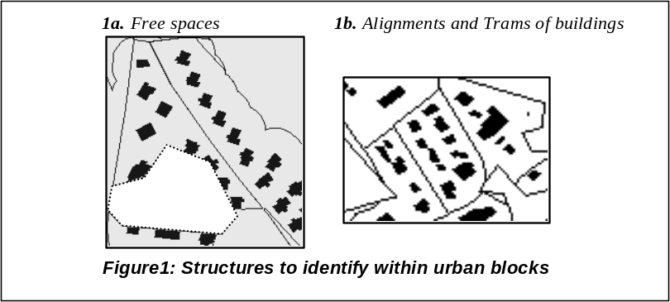
On the other hand we accentuate the multi-level enrichment of the database, that means:
- Informing buildings that they belong to one or more structures (creating relations buildings / structures).
- Informing urban blocks that they own one or more structures (creating relations blocks / structures).
- Characterising each structure to define their relevancy through different indicators.
From the six criteria of the Gestalt Theory, we make the hypothesis to find our relevant structures with only three of them (the most frequent) computed on buildings within urban blocks [Rocca Serra, 2000]:
- Proximity, which is measured by the Euclidean distance between the gravity centres of buildings.
- Similarity, Which is measured on geometrical shape criteria of buildings: elongation, orientation, and surface.
- Good continuation, which is used as the regularity of proximity, similarity and orientation of buildings. A group is perceived by the proximity of a character, but also by the distance that takes the group away from others. An alignment of buildings is not only created by the regularity of the spacing of the orientation and of the shape on the group’s buildings, but also by the different distances, orientations and shapes of the buildings that do not belong to the group.
The two next parts of this paper are dedicated to each structure: free spaces and alignments, and will detail which parameters or combination of parameters make spatial configuration of individuals become specific groups.

- Free space
A key point in the generalisation process is to manage the conflicts between objects without modifying their context. Displacement is a useful technique to separate overlapping objects but it requires free spaces that are gradually reduced and even possibly deleted. Thus, free spaces, as particular configurations of buildings, need to be identified to be preserved. Free space is defined as a significant part of a urban block without any building inside. The interest of free space lies in its structuring effect that is not only based on its capacity to decompose other structures but also on its capacity to unify elements :
- Free space as a decomposing character, plays the role of separation between objects, such as between two houses with the notion of ownership, or between districts separated by a waste land.
- Free space as a unifying character, plays role of attractive pole, such as market place, church place or public garden in downtown.
The methodology to identify free spaces is described below, the distinction between unifying or decomposing place is the objective of the next section on characterisation.
  - free space identification
The principal criterion to identify free spaces is proximity : a free space will be declared as such if the distance to any building is big enough. The method uses both “inverse” buffers to identify spaces that are far enough from all buildings, and size selections to represent only “informative” free spaces (i.e. big enough).
The method to identify free spaces is described below (figure 2):
Step 1 : Reduction of the block limits to avoid some inconsistent spaces close to the block limits. An internal buffer of 20 meters is computed (20 meters seems to be the standard distance of “ownership”).
Step 2 : Aggregation of buildings within a certain limit distance. A buffer of 20 meters around buildings to aggregate neighbour buildings is computed.
Step 3 : Intersection of both results provides spaces that do not fall within any of the two preceding buffers.
Step 4 : A filtering with the Douglas&Peucker algorithm [Douglas & Peucker, 1973] provides a form that is simpler and closer to buildings.
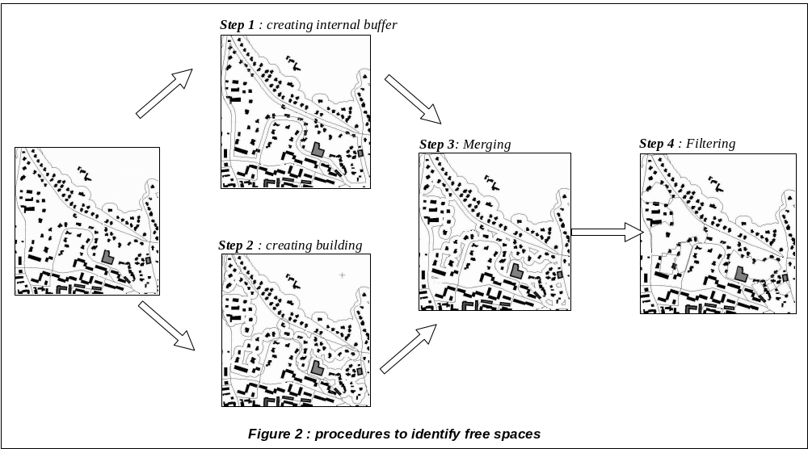2.2. free space characterisation
As the method of identification is rather simple and not very discriminating, a great number of free spaces are identified ; a characterisation of the identified free spaces is necessary. The characterisation is based on four indicators. (1) Determination of the relative importance of each free space, in order to inform and constrain the most relevant one. (2) The type of free space is defined according to its role: In the case of a decomposing one, the free space can be used to divide the urban block in several parts (as for heterogeneous block divides in several homogeneous). In such cases, free spaces are perceived as walls, separating two different zones ; (3) the main direction of the free space is therefore computed to decompose the urban block. (4) But this main direction is only valuable in case of non compact free space, which is computed by means of an elongation indicator.
    - relative importance of the free space
A_{n} is an indicator aiming at characterising the spatial relative importance of the free space (percentage within the urban block area).

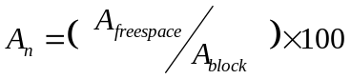
A_{freespace} : area of the free space
A_{block} : area of the block

    - type of free space: open to the street or enclosed by buildings
The terminology of open and closed comes from the neighbourhood of free spaces. Visual study of free spaces in urban blocks shows that decomposing free spaces are often open to the street, and attractive free spaces enclosed by surrounding buildings. Considering the relative importance of each interval between two successive buildings that build free space, free space is defined as open in case if a maximal relative importance is computed or closed in case of a minimal length. L_{n} is an indicator aiming at characterising the spatial importance of each arc which makes up the free space:

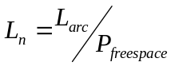
L_{arc} : length of the arc (1 arc is define between two successive buildings surrounding the free space)
P_{freespace} : perimeter of the free space

    - main orientation of free space
O_{n} is the main of free space, the method of [Regnauld 1998] being used for the computation. This method defines the direction in which the free space is the longest (mean of the two longest directions).
    - elongation of free space
E_{n} characterises the shape of free space, the higher is for the most compact of all, the circle (E_{n} = 1).

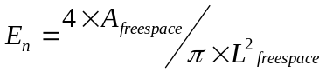
A_{freespace} : Area of the freespace
L_{freespace} : Longest length in the free space

    - results
Figure 3 shows the characterisation of two free spaces:
- Free space  makes up 12 % of the urban block area, it is a closed free space (surrounding by buildings), its shape is not compact (0,39) and the main orientation is 12 degrees.
- Free space  is more spatially important, with 22 % of the urban block area, it is an open free space (open to the street), its shape is rather longer (0,55), and the main orientation is 668 degrees.
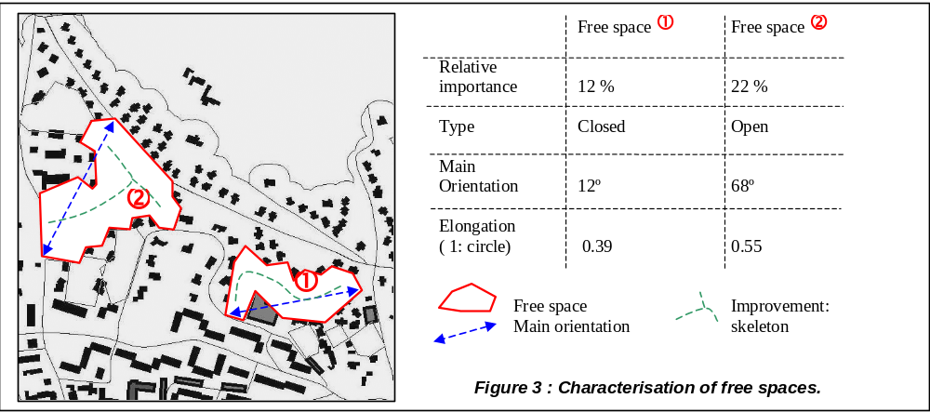Such characterisation is quite relevant, and requires precision concerning the main orientation which can be replaced by the skeleton of the free space. Once urban blocks are informed about the existence of relatives important free spaces, their characterisation by way of elongation and skeleton measures could efficiently constrain the generalisation process of displacement to preserve the shapes and surfaces of free spaces.

- Spatial disposition of buildings
Last section was about the identification and characterisation of spaces between buildings, this section deals with a dual, the particular organisation of buildings in alignments. Alignments of buildings can not be found everywhere. In our case, as urban blocks have been preliminary thematically qualified, a distinction is made between :
- Dense blocks in town centres which are often too dense to find any alignment of buildings. If an alignment exists, it is between blocks that are separated by orthogonal streets (that does not fit with our level of analysis).
- Peripheral housing blocks, wich are more adapted to alignment analysis. Collective housing blocks show one additional criterion: the own orientation of buildings, which is determinant in suburbs area.
The proposed analysis of spatial disposition of buildings relies on the study of the geometrical relations between neighbour buildings. Neighbour buildings are grouped according to the good continuity (regularity) of positions with both proximity and angles measures. A third measure can be used with building orientation, which emphasises the visual perception of alignment in case of large buildings.
  - identification of alignments
The method to identify alignments is described in figure 4:
Step 1: Creation of neighbour vectors,
Each building is assigned its gravity centre thanks to an algorithm developed by [Regnauld 1998], which takes in account not only position of the points, but also the length of arcs. Then vectors are computed, to characterise each relation between buildings by both a distance and a direction.
Step 2: Creation of triplet,
Each triplet is composed of three relatively aligned buildings: the source building, its nearest neighbour building and a third one aligned on the last two first (the direction is compared with the nearest neighbour vector and is selected only if it is close to 0 degree). These neighbouring relationships are assigned as attributes to each building.
Step 3: Grouping the triplets into structures,
Once the triplets have been computed, the aim is to group the triplets according to homogeneity of distances and angles. A recursive loop compares each triplet to group them.
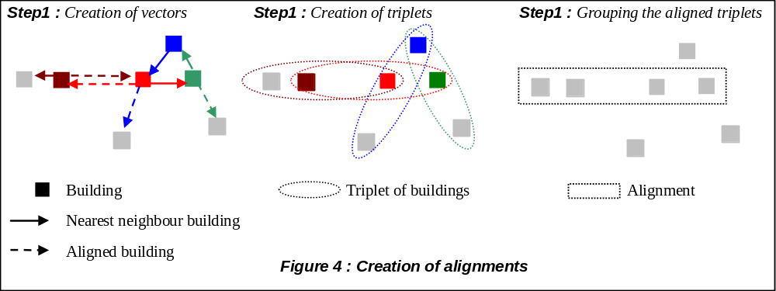
  - characterisation of alignments
The strength of this method is to accept plurality of structures for a given building. A characterisation is necessary to compare different structures to decide which one is the most structuring. To characterise the identified aligned structures, indicators are computed to define whether a structure is morphologically regular and/or extensionally important. Three main indicators are computed : number of buildings to indicate the spatial importance of the structure, distance and surface homogeneity of buildings to evaluate the morphology of the structure.
    - relative importance of alignment
N_{n} is a simple indicator aiming at characterising the numeral relative importance of the structure. The higher the percentage, the larger the structure.

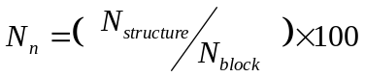
N _{Structure} : number of buildings that belong to the structure
N _{block} : number of buildings in the urban block

    - distance homogeneity of alignment
A standard deviation of the distances has been computed : N_{n} characterises distances between neighbouring buildings of a same structure: The higher the parameter, the less homogeneous the structure.

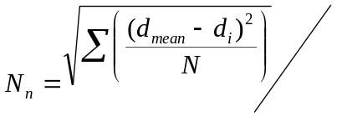d_{max}
d_{max} : maximum distance between buildings
d_{mean}: mean distance between buildings
d_{i} : unitary distance between buildings
N : number of distances calculated

    - area homogeneity of alignment
As defined above, another standard deviation is computed : A_{n} characterises the homogeneity of building areas in the structure. The higher the parameter, the less homogeneous the structure.

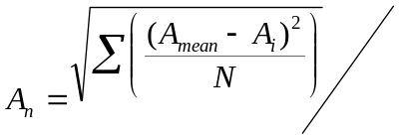A_{max}
A_{max} : maximum area of buildings
A_{mean} : mean area
A_{i} : unitary area
N : number of areas calculated

    - results
The application of this identification method provides heterogeneous results. Figure 5a shows relevant results: aligned buildings are well identified in peripheral urban blocks. On the contrary, figure 5b, shows a non really spatially organised block, where the method proposes four alignments that are not really justified, except for alignments 3 and 4 that are rather homogeneous considering the distances and the surfaces of buildings. A quick overview on the characterisation indicators shows that:
- The alignments are characterised by a rather equal importance (14 to 22 % of the block’s buildings).
- The distance indicator is not really discriminating (from 0.36 to 0.42) because of the method of distance measurement: centres of gravity do not account for the sizes of the buildings, which are visually preponderant. The measure of proximity proposed by [Ruas, 1999] would give better results: distances are computed between each pair of nearest sides of buildings.
- The last one, which characterises the homogeneity building sizes seems to be the most relevant one: alignments 3 and 4 show homogenous size ( indicators of 0.12 and 0.18) unlike to alignments 1 and 2 (indicator of 0.26 and 0.31).
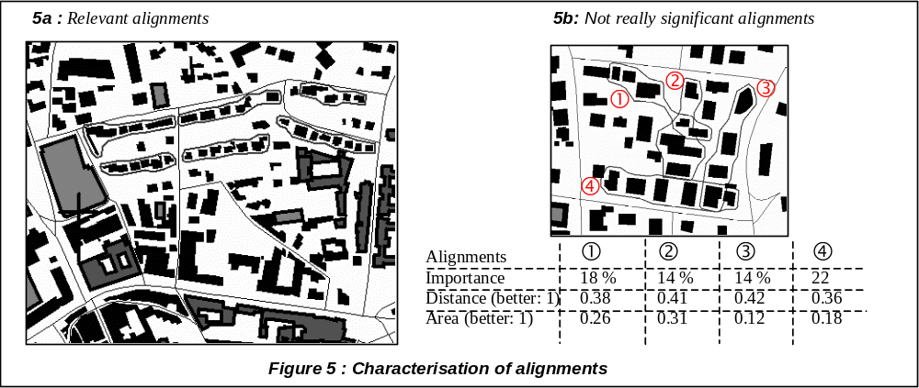
Even if the proposed method provides the possibility of identifying crossing alignments (such as figure 5b), even if it provides good results in evident cases (such as figure 5a), we need to work on the characterisation which shows some weakness.
Conclusion
The aim of this paper was to describe the inner repartition of urban blocks by identifying particular spatial configurations of buildings. Visual criteria of the gestalt theory have been used to describe two types of structures within urban blocks: free space and alignment. The proposed method of identification is based on simple principles, not time-consuming, to be easily integrated in other processes. To distinguish relevant structures, a characterisation has been computed by means of indicators to define whether a structure is morphologically regular and/or extensionally important.
The automatic analysis of free space is quite new, the results obtained are correct, they fit with the visual analysis. During characterisation, two main types of free space have been found, the main orientation and the elongation of them have been also computed. The characterisation of free spaces can be improved with the computation of their skeletons. It will be useful entity to constrain displacements in the generalisation process: the gradually reduction indeed the deletion of free space would be constrained according to the skeleton.
Alignment of buildings has already be studied by numerous authors; the strength of this method is twofold: on the one hand, it improves the geographical database description by informing each level of description on its relations (contender/content) with other levels among buildings (lower level) and urban blocks (upper level). On the other hand, it accepts plurality of alignments for a given building, getting closer to the complexity of the real world. This possibility of structure superposition involves three improvements in the generalisation process : (1) the composition of structures, such as composition of alignments to provide “trams”. (2) the identification of “pillar” buildings, without which the inner spatial organisation of blocks cannot be maintained. (3) the choice among structures in the case of keeping or emphasising one structure involving the deletion of the others. After some rough tests developed on a few urban blocks, results are quite relevant insofar as alignment identification method is applied on evident cases.

References
[Anders, Sester, 2000] « Parameter-free cluster detection in spatial databases and its application to typification » 19th Congress of the International Society for Photogrammetry and Remote Sensing / Amsterdam, Pays-Bas.
[Boffet, 2000] « Creating Urban Information for Cartographic Generalization » 9th International Symposium on Spatial Data Handling / Pekin, Chine.
[Boffet, Coquerel, 2000] « Urban Classification For Generalization Orchestration » 19th Congress of the International Society for Photogrammetry and Remote Sensing / Amsterdam, Pays-Bas.
[Boffet, 2001] « Création et Analyse Multi-Niveaux des Espaces Géographiques en milieu urbain» 5^{emes} Rencontres de THEO QUANT / Besançon, France.
[Douglas & Peucker, 1973] « Algorithms for the reduction of the numbre of points required to represent a digitalized line or its caricature n». The Canadian Cartographer, Vol 10, Num 2,
[Hangouët, 1998] Approche et méthodes pour l’automatisation de la généralisation cartographique; application en bord de ville. Rapport de thèse Université de Marne la Vallée.
[Mc Master, Shea, 1992] Generalization in digital cartography. Association of American Geographers, Washington.
[Regnauld, 1998] Généralisation du bâti : structure spatiale de type graphe et représentation cartographique. Rapport de thèse Université de Provence, Aix - Marseille I.
[Rocca Serra, 2000] Identification of spatial structures for urban zones generalization. Rapport de stage IGN.
[Rock, 1983] The logic of perception, Cambridge, MIT Press.
[Ruas, 1999] Modèle de généralisation de données géographiques à base de contraintes et d'autonomie, Thèse de doctorat en Sciences de l'Information Géographique, Université de Marne la Vallée.

