DEVELOPMENT OF ORIENTEERING MAPS' STANDARDIZATION

László Zentai
Department of Cartography, Eötvös Loránd University
H-1117 Budapest, Pázmány Péter sétány 1/A, Hungary
fax: +36-1-372 2951, e-mail: laszlo.zentai@elte.hu

The beginning

Although orienteering is practiced in every continent, it is a nearly unknown sport in most of the countries. The sport started as a military navigation test at the second half of the 19th century. The first civil (non military) event was organized at the end of the 19th century (Norway: October 31 1897, Sweden: 1900, Denmark: 1906).
Scandinavia is still the most developed area of orienteering. The main reason is probably the very complicated terrain compared to continental or Mediterranean areas, but mostly the long-term tradition of using topographic maps. In every country where orienteering was practiced before the foundation of the International Orienteering Federation (1961), local topographic maps were used for the events and training. The large scale topographic maps were allowed to use for civil purposes from the middle of the 19th century in Scandinavia, so there the map use was a part of the education and culture, much more so than in other countries.
The legend of topographic maps was different from country to country. Orienteering was not a part of the Olympic Games and international events were very rare at that time (these events before the 60’es were organized only in Nordic countries – since 1935).
Orienteering in Central European countries originated from Scandinavia before the second World War. In Hungary, for example, the first event was organized in 1925 by a prisoner of war who came back from the Soviet Union via Scandinavia. In these countries the sport was based on normal tourist activities and events. Tourist events were wide spread especially after 1950, but because of the secret military intention, it was mostly a field work exercise with map than a sport activity. Running was not allowed and the teams had to solve orienteering exercises with a normal “tourist speed”: both hurrying and late teams were punished.

Maps in the early period of orienteering

The early period of orienteering maps was the age of homemade maps. In most countries (excluding Scandinavia) there were no suitable maps available for public use. According to the running speed and the course distance the scale of maps was 1:20 000-1:40 000 (or 1:50 000-1:100 000 in the early years). In some countries the topographic maps were secret (Eastern Europe), in other areas the largest available scale of topographic maps was only 1:50 000 (Germany, Spain). Using tourist maps was a logical alternative, but in Eastern Europe the accuracy of publicly available tourist maps was not suitable for these events, so these countries tried to find more accurate tourist maps published before the communist era.
There was also a problem of copying. The only simple method of making some dozens of maps (it was the average number of participants in most events) that time was the black and white photo.
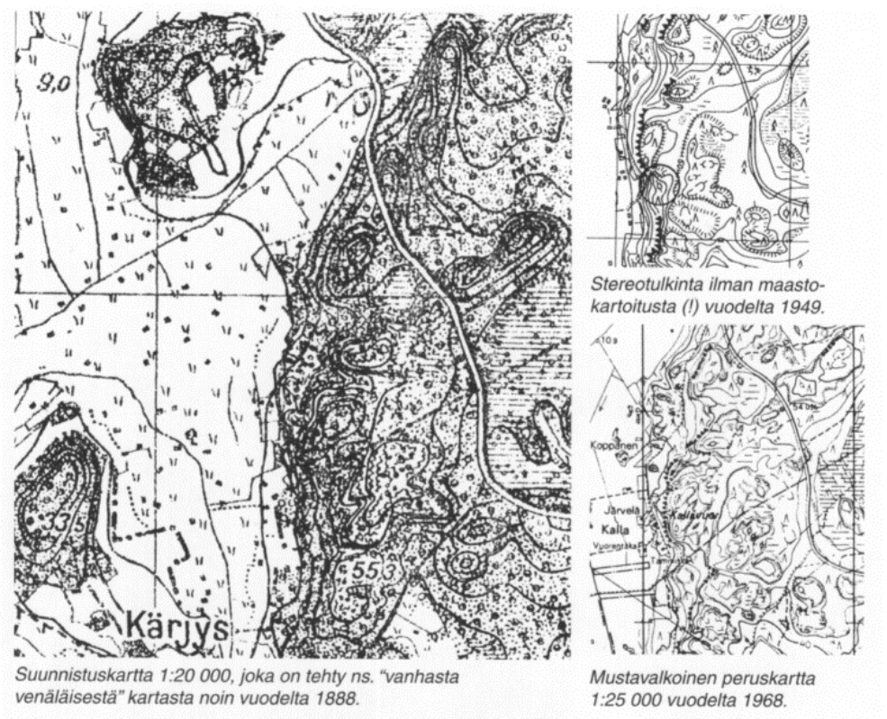
Samples from Finland (1888, 1949, 1968)

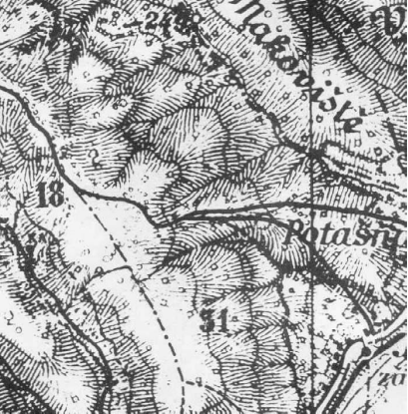
Offset printing (especially colour) was too expensive and technically very difficult for the keen organizers. To move one step further the sport had to reach the higher level: increase the number of participants in events, create international connections, form regional and continental organizations.
At that time there was no sense of speaking about legends, specifications or standardization; in most countries it was a problem even for local participants to understand maps, because the legend has changed from event to event.

The map of the first orienteering event in the Soviet Union (Ukraine) – 1963 – organized using a Czechoslovakian military topographic map published between the World Wars which used mostly hatchures instead of contour lines.
The first milestone: the foundation of the International Orienteering Federation (IOF)

In about fifteen years after the second World War sport became more and more important as a part of culture and politics. Olympic Games became more and more popular thanks to the radio (and soon television) broadcasting, it was also important politically to win in international events, in order to prove the priority of their own political system. Let’s just mention the final of the Football World Championships in 1954, where West Germany defeated Hungary. This win was one of the first successes of West Germany on international level and it allowed the country to get back into the other nations after WWII.
It was the time of the Cold War, so the sport was a scene of “battles” between the two main rival political systems. Although travelling abroad from Eastern European countries was very difficult or impossible at that time, sportsmen were exceptions. Scandinavian countries were much more open-minded or not so “Western” looked at from east, so the sport connection between the two regions has started.
There were mutual advantages:
- The Eastern European countries have studied the developed level of orienteering (including maps) of Scandinavian countries.
- Organizing international events with more participating countries has given orienteering more chance in each country to get more support from the state.

The International Orienteering Federation was founded in 1961 with only 10 countries (Bulgaria, Czechoslovakia, Denmark, Finland, Germany (East and West), Hungary, Norway, Sweden, and Switzerland). The first European Championship organized in 1962 (Löten, Norway) and in 1966 the first World Championship was organized (the first non European members of the IOF were Canada and Japan, 1969). In 1973 when other important countries (USA, Australia, Israel) joined the IOF the standardization of maps became a very important issue. Shortly after the foundation of IOF an international expert group started to work on the international legend.

The first ISOM (International Specification on Orienteering Maps)

The first step of standardization was the unification of scales and contour intervals. On the first European Orienteering Championship 1:25 000 scale maps were used with 10 meters contour interval.
The first colour orienteering map especially field worked for this sport was published in Norway in 1950. In 1962, 79 orienteering maps were published in Norway, and the situation was similar in Finland and Sweden. But the most developed orienteering country of Central Europe (Switzerland) was far behind the Scandinavians. So on the first international discussion about orienteering maps it was evident to use the mapmaking experiences of Scandinavians.
The maps of the first European Championship were at a very high level, the 5 meters equidistance was a surprise for foreign participants to give the chance of most challenging events.
In 1964 the association of Nordic countries had formed a map committee and they asked the IOF to discuss the maps of international events and to form the Map Committee of IOF. The first principles that were accepted internationally:
- The maps have to be so accurate and detailed that they give the possibility for the course planner to create a fair event and let each competitor easily identify his/her position during the course.
- The main disadvantage of using outdated topographic maps without special orienteering fieldwork is the luck factor. If a competitor has found a path not shown on the map and has been able to use it during the event can reach the control point faster than the unlucky rivals who omitted that path.
Under these circumstances the call soon came for standardized competition maps paying due regard to the particular requirements of orienteering. In the first national attempts in the sixties corrections and runnability information were added to the basic topographical maps. At the IOF level in the mid-sixties an expert group prepared proposals for representing the terrain on orienteering maps, these were summarised and presented in a "first draft" in 1967.
This era was the beginning of the introduction of special orienteering maps in Central Europe. In some countries the first colour maps were just extracts of topographic maps, but using the Scandinavian connections and experiences the first real colour orienteering maps were published: Czechoslovakia (Czech Rep.)-1961; Hungary-1964; Switzerland-1965; Czechoslovakia (Slovakia)-1966; Austria, West-Germany-1967.
In 1965 the Map Committee of the IOF was formed (the first meeting was in 1967, Zürich). All five members were cartographer (Jan Martin Larsen-Norway, Osmo Niemelä-Finland, Christer Palm-Sweden, Torkil Laursen-Denmark, Ernst Spiess-Switzerland).
The most important and urgent work of the committee was the specification of World Championship maps:
- The maps have to be new.
- The map has to show every detail of the terrain which can effect the route choice of the competitor.
- Most important is the accuracy and legibility: small and unimportant detail have to be omitted.
- The maps of international events have to use the same specification.
Suggested scale is 1:25 000 or 1:20 000, the equidistance is 5 m (depending on the terrain 10 m or 2.5 m is also allowed).
The first issue of the ISOM was ratified by the IOF-Congress in Doksy, Czechoslovakia in 1969. This issue was still not a "specification" but rather a "guideline", although it already contained quite concrete requirements. The most important specifications were the scales and the colours:
- black, brown and blue for topography,
- yellow for open ground, and
- grey or green / black for restricted runnability (vegetation).
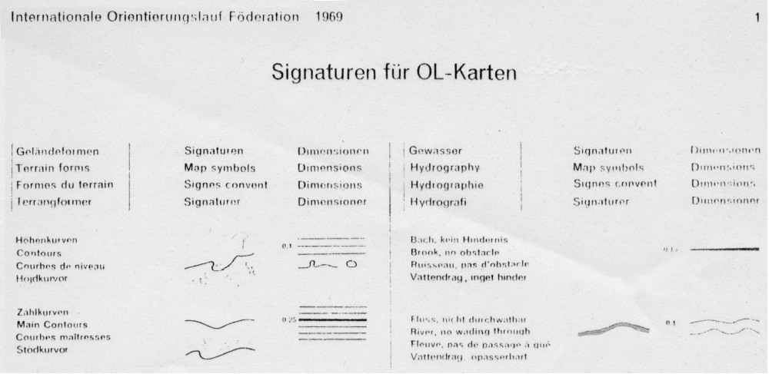
Part of the ISOM 1969

The development of ISOM-s

One of the largest discussion of these early years was the colour of the forest sign. This area symbol was traditionally green on topographic maps in every country. It was a Norwegian suggestion (1965) to use white colour (the paper colour itself) for the forest (good runnability). These maps were called negative maps and this suggestion was accepted internationally in some years.

The ISOM 1975 was the first binding specification. This version used various well-established specifications from the official topographic representations used in Scandinavia. In comparison with the first ISOM the symbols were organised into the five logical groups still used today and the following changes were made:
- green in three shades for the representation of restricted runnability due to vegetation,
- yellow screen or diagonal stripes for semi-open terrain (clearings and felled areas),
- grey for bare rock.
The ISOM 1975 was a compromise between the very different interests and requirements of the IOF member federations (at that time the IOF had 23 member countries). In some countries (Scandinavia, Czechoslovakia) green colours were not used at all, or only two shades were used neglecting the rules.
It was the introduction of “A”, “B”, “C” symbols. “A” symbols were compulsory, “B” symbols were allowed to use on special terrains and “C” for the rest (“national deviations).

The third issue of the ISOM (1982) was a further development of ISOM 1975 with the aim of consolidating the established and eliminating weaknesses. The major changes were:
- introduction of yellow screens to extend the possibilities for combining colours and thus better representing vegetation and runnability,
- green stripes to represent restricted runnability with good visibility,
- changed print colours brown, yellow and green (Pantone values).
At that time the IOF had 29 member countries.

The fourth issue of ISOM (1990) could build on the foundation of almost 20 years experience of map drawing for Foot-O. It was appropriate to discontinue the distinction between “A” and “B” symbols and to abandon the “C” symbols dating from the early, experimental phase. The established “B” symbols were incorporated into the list of definitive symbols.
At that time the IOF had 32 member countries.

The actual ISOM (ISOM 2000) has not too many changes in principal. Using digital cartography (OCAD is a special programme partly for orienteering maps), variations of symbols, line widths and screens are only limited by printing limitations. This permits saying goodbye to traditional techniques. However, exact compliance with norms, which are possible today, also has the undesirable result that too thick lines are often only poorly visible on the printed map at running speed.
In addition to the classic offset process with at least five pure colours it is thus also possible to use 4-colour printing as an alternative for orienteering maps. This process has a particular significance to prepare colour print-outs using laser- and ink-jet printers. Four colour printing should only be used for international competitions when line width, legibility and colour appearance in the map have the same quality as from offset spot colour printing with five pure colours.
Last year the IOF had 58 member countries.

Summary of the ISOM-s:

Year of publishing | Number of signs | Suggested scale | Other remarks
1969 | 52 | 1:25000, 1:20000 | First used on 1970 World Championships
1975 | 100  (A+B) | 1:20000, 1:15000 | Compulsory “A” symbols, “B” symbols for special terrain, “C” symbols for national use, if necessary
1982 | 98 | 1:15000, 1:10000 | Allowed combination of green and yellow
1990 | 105 | 1:15000, 1:10000 | No more “A”, “B”, “C” categories.
2000 | 104  (foot-o only) | 1:15000, 1:10000 | The English language version was the only official. Includes the official disciplines.
The ISOM 2000 for Foot-O is the basis of the drawing specifications for maps to be used in other forms (disciplines) of orienteering. Despite these common features, special rules for the generalisation and extra symbols and comments are needed for the disciplines:

Form of orienteering | The time of first World Championship | Limitations on the map or on the event | New signs, changes according to foot-o maps
Foot-orienteering | 1966 | - | -
Park-orienteering  (part of foot-o) | 2001 | Suitable for fair events. | Map standards are under construction.  Some new signs according to the much larger scale, especially special park features.
Ski-orienteering | 1975 | Reduced content on the map: runnability is omitted. The skiers have to ski on the tracks. | 4 kinds of green lines: ski tracks.
Mountain-bike  orienteering | 2002 | Reduced content on the map: runnability is omitted. The bikers use mainly roads. | New road classification according to "bikeability" (width and surface).
Trail-orienteering | 1999 | It is necessary to take into account that the map has to look correct from sitting position. | Map standards are under construction.  New signs - mostly point features - are predictable: Steps, fallen tree, picnic table, waste bin, etc..  Park-o map specifications seem to be OK for trail-o too.

REFERENCES

Dresen, Andreas: Revision of the International Specification for Orienteering Maps 2000
Manuscript, 2000

Palm, Christer: Maps for Orienteering
International Yearbook of Cartography, 1972. 130-136.

Spiess, Ernst: International genormte topographische Karten für den Orientierungslauf
International Yearbook of Cartography, 1972. 124-129.

Vereszki Tibor: A tájfutó térképek története (The history of orienteering maps)
Manuscript, 2001

http://lazarus.elte.hu/mc
Website of the Map Committee of the International Orienteering Federation

