MARS GLOBAL SURVEYOR DATA: THE POTENTIAL FOR CONTRIBUTIONS TO THE CARTOGRAPHY OF MARS

James R. Zimbelman
CEPS/NASM, Smithsonian Institution, Washington, D.C. 20560-0315, U.S.A.;
Ph: 202-786-2981; Fx: 202-786-2566; jrz@nasm.si.edu

New data obtained from instruments on the Mars Global Surveyor spacecraft are changing many scientific ideas about the Red Planet, and they will be very useful for improved cartographic products of Mars in the future.

A new era of Mars exploration has been opened since the Mars Global Surveyor (MGS) spacecraft reached Mars in 1997 and attained its planned mapping orbit in early 1999 (Albee et al., 1998; MGS, 2001). The Mars Orbiter Camera (MOC) provides m-scale resolution narrow angle images of targeted locations and daily global coverage with wide angle images (Malin et al., 1998; MOC, 2001). The amazing MOC images have a ground resolution as good as 1.4 m/pixel, which is revealing a completely new scale of geologic processes and landforms across the planet (Edgett and Malin, 2000; Malin and Edgett, 2000b). One of the more important implications from the MOC images is the identification of localized releases of liquid water from subsurface strata exposed along mid-latitude scarps (Malin and Edgett, 2000a). The Mars Orbiter Laser Altimeter (MOLA) is returning continuous altimetry measurements of Mars with an absolute vertical precision better than 1 meter (Smith et al., 1998; MOLA, 2001). Quantified knowledge of both elevations and slopes across the entire planet (see Figs. 1 and 2) is changing many ideas about the detailed shape and evolution of Mars (Smith et al., 1999; Head et

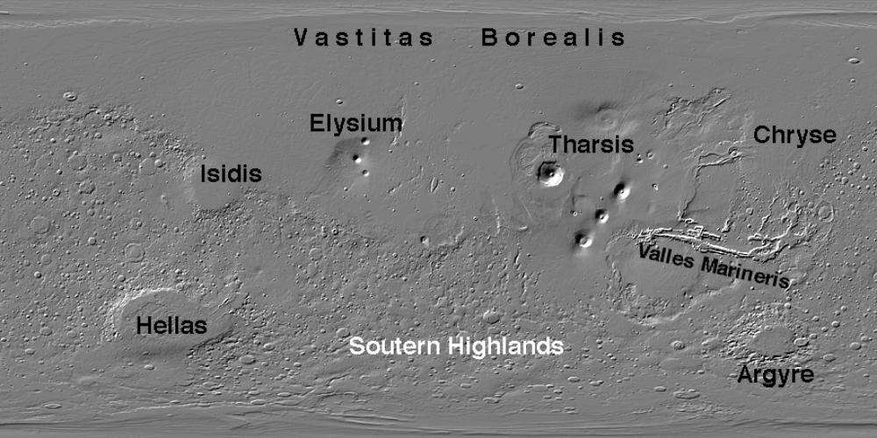
Figure 1. Shaded relief representation of the entire surface of Mars, derived from released MOLA gridded data product (simple cylindrical projection, data gridded at 16 pixels per degree; MOLA, 2001). Names shown for certain regions. The Tharsis region is shown in a full resolution view in Figure 2.

al., 1999; Sakimoto et al., 1999; Kreslavsky and Head, 2000). The Thermal Emission Spectrometer (TES) is providing compositional and physical properties constraints for the
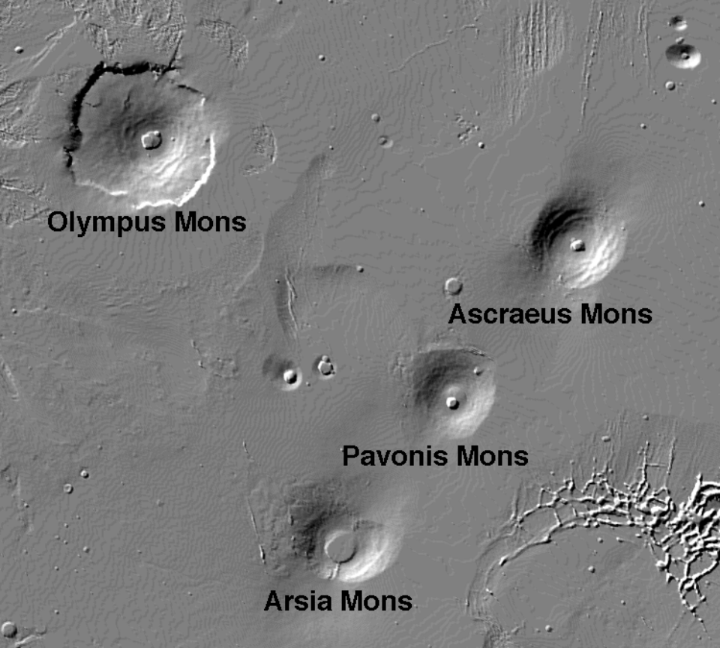
Figure 2. Shaded relief representation of the Tharsis region of Mars, derived from released MOLA gridded data product (simple cylindrical projection, data gridded at 16 pixels per degree; MOLA, 2001). Names are provided for the four large shield volcanoes in the Tharsis region. The context for the Tharsis region is provided in Figure 1.

surface of the entire planet (Christensen et al., 1998; Christensen, 2000; Mellon et al., 2000; TES, 2001). TES data have revealed two distinct volcanic rock types present on the planet; basalts in the southern highlands and basaltic andesites in the northern lowlands, consistent with compositional results obtained from the Pathfinder landing site in Chryse Planitia (Bandfield et al., 2000). The Magnetic Field Experiment and Electron Reflectometer (MAG/ER) data acquired during the aerobraking phase of the MGS mission revealed intense remnant magnetic fields in portions of the southern highlands (Acuña et al., 1998, 1999; Connerney et al., 1999; Purucker et al., 2000; MAG/ER, 2001). The magnetization preserved in the Martian crust provides new constraints on models for the formation and early evolution of Mars (Nimmo and Stevenson, 2000). The radio science team for MGS is generating a gravity map of Mars that is much superior to previously known gravity data for the planet; when combined with MOLA topography, these new data are revealing important insights about the internal structure of Mars (Zuber et al., 2000). Each conference attended by planetary scientists brings new revelations gleaned from the impressive MGS data set. The references listed at the end of this article are not a complete set of the published MGS results, but they describe some of the more important discoveries reported by the various science teams, and can lead the reader to other publications.
The MGS science results will have varying effects on cartographic products for Martian features. Most important, the MOLA data have shown that previous positional determinations are off by up to 20 km horizontally, when referenced to a body-centered coordinate system defined by the precise topographic measurements (Smith et al., 1998). The positional offsets are not systematic around the planet, so aerographic coordinates derived from pre-MGS maps will need to be corrected to the new coordinate system. MOC narrow angle data provide detailed views of small strips of the planet, but it is unlikely that areally extensive maps will be generated from the mostly non-contiguous images. MOC wide angle images, in conjunction, with selected narrow angle images obtained during a geodesy campaign, will provide a new control net for the planet, one consistent with the global topography obtained from MOLA. The TES and MAG/ER data provide global perspectives on compositional and geophysical views that are amenable to thematic map presentations (e.g., Bandfield et al., 2000; Acuña et al., 1999). The global topography from MOLA and the new gravity field maps from the radio science efforts will provide new geophysical constraints on the interior structure of the planet, some of which are already shown as thematic maps (e.g., Zuber et al., 2000). When taken together, the new data from all of the MGS science instruments are revealing a ‘new’ Mars that will greatly affect the perception of the planet as reproduced in future maps of the Red Planet.

REFERENCES

Albee, A.L., F.D. Palluconi, and R.E. Arvidson, Mars Global Surveyor mission: Overview and status, Science, 279, 1671-1672, 1998.
Acuña, M.H., J.E.P. Connerney, P. Wasilewski, R.P. Lin, K.A. Anderson, C.W. Carlson, J. McFadden, D.W. Curtis, D. Mitchell, H. Reme, C. Mazelle, J.A. Sauvaud, C. d’Uston, A. Cros, J.L. Medale, S.J. Bauer, P. Cloutier, M. Mayhew, D. Winterhalter, and N.F. Ness, Magnetic field and plasma observations at Mars: Initial results of the Mars Global Surveyor mission, Science, 279, 1676-1680, 1998.
Acuña, M.H., J.E.P. Connerney, N.F. Ness, R.P. Lin, D. Mitchell, C.W. Carlson, J. McFadden, K.A. Anderson, H. Reme, C. Mazelle, D. Vignes, P. Wasilewski, and P. Cloutier, Global distribution of crustal magnetization discovered by the Mars Global Surveyor MAG/ER experiment, Science, 284, 790-793, 1999.
Bandfield, J.L., V.E. Hamilton, and P.R. Christensen, A global view of Martian surface compositions from MGS-TES, Science, 287, 1626-1630, 2000.
Christensen, P.R., D.L. Anderson, S.C. Chase, R.T. Clancy, R.N. Clark, B.J. Conrath, H.H. Kieffer, R.O. Kuzmin, M.C. Malin, J.C. Pearl, T.L. Roush, and M.D. Smith, Results from the Mars Global Surveyor Thermal Emission Spectrometer, Science, 279, 1692-1698, 1998.
Christensen, P.R., Introduction to the special section: Mars Global Surveyor Thermal Emission Spectrometer, (introduction to thirteen research papers of TES data analysis), Journal of Geophysical Research., 105(E4), 9507, 2000.
Connerney, J.E.P., M.H. Acuña, P.J. Wasilewski, N.F. Ness, H. Reme, C. Mazelle, D. Vignes, R.P. Lin, D.L. Mitchell, and P.A. Cloutier, Magnetic lineations in the ancient crust of Mars, Science, 284, 794-798, 1999.
Edgett, K.S., and M.C. Malin, New views of Mars eolian activity, materials, and surface properties: Three vignettes from the Mars Global Surveyor Mars Orbiter Camera, Journal of Geophysical Research, 105(E1), 1623-1650, 2000.
Head, J.W., H. Hiesinger, M.A. Ivanov, M.A. Kreslavsky, S. Pratt, and B.J. Thompson, Possible ancient oceans on Mars: Evidence from Mars Orbiter Laser Altimeter data, Science, 286, 2134-2137, 1999.
Kreslavsky, M.A., and J.W. Head, Kilometer-scale roughness of Mars: Results from MOLA data analysis, Journal of Geophysical Research, 105(E11), 26695-26711, 2000.
MAG/ER, Magnetometer and Electron Reflectometer web site, http://mgs-mager.gsfc.nasa.gov/, 2001.
Malin, M.C., and K.S. Edgett, Evidence for recent groundwater seepage and surface runoff on Mars, Science, 288, 2330-2335, 2000a.
Malin, M.C., and K.S. Edgett, Sedimentary rocks of early Mars, Science, 290, 1927-1936, 2000b.
Malin, M.C., M.H. Carr, G.E. Danielson, M.E. Davies, W.K. Hartmann, A.P. Ingersoll, P.B. James, H. Masursky, A.S. McEwen, L.A. Soderblom, P. Thomas, J. Veverka, M.A. Caplinger, M.A. Ravine, T.A. Soulanille, and J.L. Warren, Early views of the Martian surface from the Mars Orbiter Camera of Mars Global Surveyor, Science, 279, 1681-1685, 1998.
Mellon, M.T., B.M. Jakisky, H.H. Kieffer, and P.R. Christensen, High-resolution thermal inertia mapping from the Mars Global Surveyor Thermal Emission Spectrometer, Icarus, 148, 437-455, 2000.
MGS, Mars Global Surveyor web site, http://mars.jpl.nasa.gov/mgs/, 2001.
MOC, Mars Orbiter Camera web site, http://www.msss.com/moc_gallery/, 2001.
MOLA, Mars Orbiter Laser Altimeter data web site, http://wufs.wustl.edu/missions/mgs/mola/, 2001.
Nimmo, F., and D.J. Stevenson, Influence of early plate tectonics on the thermal evolution and magnetic field of Mars, Journal of Geophysical Research, 105(E5), 11969-11979, 2000.
Purucker, M., D. Ravat, H. Frey, C. Voorhies, T. Sabaka, and M. Acuña, An altitude-normalized magnetic map of Mars and its intepretation, Geophysical Research Letters, 27(16), 2449-2452, 2000.
Sakimoto, S.E.H, H.V. Frey, J.B. Garvin, and J.H. Roark, Topography, roughness, layering, and slope properties of the Medusae Fossae Formation from Mars Orbiter Laser Altimeter (MOLA) and Mars Orbiter Camera (MOC) data, Journal of Geophysical Research, 104(E10), 24141-24154, 1999.
Smith, D.E., M.T. Zuber, H.V. Frey, J.B. Garvin, J.W. Head, D.O. Muhleman, G.H. Pettengill, R.J. Phillips, S.C. Solomon, H.J. Zwally, W.B. Banerdt, and T.C. Duxbury, Topography of the northern hemisphere of Mars from the Mars Orbiter Laser Altimeter, Science, 279, 1686-1692, 1998.
Smith, D.E., M.T. Zuber, S.C. Solomon, R.J. Phillips, J.W. Head, J.B. Garvin, W.B. Banerdt, D.O. Muhleman, G.H. Pettengill, G.A. Neumann, F.G. Lemoine, J.B. Abshire, O Aharonson, C.D. Brown, S.A. Hauck, A.B. Ivanov, P.J. McGovern, H.J. Zwally, and T.C. Duxbury, The global topography of Mars and implications for surface evolution, Science, 284, 1495-1503, 1999.
TES, Thermal Emission Spectrometer web site, http://emma.la.asu.edu/, 2001.
Zuber, M., S. Solomon, R. Phillips, D. Smith, G. Tyler, O. Aharonson, G. Balmino, W. Banerdt, J. Head, C. Johnson, F. Lemoine, P. McGovern, G. Neumann, D. Rowlands, and S. Zhong, Internal structure and early thermal evolution of Mars from Mars Global Surveyor topography and gravity, Science, 287, 1788-1793, 2000.

