RELIEF REPRESESNTATION OF THE SURFACE OF MARS
BY COMBINATION OF DIGITAL ELEVATION MODEL
AND SHAPE-FROM-SHADING

Egon Dorrer
Institute for Photogrammetry and Cartography
Munich Bundeswehr University
D–85577 Neubiberg, Germany

Christian Piechullek
Axel Springer Verlag AG
D–22926 Ahrensburg, Germany

Xiuguang Zhou
ESRI, Inc., Redlands, Cal, USA

ABSTRACT

Interpretation of remotely sensed imagery of planetary surfaces is seriously hampered if the direction of terrain illumination significantly deviates from the upper left as viewed by the human. Well-known in cartography as relief shading, this physiological and psychological phenomenon may give rise to inverse or conflicting depth perception, thus yielding wrong conclusions. Using Viking Orbiter imagery of Mars, the paper describes a first approach towards automatic optimization of relief shading in order to achieve uniform and best possible depth cue. Denoted "de-re-shading" (DRS), the method deals with the task of removing the actual shading situation in the original image and subsequent artificial re-shading simulating the appropriate illumination direction. Shadow regions, intrinsically smooth digital elevation model (DEM) and unknown space-variant reflectance properties (e.g. albedo) of the surface, contribute to the mathematical complexity of the problem. While pure shape-from-shading (SFS) methods in photoclinometry – frequently employed in planetological studies – need images acquired under at least two different illumination directions (photometric stereo), a requirement rarely met, SFS methods in photogrammetry are insufficient due to image matching problems on mostly featureless terrain. The proposed approach of combining the different philosophies of both methods can provide qualitatively good slope information from shading favorably supported by height information from, even low-resolution, elevation models. In the paper discussed is a novel iterative SFS-algorithm embedded in a recursive least squares estimation process encompassing the generation of orthoimagery, masking shadow areas, refining and re-shading the DEM. In the present version DRS is based on the Lambertian reflectance model. The method constitutes a problem of variational calculus with several regularization and stabilization constraints. The numerical solution is based on a system of linear difference equations derived from the associated Euler partial differential equations. Based on a Martian surface scene with given low-resolution DEM, the paper's main emphasis is placed on experimental and simulation studies. The results indicate the principal feasibility to improve a DEM.
- INTRODUCTION

From former studies regarding the optimization of shaded relief in image maps of the surface of Mars (Dorrer & Zhou, 1998) by means of "shape from shading" methods (SFS), it was found that, in principle, the same process may be capable of improving the surface elevation model (DEM). Whether the initial DEM was derived from stereophotogrammetry or, e.g., from a laser altimeter (e.g. MOLA on Mars Global Surveyor), is immaterial. It is merely decisive that the shades in an image taken from a homogeneous and uniformly illuminated surface, represent a measure for surface inclination within the level of image resolution. Since all presently known methods for height mensuration exhibit more or less pronounced smoothing effects, integration or combination of such a 3D-method with SFS is expected to delineate visible topographic discontinuities. However, only objects having homogeneous surface properties, as they occur on Mars or on the Moon, may be dealt with. Applications on Earth generally will fail.

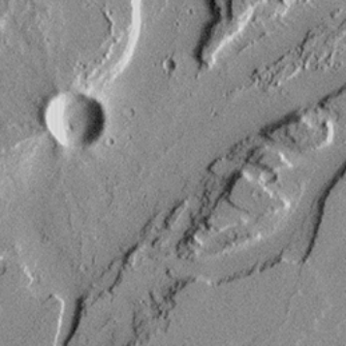
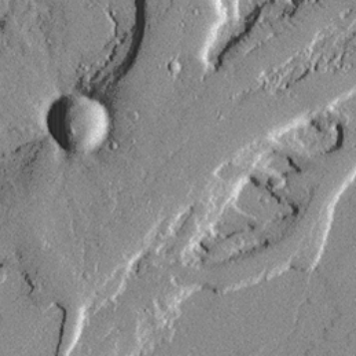
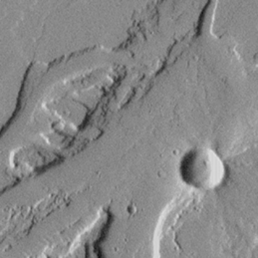

1a: Original image 1b: Enhanced negative 1c: Original after 180° rotation
Mars Global Surveyor image 1999-MOC2-102 (Malin Space Science Systems/NASA)

Figure 1. Reverse vs. upright perception of terrain relief (space–invariant albedo)

In the present context, optimization of shaded relief is understood as an artificial change of the natural illumination conditions in an image in order to present the user optimal depth perception. As known, this is the case if the terrain illumination appears to come somewhere from the upper left. Significant violation of this physiological and psychological constraint can lead to temporary or permanent relief reversal for the viewer. Fig. 1a shows such a case where part of the Martian terrain surface is illuminated from the right. Evidently, interpretation of this image is rendered difficult due to unknown terrain features. After rotating the image by 180° (Fig. 1c), illumination, now from the left, immediately causes the terrain relief to appear upright. The same effect can be achieved by forming an enhanced negative (Fig. 1b) of the original image, however, only because of surface homogeneity, i.e. space invariant reflectance (albedo). With not such space invariance, as in Fig. 2 showing different surface materials, reflected radiation is dependent – besides on surface inclination – also on differing reflectance properties. In such a case, relief perception due solely to illumination, will be disturbed, although the human viewer, by mere experience, may be able to consider this effect. Automatic methods, however, will have to fail. See also Horn's (1993) interesting study.

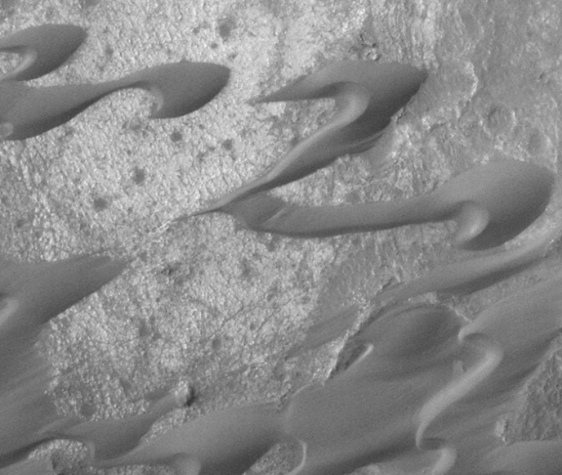
The wealth of publications on SFS and related techniques shows the enormous interest within the computer vision community. Thus, more than 450 publications are listed in the Annotated Computer Vision Bibliography (Price, 2000). Due to the complexity of the problem, the majority of researchers have confined their work to simplified, mostly synthetically produced image data and to partial tasks. In their comprehensive study, Zhang et al (1999) compared some of the most known SFS-solutions between different research groups. They come to the conclusion that neither of these methods gave satisfactory results. In the early studies of SFS, emphasis was placed on single images or photometric stereo, exclusive use of Lambert's reflectance law, and predominantly orthographic imagery. More recent investigations increasingly deal with multi image configurations, e.g. in (Hartt et al., 1989), (Heipke et al., 1994), concepts for the integration of proven photogrammetric techniques, e.g. in (Heipke, 1992), (Thompson, 1993), (Cryer et al., 1995) as well as more realistic reflectance models, e.g. in (Tagare et al., 1993), (Kautz et al., 1999).
Mars Global Surveyor image 1999-MOC2-88
(Malin Space Science Systems/NASA)

Figure 2. Perception of terrain relief
(space-variant albedo)

Pure SFS-solutions, as, e.g., developed within the context of photoclinometric studies by Rindfleisch (1961) or Kirk (1987), altogether have proven the test for areas with poor contrast or texture on planetary surfaces. However, they did not find general acceptance due to fundamentally inherent disturbances such as complex topography, different surface material, shadow areas, mostly unknown reflectance functions (Jankowski, 1991). Contrary to that, photogrammetric image matching techniques, being particularly suited just for areas rich of contrast or texture, basically complement SFS-methods. This is the main reason for the increasing interest in their mutual fusion, e.g. in (Giese et al., 1996) for planetary exploration, or (Fua et al., 1993) for general computer vision.

A universal fusion of two such different approaches still requires substantial theoretical and experimental interdisciplinary efforts. Therefore, at the current state of knowledge, studies merely based upon a combination of SFS and photogrammetry as independent modules, will faster yield useful results. Even simpler is an incorporation of already existing DEM-information in the SFS-process, as has already been proposed by Horn (1990). In principle, local or global approaches may be applied. Thus, in (Piechullek & Heipke, 1996) and in (Piechullek, 2000) a local least squares approach for iteratively solving a nonlinear system of observation equations, constituted by elevations and gray values, has been elaborated on. The global variational approach with border conditions can be traced back to Horn (1970) and has mostly been employed in computer vision, e.g. in (Horn, 1984), (Zheng & Chellappa, 1991), (Dorrer & Zhou, 1998). Extensive comparative studies emphasizing, amongst others, the deficiencies of a series of such methods, were carried out by Zhang et al. (1999).

Founded on the gained experience published in (Dorrer & Zhou, 1998), the present contribution describes some methodical extensions and empirical investigations on the refinement of a DEM by means of SFS. The principle of the developed method will be briefly discussed in Chapter 2, while Chapter 3 deals with an experimental study into estimation of individual parameters representative for the influence of associated constraints. Finally, in Chapter 4 some conclusions will be drawn and prospects made towards necessary expansions.

- RECURSIVE DEM-REFINEMENT BY SFS

By virtue of lack of terrain coverage, there do exist larger areas on Mars having sufficient homogeneous properties of a rough surface (see, e.g., Fig. 1) with prevailing diffuse reflectance suited for SFS. Even if not known, the true physical reflectance nevertheless can be approximated relatively well by Lambert's cosine law, i.e. perfect diffuse reflection. Lambertian type surfaces reflect all incident radiation and appear equally bright from all viewing directions. It is true, as against irradiance, that the governing reflected radiant intensity decreases with the cosine of the incident angle, but the area of the surface element decreases likewise. Hence, reflected radiance is isotropic with a value directly proportional to the cosine of the incident angle. The "Bidirectional Reflectance Distribution Function" (BRDF) introduced by Nicodemus et al. (1977), however, depends on surface properties only – independent of illumination and viewing direction. The BRDF is defined by the ratio of reflected radiance to (incident) irradiance in units "per steradian" and is constant for Lambertian surfaces. Consequently, the distribution of brightness – seen as shading – in the recorded image due to reflection on the object's surface, directly represents the distribution of terrain inclination.

Our computational method, originally conceived for optimizing shaded relief and denoted "De-Re-Shading" (DRS), contains as byproduct the possibility of refining an existing DEM. On the one hand, "re-shading" as a method for digital generation of shaded relief by appropriate software for artificial DEM-illumination, in principle, is a relatively simple task. "De-shading", however, as a method of removing image brightness in order to relate it to surface slope, is a comparatively complex process. In addition, each solution will be biased according to erroneous initial data, e.g. DEM, reflectance model, and inadmissible image portions, e.g. shadow regions, space variant albedo.
Illumination
Direction

Orientation
Parameters

Original

Image
I‘(x,y)

Original
DEM
Z‘(X,Y)

Orthoprojection

Ortho-
Image
I(X,Y)

Slope

Images

p/q(X,Y)

Shadow Segmentation
(Ray Tracing)

Estimating Albedo

Refined
DEM
Z(X,Y)
SFS
De-Shading

Re-Shading

| I - R |
< th

Reflectance

Map

R(X,Y)

Figure 3. Flow diagram for SFS / DRS and DEM refinement

Figure 3 exhibits a simplified diagram of the current solution to the DRS-problem, where, however, the part of albedo estimation within the nucleus of the method does not work yet. The input data required are constant illumination direction, the orientation parameters of the camera, the original image to be processed, and a DEM. The latter is needed for the transformation of the original image from its perspective geometry to an orthoimage with orthographic geometry, because standard SFS-approaches processing single images require constant viewing direction. Images with line camera geometry have not been considered so far. By means of a subsequent iterative SFS-process, both DEM and orthoimage are recursively refined, thus enabling an ever more precise location and temporary depletion of shadow regions by ray tracing. The latter is necessary because shadows possess reflectance different from illuminated surfaces. The current version simply masks the recognized shadow areas.

Formulation of the SFS-problem is based upon Horn's (1970) "image irradiance equation". This relation states that the gray value image as quantized estimation of irradiance – radiometrically calibrated for vignetting – is proportional to object radiance. The dependence of object radiance on object surface inclination can now be described by a "reflectance map" 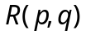 in gradient space, the gradients 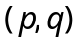 being the first partial derivatives 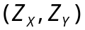 of the DEM, viz. 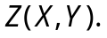 If the irradiance – brightness – of the orthoimage referred to DEM coordinate space, is denoted by 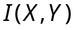, the equation reads as follows:

where a proportionality factor has been deleted by implicit scaling. In general, this equation represents a nonlinear first-order partial differential equation. With given and , its purpose is to find the surface  Due to noise, this equation is insufficient and must be replaced by a functional in order to minimize the square of the brightness difference integrated over the entire image region, viz.



thus constituting a measure of the departure from an ideal solution. To warrant uniqueness of the solution, additional constraints and border conditions are required with the purpose to pick a suitable solution. There are constraints ensuring smooth surfaces, regularization constraints for numerical stabilization and integrability constraints ensuring that, e.g., 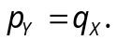

We mainly follow an algorithm published by Zheng & Chellappa (1991) except that the involved partial derivatives are defined analytically rather than numerically. Supplemental to their utilized constraints describing intensity gradient and surface gradient, our approach contains a new form of integrability constraint. We consider this as crucial for a suitable solution of the SFS-problem. Generally, SFS is a variational problem with constraints or regularization terms (Horn & Brooks, 1989). In our case, the functional is defined by
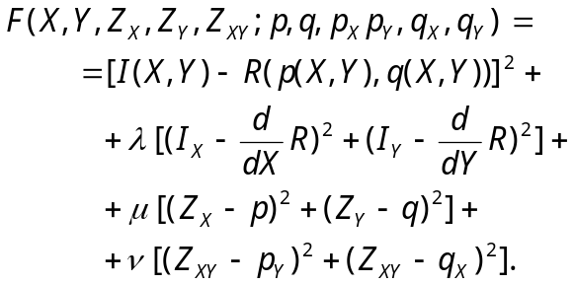

The three constraints are represented by terms with free regularization factors – instead of Lagrange multipliers – for weighing their influence. Associated with the minimization integral are the so-called Euler equations which are necessary conditions for finding extremal values of the functional. Here, they can be written formally

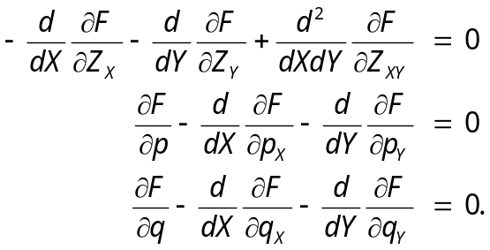

The rather lengthy actual equations are not shown here due to limited space. The numerical solution of the established and properly linearized system of partial differential equations, approximated by corresponding difference equations, yields optimal estimates for the discretized functions 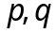 (gradient images) and  (refined DEM). The reflectance map will be simultaneously updated. The iteration process will be repeated until "agreement" is reached between and . The current experimental version is not yet optimized and requires an excessive number of iterations.

- EXPERIMENTAL RESULTS

Geometrical basis for our investigations was a 200-m-contour sketch map at scale 1:500,000 that had been produced at the Astrogeology Division, U.S. Geological Survey, Flagstaff, Arizona by conventional analytical stereocompilation techniques from a series of Viking Orbiter image scenes. Image no. 065A14 exhibiting part of the Mars-Tithonium Chasma region situated at the western end of Valles Marineris and shown in Fig. 4, was one of these images, all having been taken from different orbits at different periods of time. Nevertheless, the accidentally obtained and partly unfavorable imaging configuration had permitted a few useful stereomodels. Terrain elevations, however, could be determined photogrammetrically to an accuracy of only some 70 m at the best. Besides, systematic model deformation could not be excluded.

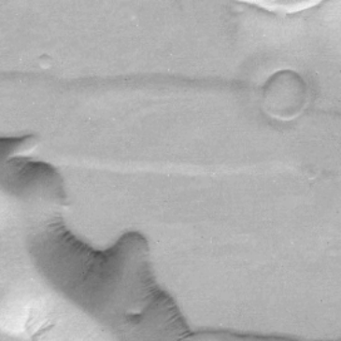
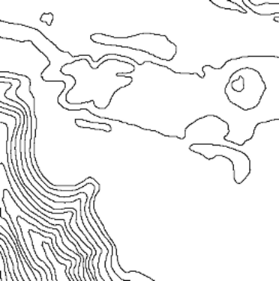
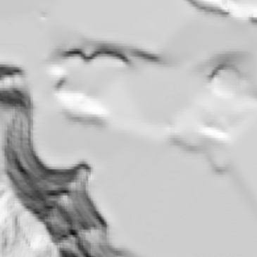

Figure 4. Figure 5. Figure 6.
Original Viking Orbiter image 065A14 Original 200-m contours DEM-aspect image

By means of the commercial program package HIFI, a DEM was derived from the digitized contours (Fig. 5) with a spatial resolution equivalent to that of the image. Due to extreme topographic differences, viz. large areas of completely flat terrain with hardly any surface texture on the one hand, and very high, steep and rough mountain slopes with sharp edges and terraces on the other hand, the elevation data in flat areas had to be interactively edited. In particular, a series of characteristic spot heights were added, derived from visual inspection of the Viking image by an experienced scientist. The geometric precision of the DEM, though, cannot reach the image inherent elevation accuracy. This may easily be verified by visually comparing the shaded DEM-aspect image in Fig. 6 with the original image (Fig. 4). The direction of artificial illumination of the (Lambertian assumed) surface corresponds to that of the original image. The errors in portions of the DEM may be explained by general difficulties during stereocompilation of predominantly featureless and textureless image contents. In addition, they are caused by stereoscenes originally not intended to be stereo, therefore possessing inhomogeneous scale and illumination conditions. Also notice the terrace-like, unrealistic rendering of the steep slope stemming from the method of contour line interpolation.

Since the original data were referenced to a spheroidal Mercator projection and in order to eliminate already considerable positional deformations, the DEM was transformed to a topocentric cartesian coordinate system with origin in scene center. The Martian spheroidal parameters as well as the planetocentric coordinates of the surface point of intersection of the principal ray were retrieved from NASA's PDS database. The orientation parameters of the camera were determined by spatial resection using 14 manually selected reference points. A section of 256x256 pixels was chosen and introduced to the DSR-algorithm.

From the series of individual tests, certain partial results of four somewhat successful tests will be discussed in the sequel, viz. in each case both the first and fourth iteration together with the contour lines derived from the refined DEM. Particularly obvious are the improvements with the number of iterations (decreasing smoothness) in the upper row (original illumination) and the increase of higher image frequencies, including noise, as well as the appearance of certain artifacts for different illumination direction in the lower row, all due to errors in the original DEM.

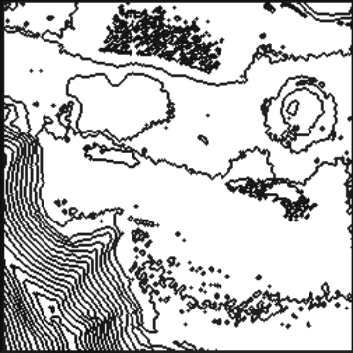

7a 7b 7c
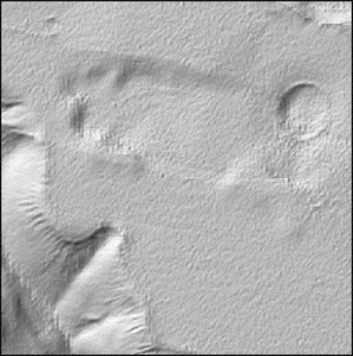
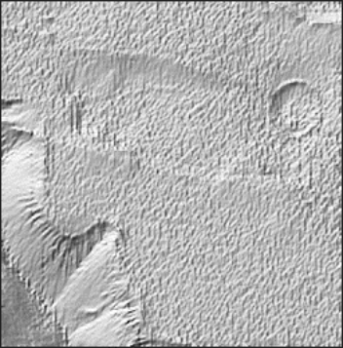
Figure 7. Test 1: Standard Method

Aspect images of the refined DEM:
7a: Original illumination iteration 1
7b: Original illumination iteration 4
7a 7d: "Cartographic" illumination
iteration 1
7e: "Cartographic" illumination
iteration 4
7c: 150-m contours of refined DEM
7d 7e

The standard method of test 1 outlined in Chapter 2 – all three factors were set to 1 – did not prove satisfactory due to iteration-dependent image noise amplification (see Fig. 7). This is not so striking in the aspect images simulating the original illumination from NNE (upper row), but is rather serious for "cartographic" illumination from NW (lower row). Here, errors of the original DEM almost fully enter and produce disturbing residual artifacts. The latter may be somewhat suppressed by means of suitable image processing measures. This is the case, e.g., if as in test 2 (Fig. 8), either the original image or – even better – as in test 3 (Fig. 9), the refined DEM will be smoothed after each iteration. In both cases a (5x5)-Gauss-filter was used. By introducing smaller weights for the gray values of the original image, viz. with the factor 0.1 as opposed to test 1 – realized by increasing the first two factors by 10 – test 4 (Fig. 10) exhibits larger systematic changes of the reconstructed elevations already after four iterations. This effect stems from higher emphasis given to the two smoothing conditions. Particularly striking are surface vaults orthogonal to the original illumination direction, viz. below the crater near the right image border and directly besides the upper end of the canyon near the left border. Obviously, the piecewise smoothness of the surface is more pronounced in test 4 than in test 1. In addition, the discrepancies between original image and computed aspect image increase with the number of iterations.
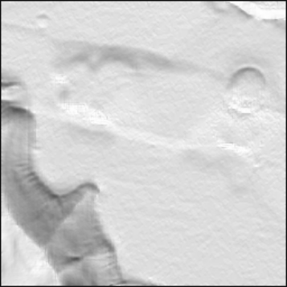
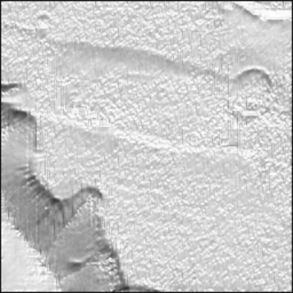
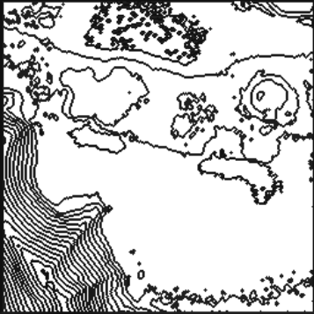

8a 8b 8c
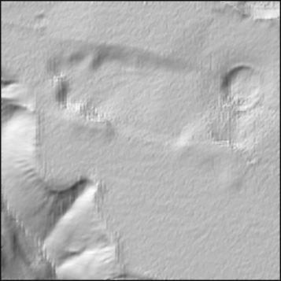
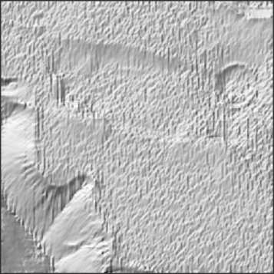
Figure 8. Test 2: Filtering of original
Image after each iteration

Aspect images of the refined DEM:
8a: Original illumination iteration 1
8b: Original illumination iteration 4
7a 8d: "Cartographic" illumination
iteration 1
8e: "Cartographic" illumination
iteration 4
8d 8e 8c: 150-m contours of refined DEM

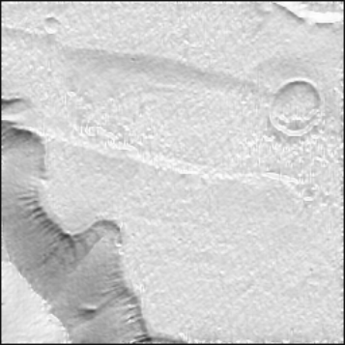
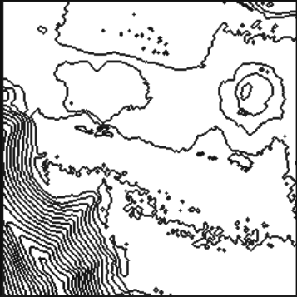

9a 9b 9c

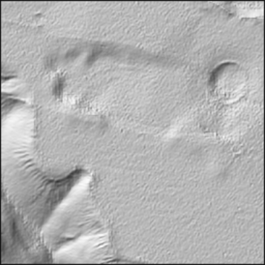
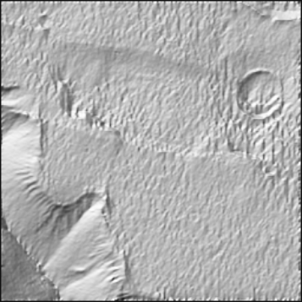
Figure 9. Test 3: Filtering of refined DEM after each iteration.

Aspect images of the refined DEM:

9a: Original illumination iteration 1
9b: Original illumination iteration 4
7a 9d: "Cartographic" illumination
iteration 1
9e: "Cartographic" illumination
iteration 4
9d 9e 9c: 150-m contours of refined DEM
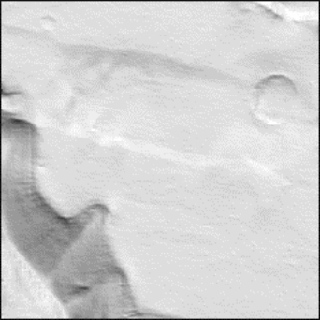
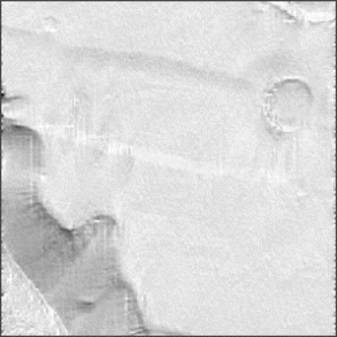
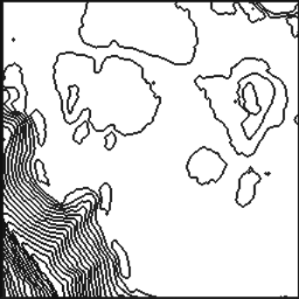

10a 10b 10c

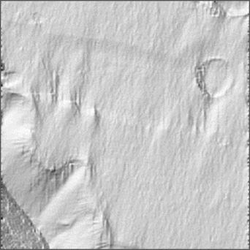
Figure 10. Test 4: Like test 1 but with weight 10.

Aspect images of refined DEM:
10a: Original illumination iteration 1
10b: Original illumination iteration 4
10d: "Cartographic" illumination
iteration 1
10e: "Cartographic" illumination
iteration 4
10d 10e 10c: 150-m contours of refined DEM

The results of test 3 (Fig. 9) seem best acceptable. Not only does terrain detail visible in the original image clearly occur, but also noise is suppressed, and systematic deformations cannot be noticed. This is also visible from the resulting contour map.

- CONCLUSIONS AND PROSPECTS

The presented results show, in principle, the suitability of the developed DRS-procedure for a refinement of given elevation models by means of shape-from-shading. However, further experimental and simulation studies are mandatory for a verification of the accuracy improvement of the DEM, an optimization of the regularization factors, as well as a validation of the relevance of the constraints. Mentioned must be a study by Horn (1990) on the dependence of such a factor on the state of iteration. In addition, investigations into stochastic aspects of the DEM for an improved integration are equally needed as an analysis and consideration of shadow areas, the incorporation of space variant albedo, and the search for a realistic reflectance model.

- ACKNOWLEDGEMENTS

Our investigation have been partially supported by Deutsche Forschungsgemeinschaft under contract IIC5 – Do 220/9–1. The authors are particularly indebted to Dr.R. Kirk of the USGS in Flagstaff, USA for the relinquishment of the Tithonium Chasma contour map.
- REFERENCES

Cryer, J.E., P.-S. Tsai, M. Shah: Integration of Shape from Shading and Stereo. Pattern Recognition, 28(1995)7, 1033–1043
Dorrer, E. & X. Zhou: Towards Optimal Relief Representation from Mars Imagery by Combination of DEM and Shape-from-Shading. Int. Arch. Phot. & Remote Sensing, Vol 32, Part 4, Stuttgart 1998, 156–161
Fua, P. & Y. Leclerc: Object-Centered Surface Reconstruction: Combining Multi-Image Stereo and Shading. Proc. DARPA Image Understanding Workshop, Washington, D.C., 1993, 1097–1120
Giese, B., J. Oberst, R. Kirk, & W. Zeitler: The Topography of Asteroid Ida: A Comparison Between Photogrammetric and Two-Dimensional Photoclinometric Image Analysis. IntArchPhRS 31, B3, III (1996), 245–250
Hartt, K. & M. Carlotto: A Method for Shape-from-Shading Using Multiple Images Acquired Under Different Viewing and Lighting Conditions. Proc. of the IEEE Conf. on Computer Vision and Pattern recognition, 1989.
Heipke, C.: Integration of Digital Image Matching and Multi Image Shape from Shading. Int. Arch. Phot. & Rem. Sensing, Vol. 29/3, 1992
Heipke, C. & C. Piechullek.: Towards Surface Reconstruction Using Multi Image Shape from Shading. Int. Arch. Phot. & Rem. Sensing, Vol. 30/3, 1994, 361–369
Horn, B.K.P.: Shape from Shading: A Method for Obtaining the Shape of a Smooth Opaque Object from One View. Ph.D. Thesis, Dept. Electrical Engineering, M.I.T., 1970
Horn, B.K.P. & M.J. Brooks: The Variational Approach to Shape from Shading. In: Horn & Brooks (eds.): Shape from Shading, The MIT Press, Cambridge, Mass., 1989, p. 173–214
Horn, B.K.P.: Height and Gradient from Shading. International Journal of Computer Vision, 5:1 (1990), 37–75
Horn, B.K.P, R.S. Szelinski, A.L. Yuille: Impossible Shaded Images. IEEE Trans. PAMI, 15(1993)2, 166–170
Jankowski, D.G. & S.W.Squyres: What's wrong with photoclinometry? Lunar Planet. Sci. XXI, 561–562
Kautz, J. & M.D. McCool: Interactive Rendering with Arbitrary BRDFs using Separable Approximations. Proc. 10th Eurographics Workshop on Rendering, June 1999, 281–292
Kirk, R.L.: A fast finite-element algorithm for two-dimensional photoclinometry. Part III of Ph.D. thesis. Div. Geological and Planetary Sciences, CalTech, Pasadena, 1987
Nicodemus, F.E., J.C. Richmond, J.J. Hsia, I.W. Ginsberg, T. Limperis: Geometrical Considerations and Nomenclature for Reflectance. NBS Monograph 160, Washington, D.C., October 1977
Piechullek, C. & C. Heipke: DTM Refinement Using Multi Image Shape from Shading. Int. Arch. Phot. & Remote Sensing, Vol. XXXI, Part B3, Vienna 1996, 644–651
Piechullek, C.: Oberflächenrekonstruktion mit Hilfe einer Mehrbild-Shape-from-Shading-Methode. Dissertation. DGK-Reihe C, Nr. 518, München 2000
Price, K.: Annotated Computer Vision Bibliography.
http://iris.usc.edu/Vision-Notes/bibliography/contents.html
Rindfleisch, T.: Photometric Method for Lunar Topography. Photogrammetric Engineering 32 (1966) 2, 262–277
Tagare, H.D. & R.J.P. deFigueiredo: A Framework for the Construction of Reflectance Maps for Machine Vision. CVGIP: Image Understanding, 57 (1993) 3, 265–282
Thompson, C.M.: Robust Photo-topography by Fusing Shape-from-Shading and Stereo. Ph.D. Thesis, M.I.T., 1993, 169 p.
Zhang, R., P.-S. Tsai, J.E. Cryer, M. Shah: Shape from Shading: A Survey. IEEE Trans, PA&MI 21 (1999), 690–706
Zheng, Q., Chellappa, R.: Estimation of Illuminant Direction, Albedo, and Shape from Shading. IEEE Transactions on Pattern Analysis and Machine Intelligence, Vol. 13, 1991, No. 7, 680–702
Zhou, X. & E. Dorrer: An Adaptive Algorithm of Shaded-Relief Images from DEMs Based on Wavelet Transform. SPIE, Vol. 2646, St. Petersburg, 1995, 212–224.

However, details may be complex, too. See, e.g., Zhou & Dorrer (1995)
The Viking Orbiter mission had taken place in 1972

