Positioning and Spatial Search of Maps with undeterminable Projections
Krisztina Irás, Binh Nguyen Thai
Department of Cartography and Geoinformatics, Eötvös Loránd University
Abstract. Users who have already accommodated to various options of web map services show the same expectations about digital historical maps. Map collections and libraries constantly make efforts to follow new technologies. A current issue that map librarians often meet is the question and possibilities of georeferencing map sheets and setting them up in GIS for making spatial queries possible. In the case of those old maps that don’t show projection grids or the map content is inconsistent with the indicated coordinates, the best results of georeferencing may be highly distorted. This way, spatial queries cannot be done with success in a large amount of cartographic material. We make basic spatial queries when we need to know e.g. which maps of our collection show a specific area or whether a town or a settlement is indicated in a specific map sheet. Our research was motivated by such simple questions of map users. We aimed to develop the method of geolocating maps that cannot be precisely georeferenced because of their content. Another target was to create an easy to use tool for tasks where geolocation is important but it is not needed to use complex mathematical calculations and transformations. Geolocator of Historical Maps is intended to widen digital registration of maps in map collections and to facilitate place name search on scanned maps. Users don’t need to identify ground points with coordinates and distort the map images to projections because the system integrates a special solution for geolocating the sheets with a variable image grid system. The spatial connection and spatial queries are based on spatial database. Geolocator stores image grids set by the user (e.g. a map librarian) and their links to the free on-line map data base within the data sheet of the maps and highlights the areas in question after spatial queries. Spatial connection also make town search possible by entering town names, so it is not needed to transcribe the toponyms of the map sheets. Each component of the system is open source and available for free on Internet. Geolocator is part of a research project and is not intended for commercial traffic. In our paper, we present the operation, the structure and the technical background of the system.
Keywords: spatial search, old maps, web service, grids

Introduction
Users’ expectations about digital map collections have dramatically changed since free on-line map services provide geographic and content search functionalities. Thus, digital map collections constantly improve their services in order to keep pace with the latest technologies. Only storing scanned images of map sheets on servers is outdated and attribute-based search is also generally resolved. The number of those digital map collections that offer tools for location-based search has already been increasing as well. In case of old maps, this functionality has been developed after the method of georeferencing became widely known. Modern solutions of georeferencing make transformations of old maps to any projections possible and digital image processing technologies serve to assemble neighboring sheets without gaps and overlaps. Furthermore, continuous image mosaics or digital 3D models of globes can be set up with geographic coordinates. This technology allows the users to search for maps by specified territories or exact locations (e.g. towns), in other words to make spatial queries.
Geolocator of Historical Maps is part of the research project of the Department of Cartography and Geoinformatics of Eötvös Loránd University. It covers two research fields: (1) to develop an on-line catalog system and database structure for map collections where there is a need for the possibility of geographical search but exact georeferencing is not needed or is not possible, and (2) to construct and manage the system entirely in open source environment.

General Problems in Geolocation of Projectionless Maps
The process of georeferencing works only in the case of those maps where projection is known, where projection grids or grids of the geographic coordinate system are correctly placed in the map and all these are consistent with the map content. Those, who work with old maps regularly, know that there is a large amount of maps that does not meet these requirements. Therefore georeferencing such maps is not easy, sometimes it is impossible.
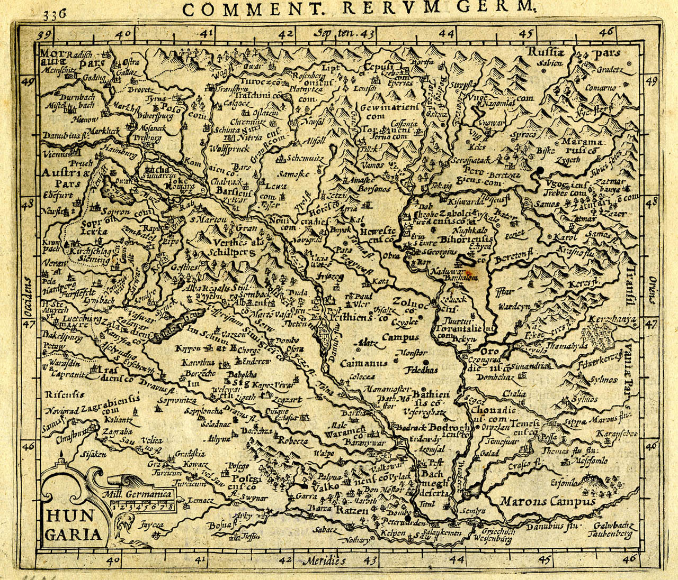
Projection girds may be missing on maps for various reasons. A good example is the diverse group of colorful portolan charts. These pieces and the maps derived from them, mostly used in maritime atlases, were created by astronomic measurements and distance estimations together with spoken and written accounts to amend land information but not by projections. Georeferencing is problematic with those old maps too where coordinates are indicated in the margin but the geographic map content is obviously inconsistent with them (Figure 1). A third group that easily falls out of georeferencing projects are those maps that were obviously prepared with a projection but the grids were not printed in the map sheet. In this case, precise identification of the projection needs professional skills in mathematics and also in projection parameters.

Figure 1. Map content doesn’t correspond to the geographic coordinates indicated in the margin: River Danube runs in an incorrect direction through the Carpathian Basin that causes erroneous placement of towns. (Hungaria, 1616. T-658. Map Collection of Department of Cartography and Geoinformatics, ELTE).
There are several methods and tools for georeferencing maps with known projections. The process, in general, consists of setting control points in the scanned image, adding them geographic coordinates and transforming the map image to the adequate projection. At the end, all the image pixels receive projection coordinates. But in the case of the above mentioned maps, the result is distorted, sometimes highly distorted, thus it is unsuitable for further works where coordinates are important, for example in spatial search. How can we geolocate these maps? How can we link the content of each sheet, at least apparently, to geographic coordinates? And how can we integrate them into a standardized system? Once these questions are answered, it is possible to make spatial queries in the content and the toponymy of the maps.
Attempts to find solution to these problems are generally based on the theory of distorting particular maps to a selected projection. This idea has some serious disadvantages even in the case when the map projection is known. First of all, one must have comprehensive knowledge on projection characteristics, parameters and transformations. Further methods e.g. the Helmert transformation and the method of Gaussian least squares are also necessary in the process. But these concepts are not commonly known among those who are not educated in mathematics and computing science at a professional level. Therefore solutions based on adequate map distortion cannot be widely disseminated because of the small number of potential users.
Another current topic in the world of digital map collections is the possibility of town search. An application that lists maps, or highlights a map section, showing town names, entered as key words, are also based on geographic coordinates that are linked to the map sheets. In theory, a detailed database of toponymy is needed for town search service on maps that cannot be georeferenced.
The concept of a manually sorted name database for each map is not feasible because this would be such a lengthy and unnecessary operation for which no institution devotes time and energy. A pilot attempt in the Hungarian National Széchényi Library aimed to create an old map’s name database automatically with the use of character recognition software but it failed of success. A service named MapRank Search is the latest, operating system of the kind and it is a available at the web page of the David Rumsey Map Collection. Here, users receive a ranked list of the Collection’s maps according to the precision of geographic match of a chosen area in Google Maps and can create a list of those items that (in theory) show the searched town name. In MapRank Search, maps prepared after 1690 are available, and the most of them contains graticule. Currently, it is not possible to refine the map view around the settlement name.

Geolocator of Historical Maps
In map collections, various applications facilitate digital map preservation and cataloguing but they lack the possibility of connecting and recording spatial information to the items as additional attributes. Geolocating maps without distorting or transforming the original scanned sheets in a simple way is an existing demand even in small map collections. Additionally, a simple tool for town name search on maps could facilitate map research.
Geolocator of Historical Maps is a web based application for storing old and mainly non-georeferenced maps. It operates without distorting the sheets to projections and includes both spatial allocation and name search on maps. The system must meet various requirements: it has to be suitable for items that differ widely in shape, size and content and also to provide optimal image quality at different resolution levels according to the authorized users’ groups.
The application has four major functionalities: (1) free-text search, (2) location-based search (3) geolocating maps and (4) user management for operators.

Options for Map Search
The main objective of Geolocator is providing a complex and easy to use map service. To fulfill this task, three functionalities of map search are available for users. In Map Window, users have the opportunity to search maps of the collection by attributes, by location and by specifying a geographical area in Google Maps. Free-text search, with multiple key words, is based on a detailed database of map attributes. In this way, items that contain the key words in any of their data fields are listed with thumbnails.
According to the search accuracy, there are two ways to make location based queries. In case we are searching for settlements, a town search bar serves to enter town names, even with alternate name forms. This tool uses a simple list of town names with additional geographic coordinates and a related database that stores alternate names. The resulting list contains those items that have at least one grid covering the area of the town (or towns) in question. It is possible to make multiple town queries as well.
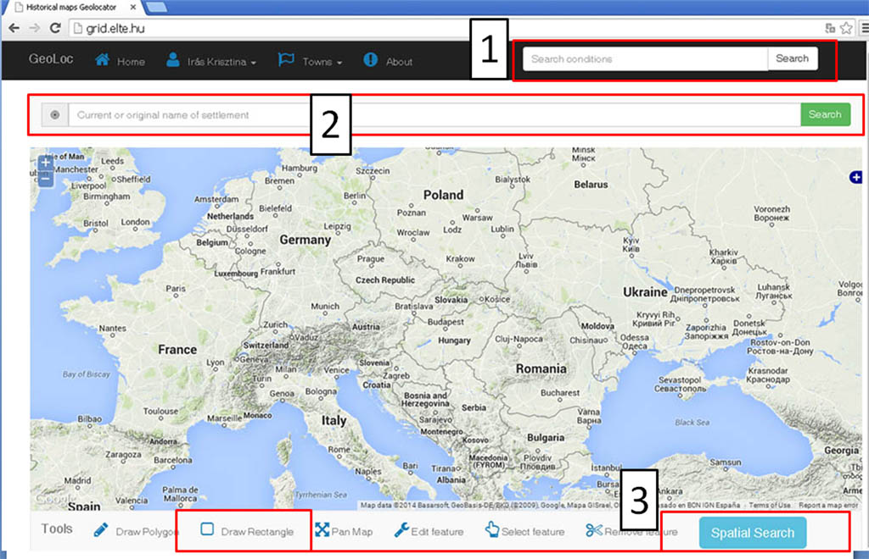
In the other case, users don’t define exact coordinates but need to know which maps of the collection show a specific area. To find the right sheets, it is enough to select the area in the Google Maps window by drawing a rectangle and to click on “Spatial Search” button (Figure 2). The result is a list of maps of which at least one previously defined grid intersects the selected area.

Figure 2. Initial page of Geolocator of Historical Maps with map search options: (1) Free-text Search Bar, (2) Town Locate Tool, (3) Spatial Search Button.

Grids and Areas
The method of geolocating the maps is based on the relation of virtual grids placed above the scanned map image to selected sections of the web map. These polygons connect image sections to the adequate areas of Google Maps. Related sections of the web map are defined by the users as the extension and location of the sections cover the same areas. However grid sections above the old map sheets are rectangular, the shape of the related area in the web map can be rectangular or irregular polygon according to the orientation or the shape of the represented area. This option facilitates accurate geolocation.
The data stored with the map image are the position of the grid cells and not geographic coordinates attached to image pixels. Each grid cell has a unique identifier that is stored with the web map polygon's spatial data. On the web map’s side, the coordinates of each polygon corners are stored in a spatial database in WGS84 coordinate system. The relationship between grid cells and the corresponding polygons is univocal.
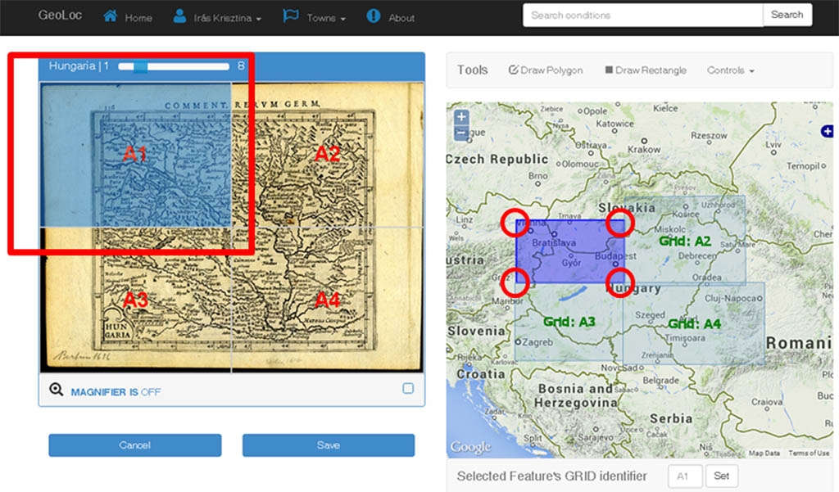
According to the size, scale or content of the scanned map, the grids can be modified arbitrary in a pre-defined series of grid density from 1x1 to 6x6. Larger number of grids is not advised, because geolocation doesn’t require smaller extent. (Figure 3)

Figure 3. The grid cells of the map image are spatially linked to selected areas in the web map.

Map Attributes and Data Sheet
Each map is linked to a series of primary and descriptive attributes. Primary attributes are file related information (file size, file type, file name, date of file creation, resolution), descriptive attributes contain data that define information on the physical item (map title, sheet size, date of creation, theme, registration number, sheet number, source, language, etc.). These data fields are easy to modify according to the standards of the collection. In the long run, a “what you see is what you get” (WYSIWYG) editor is the best solution for easier data input and clean representation of textual data. (Figure 4)
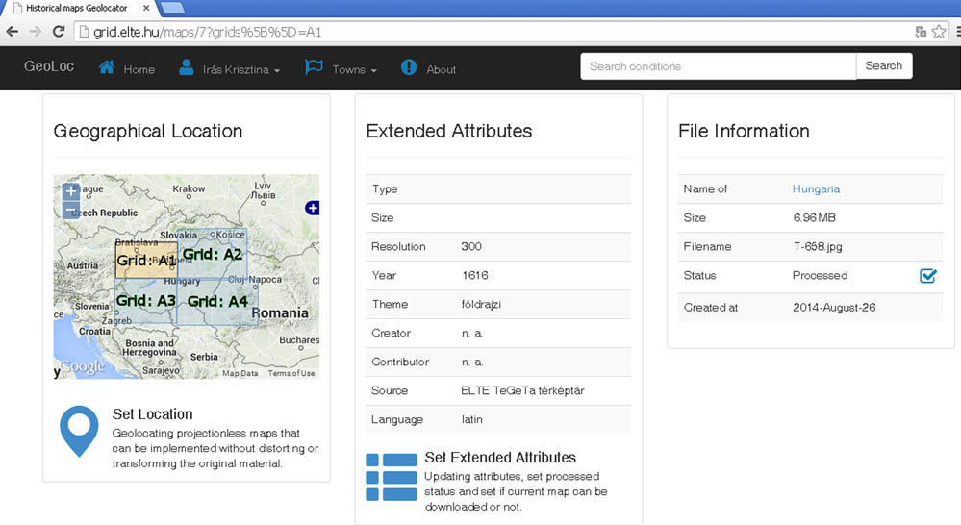
Data sheets in Geolocator show not only map attributes but also the grids set by the operators of the collection. Grid cells covering or intersecting the area of the spatial queries are highlighted. “Edit Map” window serves editing these features. In addition, allowance of downloading the scanned image in high resolution is also managed here. Grid positions and descriptive data are all easy to modify at any time when it is needed.
(Figure 5)

Figure 4. Upper section of the data sheet listing descriptive data and file information of map in Fig.1. This figure shows the data sheet in editor mode, where the user is allowed to set the grids (location) and editing the extended list of attributes.

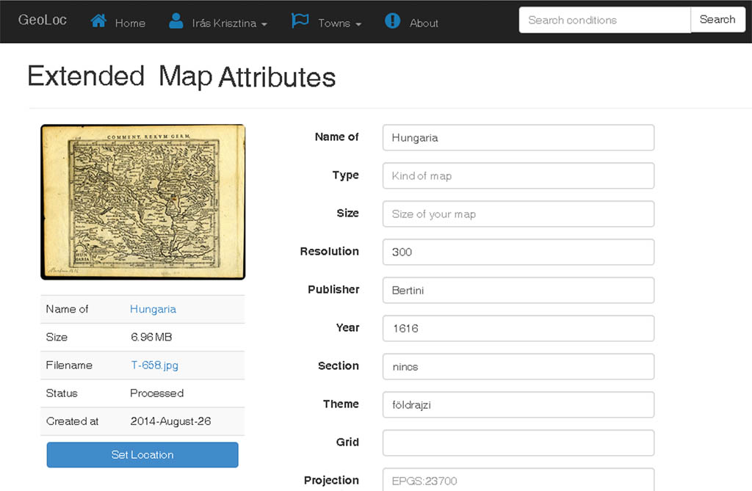
Figure 5. Edit Map window for entering map attributes and setting the grids

Structure and Technical Background
Digital map collections with items published on Internet are public service where user management (authentication and authorization; finding, viewing, editing and creating maps and related data) is key issue. Considering these conditions, we must choose the appropriate technologies and design the web application to fulfill all the requirements.

User Management, User Groups and Rights
Users of Geolocator are ranked in groups of guests, viewers, editors and administrators. “Guest” users don’t need to make a registration. They are allowed only to search for maps of the collection but cannot view the data sheets and the items in full-size resolution. The result of their search is a list of map titles with basic information and a low resolution thumbnail of the map image. This way, they can have only basic information about the map collection. Registered users (“Viewers”) are authorized to view the full data sheets (including the grid positions) of the maps, the status of the map processing (processed or unprocessed) and the actual disposition of the grids. Viewers have access to map images in full-size resolution and are allowed to download them. “Editors” have the widest range of functionalities: they edit and modify data sheets of the maps; they allow downloading option for each map sheet; they are allowed to set, modify and delete spatial grids. This feature will be explained later. As user authentication is based on username and password, users can modify only their passwords on user management user-interface. When users don’t need to view maps in Geolocator anymore, they can delete their accounts. “Administrators” form the fourth group of users. They are responsible for user management features, e.g. managing users’ registrations, granting and deleting user roles.

File System and Database
In order to make the map collection searchable for spatial queries, we must store the items in a database supporting spatial data types and spatial functions. Scanned maps of digital collections are stored in binary raster format. The most of them are stored in high-resolution image format. For viewing the items, usually we do not need highly detailed images. Therefore, the original images are simplified to four different resolutions by using ImageMagick. This software is adequate for creating, editing and converting digital images. As it is written in C/C++ language, it is fast and robust enough to handle a large amount of image files. Simplified images are stored in a dedicated directory serving images for web application, whereas original images are stored on a remote drive.
As mentioned above, a database is needed to store and catalogue descriptive information on the maps of the collection. Each map has primary and descriptive attributes. The system has to provide an interface for users where they can search for maps in a simple way. Usually search queries are received as input from a search bar, describing what users are looking for. It follows that an index structure has to be compiled to all map attributes, so that search can be performed easily within one step. By using PostgreSQL’s full-text-search technology, we are able to pass user queries and search for matches against all indexed attributes with a simple SQL query.
Along with map attributes, the database stores user information, login credentials and user roles. User credentials are stored in MD5 hashed string that is a 128 bit hexadecimal string. MD5 has been used widely in web applications for storing encrypted user information. At this stage of the development of Geolocator, security is not primary requirement yet. Therefore, MD5 hashed credential values are sufficient at the moment.
Based on user requirements and database features, we have decided to use PostgreSQL database. This is an open source database management system of which maturity, reliability and scalability factors are suitable for managing data tables of maps, towns and user credentials. (Figure 7)

Spatial Extension
Non-georeferenced maps are split into smaller grids and each grid is stored as a spatial regular polygon. To store spatial-based data, we support functions like modification, deletion and view of spatial grids on web application’s interface. An intermediate descriptive language is suitable for it, namely Well-Known-Text format (WKT) designed for representing vector-geometry objects with projection system information. WKT has been defined and maintained by Open Geospatial Consortium (OGC). As for spatial queries, the following types of queries are frequently used: intersection, contains and relate on vector-geometry objects.
PostGIS, an extension of PostgreSQL database, adds geometry data-types and functions supporting not only vector-geometry but also raster-based data. It also follows recommendations by OGC for SQL on simple features. In the development of Geolocator, the most important elements are supporting geometry-types and geography types; spatial operators for measurement, spatial operators for relations of objects; spatial operators for determining set operations; spatial indexing methods.

Town Data
Town data management is an additional issue. We have stored spatial information on every town in point spatial data-type, therefore spatial queries can be performed on these points and grid cells of maps. However we also need to find maps, containing multiple towns at the same time, this feature should work similarly like single town queries. (Figure 6)
Each town is identified by its official name but past name variations, a short description and spatial data (latitude and longitude) are stored as well. These geographic and descriptive data of the towns can be added manually by editors or uploaded into spatial database by a script.

Web Framework
Working in open source environment was prime condition in our project. This led us to find a mature, reliable and well documented open source web framework. Most frameworks are based on widely spread script languages e.g. PHP, Python and Ruby. Some of them, Symfony, Django or Ruby on Rails, are widely used among developers.
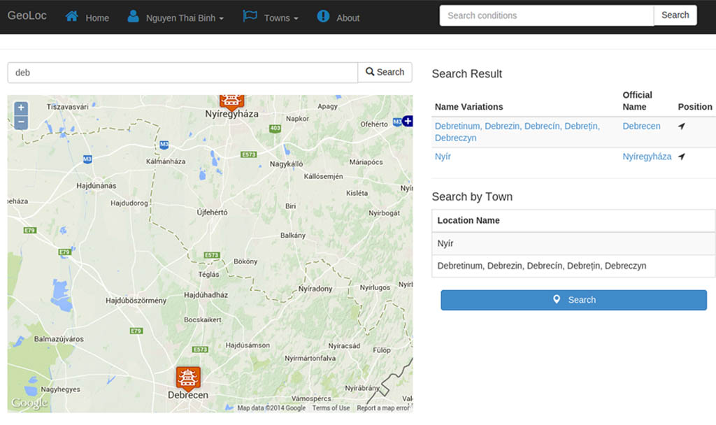
We chose Ruby on Rails (RoR) for two reasons. On the one hand, it is adequate for rapid and robust web development. On the other hand, it is based on Ruby programming language, which is very expressive and easily adoptable with both object oriented and script language background. RoR is a full-stack web application development framework, based on Model-View-Controller layered design pattern as other modern Web application development frameworks. Model layer is responsible for communicating with database and implementing business logic; Controller layer is responsible for managing user interaction logic; and at last, View layer is responsible for displaying information for end users. On View layer, we use freely distributed third-party libraries of reusable software components for displaying maps and user interface design templates.
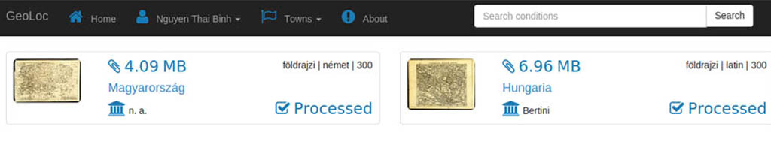
Figure 6. Multiple town query for two Hungarian towns (Debrecen and Nyíregy-háza) and the list of the items with a grid covering the areas in question.

JavaScript and CSS libraries
For displaying web-maps, Geolocator uses Open Layers, an open source JavaScript library for displaying spatial data on web browser. Our web application requires several functionalities: displaying grids, editing grids, displaying towns, editing towns (coordinates and descriptive data), displaying grids found in search results.
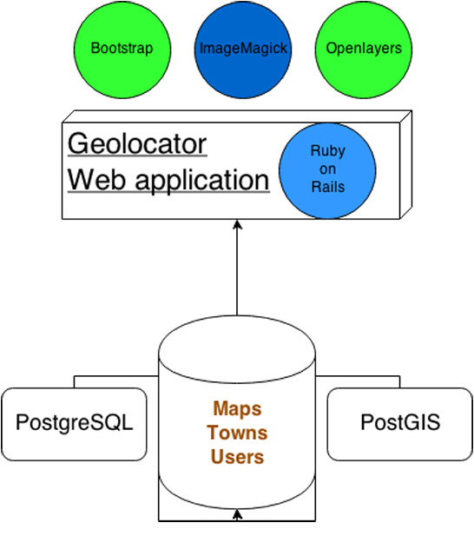
As HTML and CSS templates are needed for designing web applications, user interface template of Geolocator is elaborated in Bootstrap CSS framework. It also contains many additional JavaScript components like Tooltip, Tabs, Popover, etc. that are useful in any web map service.

Figure 7. System architecture of Geolocator web application.

Conclusions
As projectionless maps are always problematic when a map collection is being turned georeferenced, our research is focused on those items that don’t show projection grids. Geolocator of Historical Maps is an alternative tool for involving such old maps into the digital world. The process, by nature of these maps, can’t be executed with the same accuracy as in the case of those maps of which projection is known or recognizable. For users, understanding the method and the functions of Geolocator don’t require much time or special knowledge, so learning its operation is easy even with general computing knowledge. Both the operator’s and the user’s interfaces intentionally received a modest but functional design, facilitating this way their operation. The entire system is open to further, even personalized development according to the requirements of different map collections.
In the second phase of the project, we focus on specifying users’ authentication for different user groups and for different map groups. Another future issue is geolocation of map images stored on remote servers. At this stage, Geolocator is ready to serve individual map collections but with integrated remote relationship functionalities, the system will be able to link virtual map collections of distant institutions.
References
Irás, K. (2010). Cartographic Analysis of Portolan Charts with Use of Digital Methods. Doctoral thesis, ELTE, Budapest.
Molnár G., Timár G., Székely B. (2008). On the georeference of the Lazarus map (1528) of Hungary (Lázár térképének georeferálásáról). Geodézia és Kartográfia 60(4): 26-30.
Plihál, K (2007), Mihalik, J. (2007). Two oral presentations under the title Computer Aided Searching of City and Place Names of Old Maps (Telepü-lés- és helynevek keresése régi térképeken, számítógépes támogatással)
Eger, Networkshop, 2007.
(http://videotorium.hu/hu/recordings/details/1774,Helynevek_keresese_Interneten_publikalt_regi_terkepeken_szamitogepes_tamogatassal)
Timár G., Molnár G. (2008): Georeference of the map sheets of the third military survey of the Austro-Hungarian Monarchy (A harmadik katonai felmérés térképeinek georeferálása). Geodézia és Kartográfia 60(1-2): 23-27.
www.davidrumsey.com/view/maprank-search
postgis.net
rubyonrails.org
openlayers.org
getbootstrap.com

IRÁS 2010, p. 52.
Mihalik 2007, Molnár–Timár–Székely 2008, Timár– Molnár 2008
Plihál 2007
www.davidrumsey.com/view/maprank-search
Geolocator of Historical Maps (grid.elte.hu) belongs to the Department of Cartography and Geoinformatics of ELTE but was created in the frame of an interinstitutional cooperation with the Map Collection of the National Széchényi Library. The application is currently bilingual (English and Hungarian).
Four resolution levels of map images: thumbnail (100x100 pixels), medium (500x375 pixels), large (1000x1000 pixels), original (not changed)

