Atlas Relational Patterns as the Means of Big Data Handling

Chabanyuk Victor*, Dyshlyk Oleksandr*

* Institute of Geography, National Academy of Sciences of Ukraine
Abstract. This article describes the possibilities of designing of Electronic atlases and/or Atlas information systems with the help of cartographic patterns in the process of Big Data handling. The authors have analyzed the previous experience regarding Big Data handling which was performed as the part of the French-German Chernobyl Initiative and other projects dedicated thereto, including the project dedicated to the National Atlas of Ukraine. The article focuses upon the relational patterns, namely ProSF (Project Solutions Framework), GeoSF (GeoSolutions Framework), AtlasSF (Atlas Solutions Framework) and АtIS CF (Atlas Information Systems Conceptual Framework). Furthermore, АtIS CF is used for the analysis of the National atlas of Netherlands prototype to prove wider applicability of created cartographic patterns. Conclusions are representing opinion of authors concerning the patterns as the means of Big Data handling in the modern cartography.
Keywords: Big Data, Atlas Relational Patterns, Atlas, Atlas Solutions Framework, GeoSolutions Framework

1. Introduction
We faced such phenomenon which is now called “Big Data” more than 15 years ago in the projects of the French-German Chernobyl Initiative (FGI). With the aim of proper information handling connected to the consequences of Chornobyl disaster, two interrelated means were used – Project Solutions Framework (ProSF) and weak integration of projects results and materials with the help of notion of information system in a broader sense. At the same time, ProSF was expanded to the GeoSolutions Framework (GeoSF) which in its turn was proposed as a means for National Spatial Data Infrastructure (NSDI) creation [Chabanyuk V.S., Dyshlyk O.P., Markov S.Yu., 2005].
The second experience we dealt with the Big Data in the National Atlas of Ukraine (NAU) project which started over 15 years ago. This project is still in progress now, because NAU products require everlasting support, updating and evolution. In order to handle the Big Data for NAU project, specialization of GeoSF – an Atlas Solutions Framework (AtlasSF) – was used [Rudenko L.G., et al., 2007].
Due to the tremendous changes in the IT field for the last 5-10 years, we involved additional information handling means (especially means related to the geosystem models). Therefore, we used Conceptual Framework of Electronic atlases and Atlas information systems (АtIS CF) and other necessary means.

2. Main definitions
Some terms used in our research do not have the common-recognized meaning. We hereby offer the variants that will be the most appropriate for our research.

Big Data definition
Big Data are often defined by three characteristics: Volume, in terms of large-scale data storage and processing; Variety, or the availability of data in different types and formats; and Velocity, which refers to the fast rate of new data acquisition. However, in many papers, in our opinion, the definition of the term “data” is often forgotten beyond these three “Vs”. In this article we everywhere remember that data are “a representation of facts, concepts, or instructions in a manner suitable for communication, interpretation, or processing by humans or by automatic means” [ISO/IEC/IEEE 24765-2010(E)]. Spatial data are data that have a particular spatial attribute.
We hold a Big Data viewpoint of authors, who strongly connect 3Vs with user and the environment in which Big Data are used. For example, [Evans M.R., et al., 2013] state that “Whether spatial data is defined as “Big” depends on the context. Spatial big data cannot be defined without reference to value proposition (use-case) and user experience, elements which in turn depend on the computational platform, use-case, and dataset at hand.” [Karimi H.A., Ed., 2014; Preface] argues “… that the answer to the question of “What is big data? depends on when the question is asked, what application is involved, and what computing resources are available. In other words, understanding what big data is requires an analysis of time, applications, and resources.”
The monograph [Mayer-Schonberger V., Cukier K., 2013] gives us very interesting Big Data ideas and examples, such as:
- More: Big Data are characterized by formula N=All, that means all actual data. Analysis is increasingly moving from limited samples to the whole population.
- Correlations: Correlations have more priority then cause-result conclusions. Instead of trying to uncover causality, the reasons behind things, it is often sufficient to simply uncover practical answers to questions.
- Messy: The benefit of using more data often outweighs cleaner but smaller datasets.
- Non-computer example: Interesting «non-computer» example of big spatial data from the middle of the 19-th century: the use of marine logbooks for optimization of sea routs by Maury Matthew Fontaine.

Definition of Atlas information systems and Electronic atlases
The term "system" stands, in general, for a set of some things and a relation among the things. The term «relation» in the systems science includes the whole set of kindred terms, such as constraint, structure, information, organization, cohesion, interaction, coupling, linkage, interconnection, dependence, correlation, pattern, etc. [Klir G.J., 1985].
Using [Klir G.J., 1985] we define a Geographic system (GeoSystem) as an ordered pair (A, R), where A denotes a set of relevant things including geographic ones and R denotes a relation among the things in set A. To make such system conception pragmatically useful, it has to be refined in the sense that specific classes of ordered pairs (A, R), relevant to recognized problems, must be introduced. Such classes can basically be introduced by one of two fundamentally different criteria: a) by a restriction to systems which are based on certain kinds of things; b) by a restriction to systems which are based on certain kinds of relations.
Classification criteria (a) and (b) can be viewed as orthogonal. Criterion (a) is exemplified by the traditional classification of science and technology into disciplines and specializations, each focusing on the study of certain kinds of things without committing to any particular kind of relations. This classification is essentially experimentally based. Criterion (b) leads to fundamentally different classes of systems, each characterized by a specific kind of relations with no commitment to any particular kind of things on which the relations are defined. This classification is related primarily to data processing rather than data acquisition and, as such, it is predominantly theoretically based.
The largest classes of systems based on criterion (b) are those which characterize various epistemological levels, i.e., levels of knowledge regarding the phenomena under consideration. In summary, it is reasonable to characterize the development of science during the second half of 20th century in terms of a major transition from a one-dimensional science - primarily experimentally based - into a two-dimensional science, in the course of which systems science - primarily relationally based - gradually enters as the second dimension. The significance of this radically new paradigm of science - the two-dimensional science - has not been fully realized as yet, but its implications for the future seem to be quite profound [Klir G.J., 1985; p. 8].
On our opinion, geography and cartography as sciences are also influenced by the systems theory through the “second” dimension. The main results of this article are examples of such influence. Our research focuses upon the geosystems and their models which are distinguished with the help of classifying criterion (b). Moreover, we analyze specific relations – patterns – named as “atlas conceptual framework” and “atlas (geo, project) solutions framework”. As our research is limited to the Atlas information systems and Electronic atlases, such frameworks are restricted by the name “atlas relational patterns”, however, we are aware of their usage for much bigger set of cartographic systems.
A Cartographic system for the goals of this article is defined as a geographic system model, in which geographic things (phenomena) are represented (mainly) in the form of maps. The research describes the cartographic models of two geosystems. Such systems may be considered as the Big ones, taking into consideration the existing characteristics of their models. Besides, the formula N=All is used while modeling the systems:
1. “Thematic” geographic system that appeared in Ukraine due to the 1986 Chornobyl disaster. The disaster had strong negative influence both on the nature and the population of the half territory of Ukraine - 12 of 25 regions (oblasts) have received special status. Measures dedicated to the liquidation of the consequences of the disaster resulted in significant changes in economic system of Ukraine. Thus, 12% of state budget was used for the abovementioned measures during the first years after disaster.
2. “National” geographic system of Ukraine which is modelled by the National Atlas of Ukraine (NAU). The NAU version 1.0 comprises of one general and five thematic map blocks: 1) general characteristics (38 maps), 2) history (79 maps), 3) environmental conditions and natural resources (320 maps), 4) population and human development (181 maps), 5) economy (181 maps), 6) ecological state (76 maps).
Hereafter we analyze the special type of the Cartographic systems known as Atlas information systems (AtIS) and its kinds known as Electronic atlases (EA). We follow the two definitions of the AtIS: direct and indirect.
Direct definition of (multimedia) Atlas information system is presented in [Hurni L., 2008]. The adjective "multimedia" is almost always neglected by us, because all AtIS that we are interested in are multimedia. It is difficult to find an example of AtIS that would not be multimedia.
Indirect AtIS definition is presented in [Kraak M.-J., Ormeling F., 2010]: “The definition by Van Elzakker (1993) of electronic atlases refers mainly to this third, analytical electronic atlas type: ‘An electronic atlas is a computerized GIS related to a certain area or theme in connection with a given purpose, with an additional narrative faculty in which maps play a dominant role’. As these electronic atlases tend to become more complex the term ‘atlas information systems’ can also be used for them.”
Indirect AtIS definition is used to emphasize the general character of the Atlas information systems in relation to the Electronic atlases. In fact, [Kraak M.-J., Ormeling F., 2010] establish the generalization chain of the Electronic atlases which we extend to the Cartographic systems: view-only atlas (is a) interactive Electronic atlas (is a) analytical Electronic atlas (is a) Atlas information system (is a) Cartographic system.
We use also such atlas definition: “A Geographic atlas is the systematic collection of maps which were created according to the unified program as holistic product. Internal atlas unity is procured by the consistency, mutual supplementing and interrelation of maps and sections, rational selection of projections and scales, unified settings of cartographic generalization, coherent system of symbol codes and unified design” [Berlyant А.М., Koshkarev А.V., 1999]. This definition is based on assumption that atlas is created by the specialists with “classic” cartographic knowledge. So, it is definition of an Atlas of classic type – geographic atlas, created by specialists with classic cartographic knowledge for the users who may not have such knowledge.
The notion of Cartographic system is polymorphic. We can consider it from the three viewpoints: geographic, information and system. Due to the limitations of volume, we hereby analyze only the geographic viewpoint for the Cartographic systems which are Cartographic information systems (CIS).
CIS is a kind of geographic information system (GIS). GISs are models of the bigger set of geosystems than studied by us. By the way, some relations of such geosystems can be modelled by atlas relational patterns. Our research deals with the subset of geosystems which are studied by so-called “relational geographies”, which include for example post-structural geographies [Cresswell T., 2013; Chapter 11].
Certain notion about relations which help to distinguish the geosystems through classifying criterion (b) is exemplified in work of [Cresswell T., 2013; p. 218]: “One way of thinking about post-structural geographies is as relational geographies. Rather than thinking about the inhabited world as a set of discrete things with their own essences (this place, different from that place), we can think about the world as formed through the ways in which things relate to each other. One popular illustration of this approach is to consider the difference between topography and topology. While topography refers to the discrete shape of the land and is often used to denote a discrete place, topology refers to the connectedness of things...
In Post-Structural Geographies, Murdoch (2006) argues that it is this theme of rationality that lies at the heart of post-structural geographies. It is not spaces or places in and of themselves that are at the heart of such an approach, he argues, but the ways in which they become related. This relational approach to space, he suggests, draws our attention to the ways in which things become related and how this produces relational spaces.”

Patterns definition
In this article the notion of the “pattern” is fundamental. As we deal with the information systems, in practice we often use standard definitions from [Booch G., Rumbaugh J., Jacobson I., 2005]: “a pattern is a common solution to a common problem in a given context; a framework is an architectural pattern that provides an extensible template for applications within a domain.”
An architectural pattern is a named collection of architectural design decisions that are applicable to a recurring design problem, parameterized to account for different software development contexts in which that problem appears [Taylor R.N., et al., 2010]. An architectural pattern expresses fundamental structural organization schemas for software systems. It provides a set of predefined subsystems, specifies their responsibilities, and includes rules and guidelines for organizing the relationships between them [Buschmann F., et al., 2001].
We are using as a primary the definition of pattern from [Ackerman L., Gonzalez C., 2011]: “a pattern is a proven best-practice solution to a known, recurring problem within a given context.” An architectural pattern for us is a general, reusable solution to a commonly occurring problem in Atlas information system architecture within a given context. A framework for us is architectural pattern for whole Atlas information system or some its logical parts.
More meanings of term pattern used in this article can be extracted from the Christopher Alexander books. In [Alexander C., et al., 1977] pattern “… describes a problem which occurs over and over again in our environment, and then describes the core of the solution to that problem, in such a way that you can use this solution a million times over, without ever doing it the same way twice.” In [Alexander C., 1979]: “Each pattern is a three-part rule, which expresses a relation between a certain context, a problem, and a solution. As an element in the world, each pattern is a relation between a certain context, a certain system of forces which occurs repeatedly in that context, and a certain spatial configuration which allows these forces to resolve themselves. As an element of language, a pattern is an instruction, which shows how this spatial configuration can be used, over and over again, to resolve the given system of forces, wherever the context makes it relevant. The pattern is, in short, at the same time a thing, which happens in the world, and the rule which tells us how to create that thing, and when we must create it. It is both a process and a thing; both description of a thing which is alive, and description of the process which will generate that thing.”
The patterns are widely used for creation of the information systems (IS) over the last 20 years starting from the publication of the monograph [Gamma E. et al., 1995]. In addition to the patterns usage as the software IS elements (design patterns in [Gamma E. et al., 1995]), we can observe the popularity of patterns usage for other IS elements. Thus, a monograph [Blaha M., 2010] describes the patterns usage as the dataware IS elements. The monograph [Ackerman L., Gonzalez C., 2011] deals with the patterns usage for IS development processes as addition to their usage for the products (IS software or dataware elements). In general, the issue regarding usage of patterns in IS has been discussed in numerous studies – for example, there are more than 100 monographs dedicated thereto.

Abductive inference definition
The main results of our work were obtained by applying the research methodology, based on the concept of «abductive inference». This concept and its use in cartography were considered in rare monograph [Sventek Y.V., 1999]. After our work had been finished and sent to the scientific committee of ICC 27 (November, 2014), we have read a very important and useful for us article [Miller H.J., Goodchild M.F., 2014].
The main content of this article is useful for us, as it covers the issues which in our opinion are close to the problems of our work. Such as, [Miller H.J., Goodchild M.F., 2014; Abstract]: “The context for geographic research has shifted from a data-scarce to a data-rich environment, in which the most fundamental changes are not just the volume of data, but the variety and the velocity at which we can capture georeferenced data; trends often associated with the concept of Big Data. A data-driven geography may be emerging in response to the wealth of georeferenced data flowing from sensors and people in the environment. Although this may seem revolutionary, in fact it may be better described as evolutionary. Some of the issues raised by data-driven geography have in fact been longstanding issues in geographic research, namely, large data volumes, dealing with populations and messy data, and tensions between idiographic versus nomothetic knowledge. The belief that spatial context matters is a major theme in geographic thought and a major motivation behind approaches such as time geography, disaggregate spatial statistics and GIS science. There is potential to use Big Data to inform both geographic knowledge-discovery and spatial modeling. However, there are challenges, such as how to formalize geographic knowledge to clean data and to ignore spurious patterns, and how to build data-driven models that are both true and understandable.”
Another useful and important result for us is the consideration of abductive inference: “Abductive inference starts with data describing something and ends with a hypothesis that explains the data. It is a weaker form of inference relative to deductive or inductive reasoning: deductive inference shows that X must be true, inductive inference shows that X is true, while abductive inference shows only that X may be true. Nevertheless, abductive inference is critically important in science, particularly in the initial discovery stage that precedes the use of deductive or inductive approaches to knowledge construction (Miller 2010).
Abductive deductive inference requires four capabilities: i) the ability to posit new fragments of theory; ii) a massive set of knowledge to draw from, ranging from common sense to domain expertise; iii) a means of searching through this knowledge collection for connections between data patterns and possible explanations, and; iv) complex problem-solving strategies such as analogy, approximation, and guesses. Humans have proven to be more successful than machines in performing these complex tasks, suggesting that data-driven knowledge discovery should try to leverage these human capabilities through methods such as geovisualization rather than try to automate the discovery process. Gahegan (2009) envisions a human-centered process where geovisualization serves as the central framework for creating chains of inference among abductive, inductive, and deductive approaches in science, allowing more interactions and synergy among these approaches to geographic knowledge building.”

3. (Geo) Solutions Frameworks
First (Geo) Solutions Framework – Project Solutions Framework (ProSF) - was identified and constructed in the Projects of “The French-German Initiative For Chernobyl” (FGI). The FGI objective was to create a reliable and objective information database on radiation, ecological, and medical consequences of the 1986 year Chornobyl accident. The FGI consisted of three Projects, implemented in period 1998-2003:
- Sarcophagus safety (6 Sub-Projects).
- Radioecological consequences of the Chernobyl accident (9 Sub-Projects).
- Health effects of the Chernobyl accident (10 Sub-Projects).
More than 20 scientific and research institutes and organizations of Ukraine, France, Germany, Russia, and Belarus took part in the database creation. The total number of “thematic” Sub-Projects was 52. The situation was complicated by the fact that relevant databases and other materials shall be related to each subject and shall be established by research institutions in Belarus, Ukraine and Russia, each having very different experience in IT development. Each Sub-Project in the period of 3 years produced large quantity of different type products and materials: reports, databases, maps, work (intermediate) products, videos, images, presentations etc. All these products and materials are representing in some manner the different parts of Chornobyl accident thematic geosystem. Collected materials fit to the “3Vs” of Big Data: Volume, Variety and Velocity. More information on the application of ProSF in FGI can found in [Chabanyuk V.S., Dyshlyk O.P., 2015]. Cited reference is describing also weak integrated information system of the FGI products and materials - ChIIS-FGI. ChIIS-FGI front-end (ChIIS-FGI light CD) was an Atlas information system in the narrower sense. ChIIS-FGI back-end can be defined as a ChIIS-FGI AtIS infrastructure (see below).
ProSF was used to coordinate and to manage the development of numerous information products and processes in all FGI Sub-Projects. The ProSF structure also as all other (Geo) Solutions Frameworks is shown on Figure 1a.
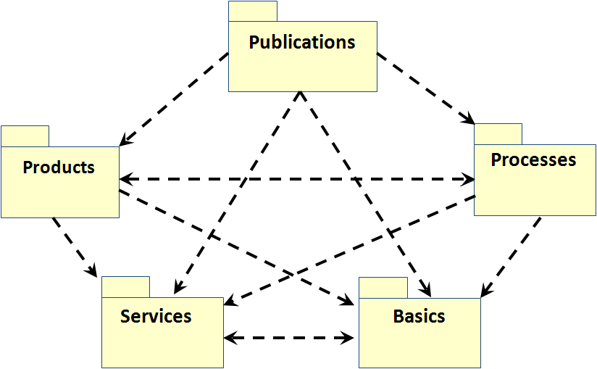  a | 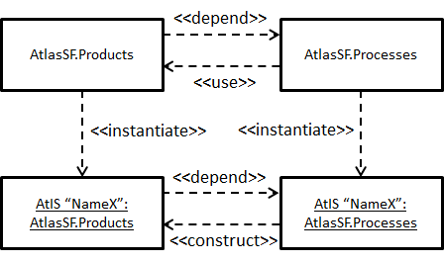  b
Figure 1: (Geo) Solutions Framework. a – conceptual structure, b – product-process dualism
In parallel to FGI it was identified that similar to ProSF Solution Frameworks exist and can be used for and in other models of geosystems. So, we have created: 1) GeoSolutions Framework (GeoSF), which was proposed to use as a means for National Spatial Data Infrastructure (NSDI) construction [Chabanyuk V.S., Dyshlyk O.P., Markov S.Yu., 2005] and 2) Atlas Solutions Framework (AtlasSF), which was used for the development of more than 10 AtISs and EAs in period 2000-2010.
When somebody is talking about an Electronic atlas (EA) or Atlas information system (AtIS), he/she generally refers to a specific information product, which is also called the end-user product. An example of such product is the Electronic version of the National Atlas of Ukraine 2007 [Rudenko L.G., et al., 2007] (denoted ElNAU2007). Such information products are the result of a specific organized activity of specialists group that adheres to a certain process of developing an information product. It is arguable that the product cannot be created without process and Vice versa, the process without a product makes no sense. There is a dualism between product and process. This dualism is the first key concept and construct of the Solutions Framework.
EA and AtIS information products consist of such elements as contents tree, thematic maps, non-cartographic elements etc. Each of these elements can be created as original - from the scratch. However, these products are focused on average end-users, so for each element you should find typical solutions that simultaneously need to be of high quality. Another reason for searching typical solutions is the experience of developers, labor costs and their financial equivalent - means, which are always a serious limitation. The presence of a certain set of typical solutions to typical problems in AtIS/EA context is the second key concept and construct of Solutions Framework.
Explanations to the Figure 1b:
- AtlasSF.Products, AtlasSF.Processes – Product and Process patterns (shown in notation of classes) of AtlasSF. Their dualism: AtlasSF.Processes “use” AtlasSF.Products, AtlasSF.Products “depend on” AtlasSF.Processes.
- Object AtIS “NameX”: AtlasSF.Processes (shown in notation of object) “instantiates” AtlasSF.Processes. It fact, this object is in some sense the «constructor» of AtlasSF.Products class. It creates the AtIS “NameX”: AtlasSF.Products object - instantiation of AtlasSF.Products. “NameX” here can be ElNAU2007 or any other created in period 2000-2010 AtIS or EA.
Two main versions of AtlasSF were released within the period from 2000 till 2010. So, we are using package notation for the sets of AtlasSF Products and Processes patterns. Apart from the Products and Processes packages, there are other patterns of the AtlasSF mentioned on the Figure 1a:
- AtlasSF Basics package includes the Ukraine Base map pattern, Database of the Ukraine administrative and territorial division objects and some other geoobjects, Classifier of the Ukraine administrative and territorial division of Ukraine, Topographic map Classifier, Glossary pattern and some other elements. It is important to note that this package is in relation to the other AtlasSF packages (Products, Processes), which is similar to the relation between the AtlasSF and a certain Electronic atlas and/or its development process/project.
- Publications package includes the templates of product and project presentations, templates of electronic and printed articles, example of product’s demo version etc. The necessity of this package was proved by its usage for the large-scale projects which in their turn involve significant efforts for information exchange both between the project members and the outside environment.
- Elements of the AtlasSF Services package play the supplementary role. The most important elements of this package are the patterns of the warehouses for electronic and printed files and the service software patterns. Other elements of the package include, for example, the guideline for design of the front and back cover of the optical disc which contains the interim and final versions of the product.
The elements of the Processes, Basics, Publications and Services packages are interpreted as patterns in rather free form. For example, for the elements of Process package it is used even different, not “pattern”, terminology.

4. Conceptual Framework of Atlas information systems
There are long living AtISs, such as Electronic version of NAU (ElNAU2007). ElNAU is “living” now more than 8 years. ElNAU project is living more than 15 years, if we will include Atlas of Ukraine 2000 (recognized as ElNAU pilot version; noted as ElNAU2000). Long living AtISs have compelled for the developers the task to have few variants of products/systems. These products/systems are related to the three main information system development phases: research, development and delivery.
Only delivery phase result is related usually to the concrete end-user product. But there are also products/systems which exist on development phase. Long living AtISs are requiring also to have somehow organized artefacts which are needed for the system evolution (new versions creation), support and maintenance. We argue that collection of all such artefacts and products/systems is agreed to the Big Data definition for long living AtISs, which are modelling Big geosystems. For such collection we use notion of Information System in the broader sense (ISb): The totality of all formal and informal data representation and processing activity whithin an organization (can be virtual, uniting few different organizations and persons), including the associated communication, both internally and with the outside world [Falkenberg E.D., Lindgreen P., Eds., 1987].
For the AtISs, created with the help of AtlasSF, it is useful to have full access not only to the AtIS structure and contents, existed at the development phase. It is extremely useful to have Atlas Solutions Framework, which Products package consists of eight patterns and one framework: 1) User Interface; 2) Contents/solution Tree; 3) Cartographic Component; 4) Thematic Maps (few patterns); 5) Non-Cartographic Elements (for example, HTML documents or photography); 6) Base Map; 7) Atlas Search; 8) Atlas Presentation (Workspace); and 9) Atlas Architecture Framework which unites patterns 1-8. Such approach facilitates the execution of the tasks such as refactoring (fault resolution) and designing of other atlases being similar to the ElNAU2007.
By using AtlasSF (see Figure 2), in addition to ElNAU2000 and ElNAU2007, some other classic atlases were created. For example, Atlas of Radioactive Contamination of Ukraine, which was released on CD in 2002 (Version 1.0, hereinafter – RadAtlas2002) and in 2008 (Version 2.0, hereinafter – RadAtlas2008).
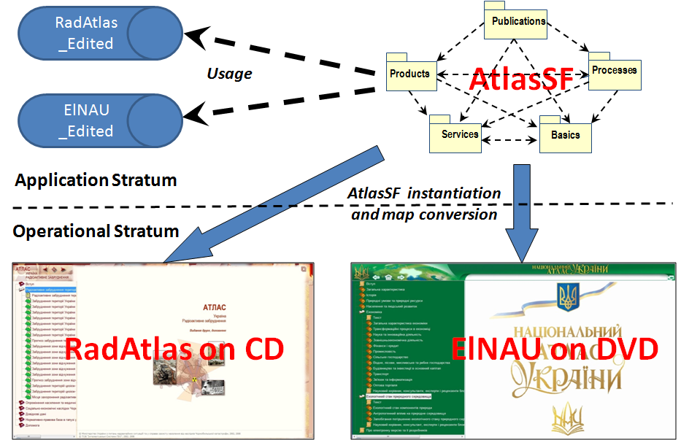
Figure 2: Principle of AtlasSF usage for classic EA creation. RadAtlas_Edited and ElNAU_Edited are examples of development phase AtISs (invisible for end-users)
There are tasks which need approaches additional to the AtlasSF usage. They are: existed AtIS evolutions, creation of new AtISs and - in the cases of revolutionary changes of information technologies – existed AtIS maintenance. To solve described tasks we have performed re-engineering of the whole project. The main result of such re-engineering is the ElNAU Conceptual Framework (CF) [Chabanyuk V.S., Dyshlyk O.P., 2014]. ElNAU CF exists for every classic atlas, including mentioned above RadAtlases of both versions. This article demonstrates the AtIS Conceptual Framework only and necessary comments upon it. As classic atlases are noted also as Web 1.0 atlases, we use this term for Figure 3 to mark the classic Electronic atlases (AtISs).
Classic AtIS CF also as ElNAU CF define the conceptual structure of ElNAU ISb. ElNAU ISb is created by the some semantic connection of ElNAU2000, ElNAU2007, ElNAU2010 editions and ISb named as ElNAU Infrastructure.
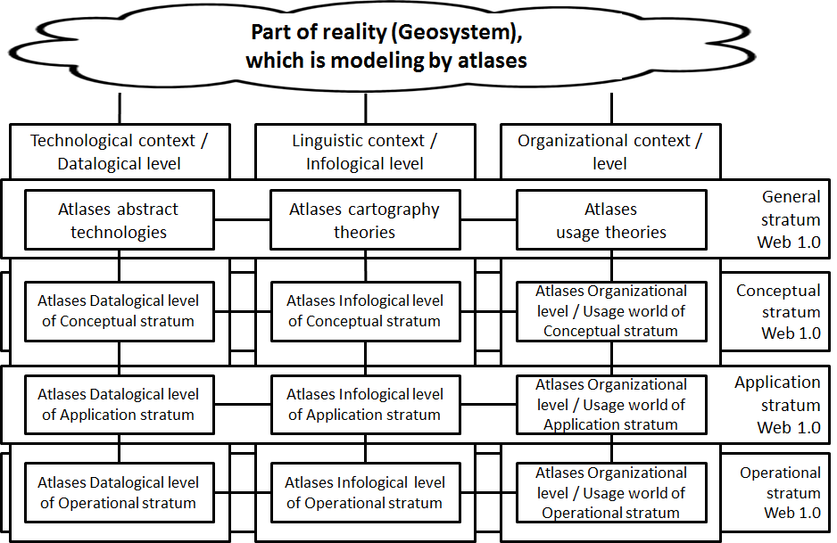
Figure 3: Conceptual Framework of ElNAU and other classic EAs
Classic AtIS CF (Figure 3) illustrates the structure of the Classic Electronic atlases. However, nowadays we can see the atlases (and AtISs) which can be called as the Neo-classic atlases (and AtISs). It means that AtIS CF has third dimension which may be called as formations. We distinguish the following formations: Web 1.0, Web 1.0х1.0, Web 2.0 and Web 3.0.
Web 1.0x1.0 formation is known as the formation which differs from the Web 1.0 by its ability to change the atlas elements by the end-user. Moreover, Web 1.0x1.0 uses HTML5 instead of HTML4. Finally, Web 1.0x1.0 is used for the mobile powered atlases without Internet connection, which, however, may be connected to the Internet and perform server swapping.

5. Atlas Relational Patterns in the Spatial Big Data: To Be or Not to Be
Electronic atlases and AtIS are information systems. The vast majority of other cartographic systems shall also thought to be the information systems. Therefore, it looks quite unusual why usage of patterns in cartography is so unpopular today. The works that deal with the cartographic patterns are not very numerous. Thus, only Chapter 12 of the [Karimi H.A., Ed., 2014] deals with the patterns as the means of Big Data handling. Some cartographic patterns are described in the monograph [O'Sullivan D., Perry G.L.W., 2013]. Most known examples are cartographic things’ patterns.
Does it mean that absence of cartographic (atlas) relational patterns in cartography is the sign that we are doing something wrong? Does it mean that our approach to the Big Data handling is not of considerable importance? We cannot give the final answer now (see also definition of abductive inference). We can observe both pros and cons.
Solutions Frameworks have three implementations: as the ProSF system, as the portal system GeoSF and as the AtlasSF. Portal system GeoSF was used for the creation of FGI ISb systems also as for the National atlas portal prototyping (see [Rudenko L.G., et al., 2007]). Some classic national and thematic atlases (or Web 1.0 atlases) were created with the help of AtlasSF. Apart from the end-user products (for example, DVD version of the ElNAU), each atlas has its own infrastructure used for support and evolution. Such infrastructure over Operational stratum has its own structure very similar to the Solutions Framework conceptual structure. The process of thematic maps’ construction is also very important. If we limit to the Datalogical level, we can say that there is the technology that let us construct various thematic maps. If we look into the Infological level, we have to admit that methodology of thematic maps construction requires further research. Conceptual stratum has been studied less than the Application one. But it is should be noted that Conceptual stratum contains such often used objects as basic map and geoobjects database, including the description of administrative-territorial division of Ukraine.
The worthiness of our approach may be evidenced by the works of the Dutch atlas school (see [Kraak M.-J., et al., 2009], [Köbben B., 2013] and others). We use the AtIS CF for analysis of the Electronic version of the National Atlas of Netherlands (hereinafter – ElNAN).
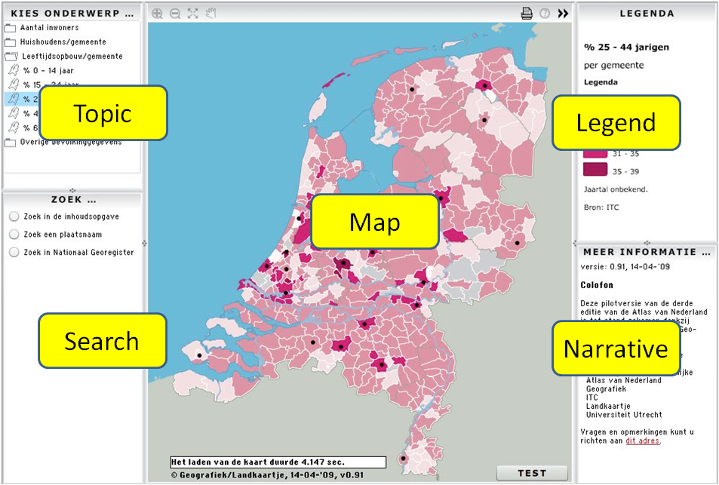  a | 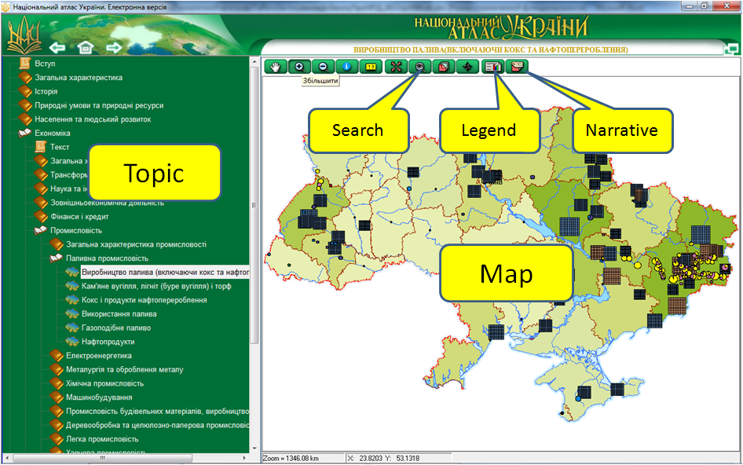  b
Figure 4: Comparison of National atlases interfaces. а – ElNAN [Kraak M.-J., Ormeling F., Köbben B., et al., 2009], b - ElNAU
ElNAN and ElNAU user interfaces are represented on the Figure 4. Their comparison results in the conclusion that both “operational” atlases are quite similar. The differences are in implementation. Changes in content in both cases occurred on the Application stratum. Therefore, end-user deals with the similar cartographic systems on the Operational stratum.
Let us represent the ElNAN Conceptual structure and part of AtIS (ElNAU) Conceptual Framework (Figure 5).
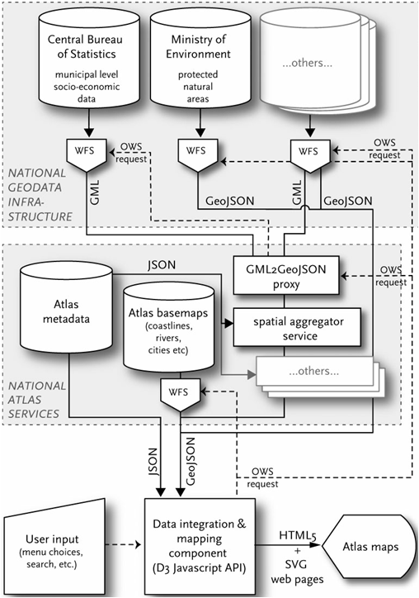  a | 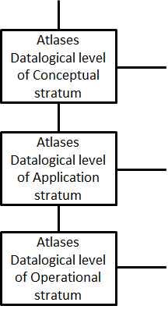  b
Figure 5: Comparison of ElNAN Conceptual structure. a - [KöbbenB., 2013], b - (part of) AtIS (ElNAU) Conceptual Framework
In our opinion, ElNAN National Atlas Services (Figure 5a) are belonging to the same - Application – stratum as in the case of ElNAU CF (Figure 5b). According to the AtIS CF, National GeoData Infrastructure belongs to the Conceptual stratum. More deep comparison of ElNAN and ElNAU can be found in [Chabanyuk V.S., Dyshlyk O.P., 2015].

6. Conclusion
In both abovementioned experiences with the Big Data handling we had to build (dealt with) multilevel hierarchical Atlas information systems in a broader sense. Recent studies of the authors [Chabanyuk V.S., Dyshlyk О.P., 2014], [Chabanyuk V.S., Dyshlyk O.P., 2015] show that the structure of these systems corresponds to the specific Conceptual Framework of АtІS.
The gathered experience and its comprehension allow us to make a conclusion that attempts to model Big national or thematic geosystems inevitably lead to the information systems with abovementioned AtIS structure. Such AtISs have described above context (level), stratum and formation hierarchies.
Web 1.0x1.0 and Web 2.0 formations deserve individual attention. From the viewpoint of modern cartographic systems, these formations are outside the classic cartography and classic atlases such as the National Atlases of the Ukraine and/or the Netherlands. Created atlases correspond to the vision of the "classic" cartographers about the cartographic models of the geosystems. "Neo-classic" cartographers create neo-classic cartographic models of the geosystems in the formations of the Web 1.0x1.0, Web 2.0 and Web 3.0. AtIS CF draws the attention to the fact that there are relations between of the Web 1.0 formation on the one hand, and the Web 1.0x1.0, Web 2.0 and Web 3.0 formations on the other hand. According to authors’ opinion, the investigation and search of these relations is one of the most important tasks of modern cartography. Without doubt, this research should be done in Big Data context.
References
[Ackerman L., Gonzalez C., 2011] Ackerman Lee, Gonzalez Celso. Patterns-Based Engineering: Successfully Delivering Solutions via Patterns.- Addison-Wesley, 2011.- 444 p.
[Alexander C., 1979] Alexander Christopher. The Timeless Way Of Building.- Oxford University Press, 1979.- 552 p.
[Alexander C., et al., 1977] Alexander Christopher, Ishikawa Sara, Silverstein Murray. A Pattern Language: Towns, Buildings, Construction.- Oxford University Press, 1977.- 1171 p.
[Berlyant А.М., Koshkarev А.V., 1999] Baranov Y.B., Berlyant А.М., Kapralov Е.G., Koshkarev А.V. Serapinas B.B., Philippov Y.А. Geoinformatics. Dictionary of basic terms. М.: GIS-Association, 1999. 204 p. Edited by Berlyant А.М. and Koshkarev А.V.
[Blaha M., 2010] Blaha Michael. Patterns of Data Modeling (Emerging Directions in Database Systems and Applications).- CRC Press, 2010. – 240 p.
[Booch G., et al., 2005] BoochGrady, Rumbaugh James, Jacobson Ivar. The Unified Modeling Language User Guide.- Addison-Wesley, 2005, 2nd Ed.- 496 p.
[Buschmann F., et al., 2001 (1996)] Buschmann Frank, Meunier Regine, Rohnert Hans, Sommerlad Peter, Stal Michael. Pattern-Oriented Software Architecture, Volume 1: A System of Patterns.- Wiley, 2001 (1996).- 467 p.
[Chabanyuk V.S., Dyshlyk O.P., Markov S.Y., 2005] Chabanyuk V.S., Dyshlyk O.P., Markov S.Y. Geosolutions Framework as the NSDI construction means, pp. 114-122 // Scientific and Technical Collection: Engineered heodeziya. Vol. 51.- Кyiyv, KNUCA, 2005 (in Ukrainian).
[Chabanyuk V.S., Dyshlyk O.P., 2014] Chabanyuk V.S., Dyshlyk O.P. Conceptual Framework of the Electronic Version of the National Atlas of Ukraine.- Ukrainian Geographical Journal, 2014, № 2, pp. 58-68 (in Ukrainian).
[Chabanyuk V.S, Dyshlyk O.S., 2015] Chabanyuk V., Dyshlyk O. Cartographical Patterns as the Means of Big Data Handling in Atlas Mapping, pp. 159-167 // Modern achievements of geodesic science and industry. Collection of scientific papers of Western Geodetic Society of USGS, Issue I (29).- Lviv: Lviv Politechnic Press, 2015. - 192 p.
[Cresswell T., 2013] Cresswell Tim. Geographic Thought: A Critical Introduction (Critical Introductions to Geography).- Wiley-Blackwell, 2013.- 290 p.
[Evans M.R., et al., 2013] Evans Michael R., Oliver Dev, Yang KwangSoo, Zhou Xun, Shekhar Sashi. Enabling Spatial Big Data via CyberGIS: Challenges and Opportunities.- 22 p. // Wang S., Goodchild M.F., Editors. CyberGIS: Fostering a New Wave of Geospatial Innovation and Discovery. Springer Book, 2013.
[Falkenberg E.D., Lindgreen P., Eds., 1987] Information System Concepts: An In-depth Analysis / Falkenberg E.D., Lindgreen P., Eds. North-Holland, Amsterdam et al., 1989.- 357 p.
[Gamma E., et al., 1995] Gamma Erich, Helm Richard, Johnson Ralph, Vlissides John M. Design Patterns: Elements of Reusable Object-Oriented Software.- Addison-Wesley, 1995.- 395 p.
[ISO/IEC/IEEE 24765-2010(E)] International Standard ISO/IEC/IEEE 24765. Systems and software engineering — Vocabulary.- ISO/IEC/IEEE, 2010.- 410 p.
[Karimi H.A., Ed., 2014] Karimi Hassan A., Editor. Big Data: Techniques and Technologies in Geoinformatics.- CRC Press, 2014.- 290 p.
[Klir G.J., 1985] Klir George J. Architecture of Systems Problem Solving.- Springer, 1985.- 540 p.
[Köbben B., 2013] Köbben Barend. Towards a National Atlas of the Netherlands as Part of the National Spatial Data Infrastructure.- The Cartographic Journal, Vol.50, No.3, pp. 225–231.
[Kraak M.-J., et al., 2009] Kraak Menno-Jan, Ormeling Ferjan, Köbben Barend, Aditya Trias. The Potential of a National Atlas as Integral Part of the Spatial Data Infrastructure Exemplified by the New Dutch National Atlas, pp. 9-20 // SDI Convergence, 2009.
[Mayer-Schonberger V., Cukier K., 2013] Mayer-Schonberger Viktor, Cukier Kenneth. Big Data: A Revolution, That Will Transform How We Live, Work and Think.- Houghton Mifflin Harcourt, 2013.- 257 p.
[O'Sullivan D., Perry G.L.W., 2013] O'Sullivan David, Perry George L.W. Spatial Simulation: Exploring Pattern and Process.- Wiley-Blackwell, 2013.- 305 (342) p.
[Rudenko L.G., et al., 2007] Rudenko L.G., Bochkovska A.I., Kozachenko T.I., Parhomenko G.O., Razov V.P., Lyashenko D.O., Chabanyuk V.S. The National Atlas of Ukraine. Scientific bases of creation and their implementation.- K.: Аkademperiodyka, 2007.- 408 p. Edited by Rudenko L.G. (in Ukrainian).
[Sventek Y.V., 1999] Sventek Y.V. Theoretical and practical aspects of modern cartography.- EditorialURSS, 1999.- 76 p.
[Taylor R.N., et al., 2010] Taylor Richard N., Medvidovic Nenad, Dashofy Eric M. Software Architecture: Foundations, Theory, and Practice.- Wiley, 2010.- 712 p.

Automated “Information Systems in the narrower sense” are defined as “Computer-based sub-systems, intended to provide recording and supporting services for organizational operation and management” [Falkenberg E.D., Lindgreen P., Eds., 1987]
Infrastructure (lat. Infra – “lower” and Structura – construction) of the ElNAU is defined as the complex of interrelated artefacts that comprise and/or provide the basis for the task execution: operability support, update and development of ElNAU2000, ElNAU2007, ElNAU2010 Atlases and design of the new ElNAU versions. ElNAU2010 is the last edition of ElNAU released in 2010 (Version 1.1)

