Cartographic Assessment Methods of the
Waters Ecological Status based on
Satellite Data
T.V. Vereshchaka, Z.V. Andreeva
Moscow State University of Geodesy and Cartography
Abstract. Conceptual problems of cartographic assessment of the marine environment are considered. Assessment criteria and environmental factors affecting the ecological state are shown. Maps system and its substantiation are proposed; special features of thematic, mathematical and geographical contents of maps are described. The developed method of the marine environment assessment based on cartographic and satellite data is presented.
Keywords: ecological status of water areas, bio-indication, maps system

Introduction
Most widely used currently in the evaluation of the ecological status of water bodies is the approach based on the account of a number of hydrochemical characteristics and analysis of their deviation from the values of maximum allowable concentrations. This approach, despite considerable elaboration, has significant drawbacks: limited (or a lack of) factual information and the inability to produce it as often as necessary; chances to leave unaccounted some meaningful parameters study of ecosystem being studied. In addition, the state of the ecosystem is determined not only through complex hydrochemical elements under consideration but depends on the nature of their interaction and its consequences. Therefore, when assessing the ecological status of water bodies, we found it more reliable to use the principle of bio-indication, which allows us to give an integrated assessment of the water environment based on the state of its living organisms. Phytoplankton community has been selected as the object of bio-indication of waters due to the key value of planktonic algae during the life of the oceans.

Evaluation Criteria and Ecologically Important
Environmental Factors
The aquatic system is characterized by favorable environmental conditions at a relatively constant level of biological productivity of the waters, taking into account the seasonal dynamics. Balanced functioning ecosystems are supported by the balance between production and destruction processes.
Nowadays the level of biological productivity of coastal areas and inland waters is mainly determined by anthropogenic activity. It often causes anthropogenic eutrophication – significant increase of the level of biological productivity due to nutrients enrichment, primarily nitrogen and phosphorus, which causes outbreaks of phytoplankton blooms, and as a result, disruption of the balance of the ecosystem functioning. The outbreaks of phytoplankton blooms lead to extensive extinction of phytoplankton cells, which is accompanied by intense formation of biogenic organic films. Biogenic films are formed during the life and the expansion of marine organisms, mainly phytoplankton and zooplankton. The films consist of surfactants which are accumulated on the sea surface. It is found that the number of biogenic organic films increases during the outbreaks of phytoplankton blooms.
Therefore, the main criterion for assessing the ecological status of water bodies adopted is the biological productivity of waters. The concentration of chlorophyll-а* – the main photosynthetic pigment of phytoplankton – and the zones of spatial localization of biogenic films on the sea surface can be very tentatively considered as the indicators characterizing the level of biological productivity. – Figure 1.
An essential task in the study of the mechanisms of functioning of aquatic ecosystems is to reveal a complex of environmentally significant factors influencing the development of the biological processes in the aquatic environment. Among these factors, we include light intensity, sea surface temperature (SST), the speed and direction of low wind over water, the circulation of water masses, amount of precipitations, water transparency. Depending on the characteristics of the water area, the complex of these factors may be supplemented and updated.
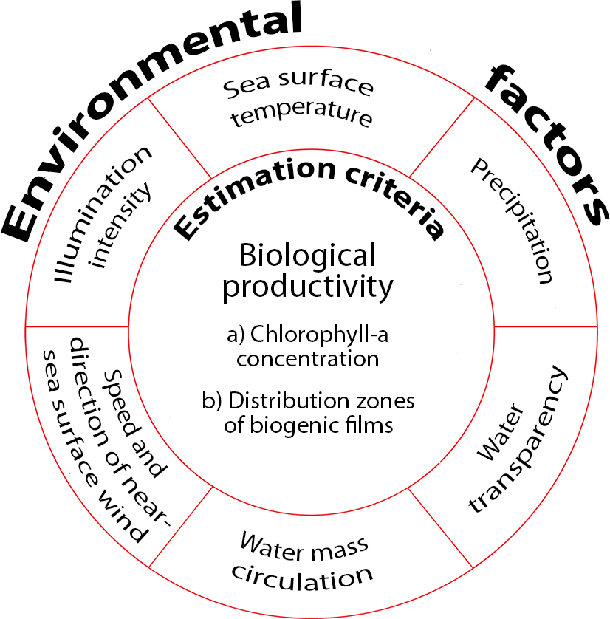
Figure 1. Assessment criteria for the ecological status of water bodies and the factors determining it.

Illumination Intensity
It is known that the process of photosynthesis in the ocean is limited by the depth to which sunlight penetrates – low solar radiation reduces the power of the euphotic layer (the layer of photosynthesis). A change of the solar radiation value also has a significant impact on the stratification of the water masses. In the middle and high latitudes, an intensive mixing of water masses takes place in winter due to strong cooling of the surface layer, which leads to the smooth removal of phytoplankton cells from the euphotic zone into deeper horizons with insufficient light, and as a consequence, to reduction of the biological productivity level. At the same time, in the summer season, an increase of solar radiation causes the formation of a clearly expressed seasonal thermocline that restricts entry of nutrients into the euphotic zone and also leads to a decrease in primary production [2].

Sea Surface Temperature
It specifies the seasonal cycle in the development of phytoplankton. By itself, the low / high temperature is not an obstacle for the development of primary production. However, its indirect effect is of great importance due to the stratification of the water column. The stability of the water column is largely dependent on the temperature, since its increase or decrease changes the density of water masses and determines the nature of their agitation. Upwelling phenomena also contribute to the increase of biological productivity.

Speed and Direction of Near-Sea Surface Wind
Wind speed is a factor that affects the stability of water masses. The nature of the wind effects is determined by the geographic location of the area. If in the high latitudes, an increased wind action should be seen as the cause for a low level of primary production in the cold season and as one for its improvement in a warm season, in the low latitudes the strong wind promotes bio-efficiency all year because of the rising of underlying water masses, rich in nutrients. In shallow water, wind mixing also leads to the enrichment of the euphotic layer by nutrients coming from the bottom, and contributes to the intensive development of phytoplankton.

Precipitation
During the period of heavy rainfall and snowmelt, river discharge multiplies considerably the removal of nutrients into the shelf zone waters and often causes outbreaks of phytoplankton blooms, thereby determining the degree of anthropogenic eutrophication of the coastal areas.

Water Transparency
It affects the depth of light penetration into the water column. Even with strong solar radiation, primary production in the water column does not reach high values if the water is cloudy, and the sun's rays are absorbed or scattered in the uppermost layer. An increased transparency enhances the water environment (depthward) for the development of phytoplankton. However, phytoplankton itself can be the source water turbidity – in highly productive waters, it develops actively at the surface, absorbing solar radiation and limiting the amount of light entering the deeper layers [4].

Circulation of Water Masses
It causes the development and spatial distribution of phytoplankton. In various parts of the sea, it varies considerably depending on the speed and direction of wind, water warm-up, the intensity of the river flow, the configuration of the coastline, and others.

Maps System and Its Rationale
In accordance with the environmentally significant environmental factors and the evaluation criteria adopted by the ecological status of water bodies there has been developed a system of maps containing an optimal range of thematic subjects. As a result of directionally oriented ecological and detailed case studies, two groups of maps have been identified that form the basis for the techniques of cartographic assessing of the ecological status of water bodies (Figure 2).
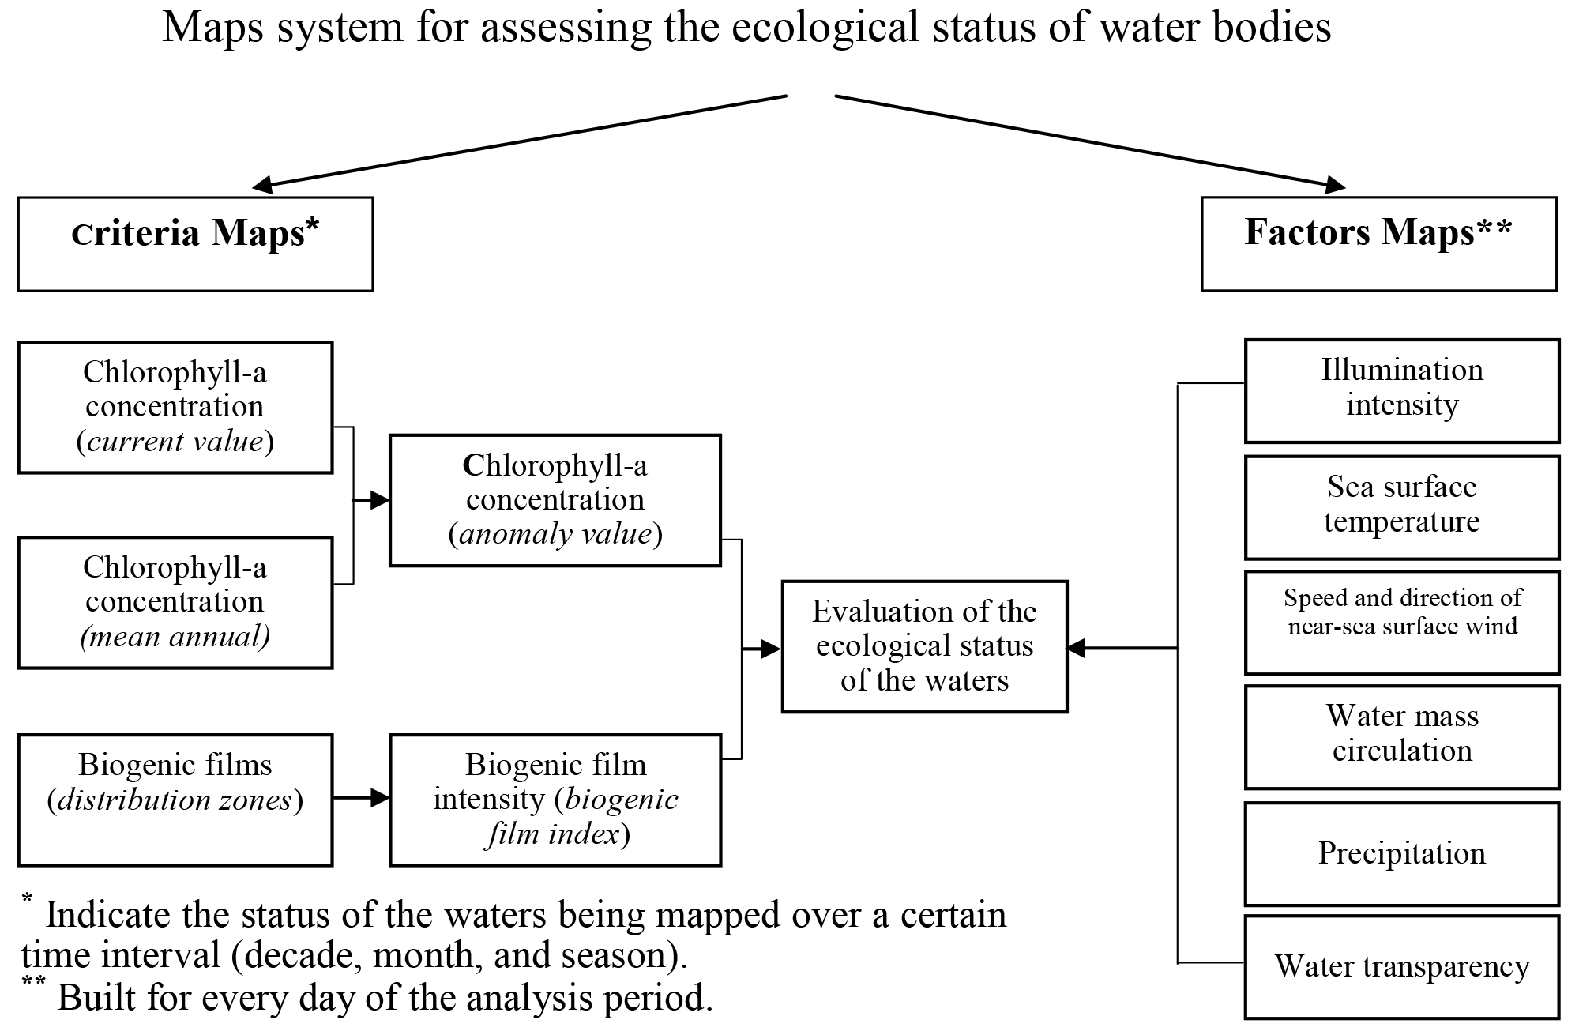
Figure 2. The maps system of the ecological status of water bodies.

Criteria Maps
Chlorophyll-a concentration maps. They show the distribution of current (averaged over a certain period) values of chlorophyll-a concentration. Homogenization of daily data has been done by calculating their medians. The choice of this averaging algorithm can minimize the contribution of the extreme values of the parameter, identifying the most characteristic ecosystems. Due to the fact that the distribution of values of chlorophyll concentration is subject to the log-normal law, a logarithmic scale has been chosen to be shown on the map. The values of chlorophyll-a concentration are determined from satellite data of optical scanners of the ocean color.
Chlorophyll-a anomaly concentration maps. They reflect the distribution of anomaly concentrations of chlorophyll-a; allow us to establish whether the current ecological condition is characteristic of the waters. The creation of the maps suggests preliminary construction of chlorophyll concentration-value distribution fields taken as the norm.
Defining standards is a complex methodological problem and approaches to solving it are dictate determined by the following features of waters:
• Uniqueness. Any ecosystem is unique in the character of geographical conditions and features of anthropogenic impact on it, and therefore, the level of biological productivity, taken as the norm; it is the parameter characterizing the particular ecosystem.
• Stage of development. A certain level of biological productivity corresponds to a particular status (the successional stage of the development) of the ecosystem community. At the initial stages of succession, primary production has several times the magnitude of the degradation processes, and the opposite is observed in mature communities [4].
• Seasonal cycle of development. The values of chlorophyll-a concentration, taken as the norm, should be determined according to the season of the year.
• Spatial heterogeneity. The values of chlorophyll-a concentration, taken as the norm, can be different even within the same water area, depending on the influence of several factors (proximity / distance from the coast, the circulation of water masses, and others.).
In accordance with these particularities, it is thought to be optimal to accept monthly mean annual values of chlorophyll-a concentration as its normal value. Then the anomaly of chlorophyll-a concentration can be estimated by calculating the deviations from the actual values of the mean annual.
Biogenic film distribution zone maps. They reflect the frequency of the spatial localization of biogenic organic films on the sea surface (for the time interval adopted for chlorophyll maps). Distribution zones of biogenic films are shown on the map by the method of quantitative background. The number of graduations of the scale corresponds to the frequency (the number) of film displays on the surface of the sea. The identification of biogenic films has been performed from radar data [1].
Biogenic film intensity maps (biogenic film index). The frequency of the spatial localization of biogenic origin films has been converted into the index of the intensity of the sea surface covering by nutrient films that is computed for each one-degree zone of waters by the formula proposed by the authors:
I = S _{films} / S _{zones} × n, where:
I is the index of biogenic films;
S _{films} is the distribution area of the films;
S _{zones} is a one-degree square area, 1 ° × 1 ° (binding to a regular grid);
n is the frequency of manifestation of biogenic films.
The resulting index (I) is converted into the system of points of the conditional quality class scale. The degree of the well-being of waters is shown on the map by hatching in the six grade scale scores. The zone with the minimum value of the index (I) is assigned a score of 1; with a maximum index - 5. The one-degree areas where the film is not recorded are assigned with a score of 0.
Waters ecological well-being assessment maps. The maps contain chlorophyll-a concentration anomalies and the frequency of the spatial localization of biogenic films (Figure 3). A joint analysis of two case stories that are based on two types of satellite data (optical and radar ones) allows us to differentiate the area surveyed by the severity of the environmental status and obtain a summary estimate of the status of the waters on the basis of the criteria selected.
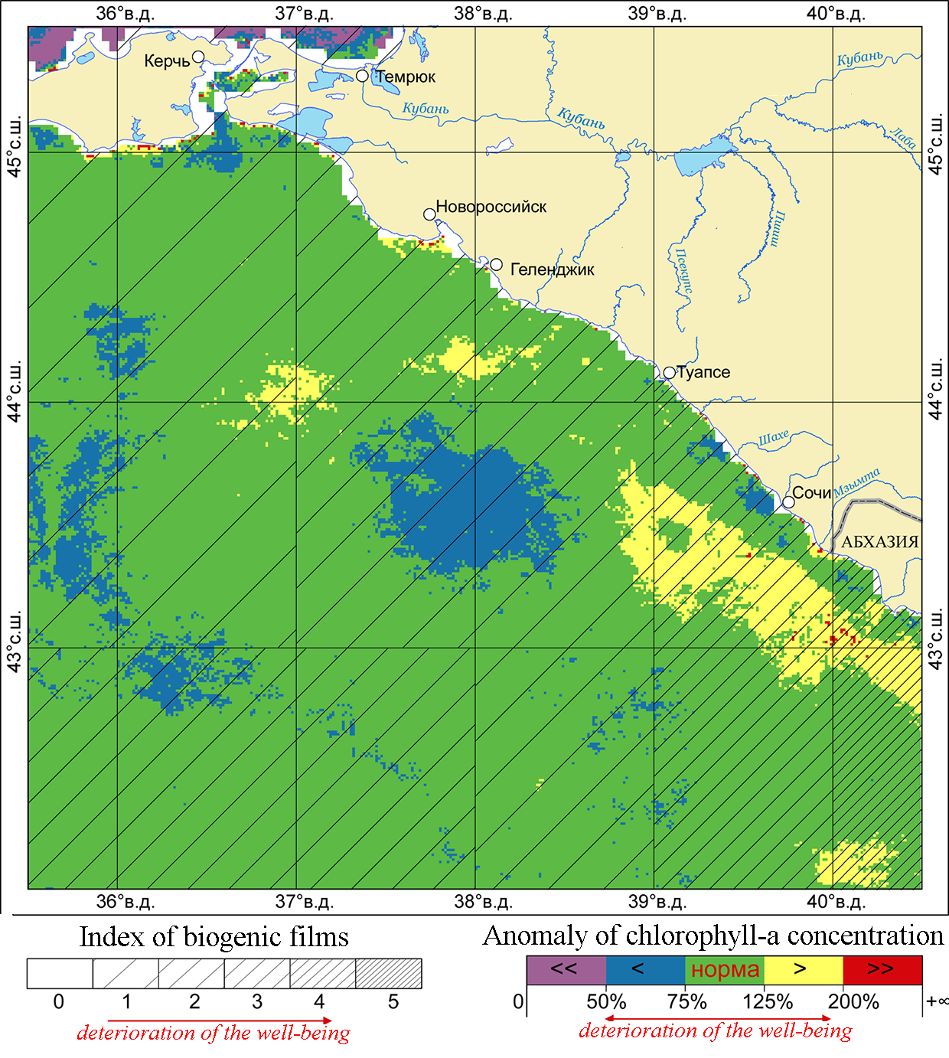
Figure 3. Assessment of ecological well-being (the Russian sector of the Black Sea, May, 2011).

Factors Maps
This group of maps is more diverse and represented by particular subjects, relevant to specific environmental factors. Factor maps account for analytical mapping, where the scientific ideas about the nature, the relationships and patterns of the phenomena and processes occurring in the waters are included. The presence of maps like these provides a necessary reference-and-factual basis for the analysis of the first group of maps. The dynamics of various phenomena on factor maps is revealed by creating a series of such maps recording certain periods or different stages of changes in the processes studied.
Illumination intensity maps. They reflect the distribution of the daily values of photosynthetically available radiation (PAR) – a parameter defined as the total flux of photons of light in the wavelength range from 400 nm to 700 nm, passing through the boundary between the ocean and atmosphere (its unit is an Einstein / m² / day). It is important to use the amount of radiation integrated per day rather than the instantaneous values of PAR, recorded at the time of observation. This is due to the fact that the level of biological waters efficiency depends not only on the intensity of PAR, but is also determined by the duration of the day. The source data for mapping have been satellite optical data in the visible range of the EMS.
Sea surface temperature maps. They represent the distribution of the daily values of the surface temperature (the unit is a degree Celsius), constructed from thermal infrared (IR) range data. To avoid accounting the day warm-up of the surface water there have been used SST data obtained during the night.
Maps of the near-sea surface wind. They describe the daily values of the velocity and direction of low winds over water (their units are m / s and degrees) derived from satellite scatterometer data.
Precipitation maps. They depict the distribution of the daily values of precipitation (its unit is mm / day) within the boundaries of the catchment to be mapped. The source of the information for building the map was the data of the Global Precipitation Climatology Project (GPCP) [6]. The intensity of rainfall in the framework of this project is estimated by combining different satellite data without the use of numerical models. The GPCP final product provides information on the global distribution of precipitation, obtained with a spatial resolution of 1° and a temporal resolution of 1 day.
Water transparency maps. They reveal a picture of the distribution of the daily values of diffuse attenuation coefficient of solar radiation – the parameter characterizing the degree of attenuation of solar radiation in the blue part of the spectrum (490 nm) as it penetrates deeper into the water masses and scattered by the particles contained in the water (its unit being m⁻¹) . Satellite optical data in the visible range of the EMS were used as initial information.
Water mass circulation maps. They show the peculiarities of the circulation of water masses – the system of currents of the oceans, the vortex formation of different scales, the locations of frontal zones, and others. Maps have been based on visual interpretation of optical images in the visible and thermal infrared ranges. The maps of low winds over water and altimetry data obtained by CCAR algorithms have been used as supporting information [5].
When designing the waters maps and their series, it is of essence to develop mathematical and general geographic bases that have their own specifics, which means they consider the processes taking place both in the area itself and in the adjacent land to view the features of the circulation of water masses and the flows of matter and energy. Of great importance is ensuring the comparability of the scale of the maps and the spatial resolution of the satellite images used.
General geographic framework is designed on the basis of the general geographic, bathymetric (GEBCO Digital Atlas) and nautical charts. Its required elements are the coastline; rivers, lakes, and reservoirs; isobaths and isohypses; settlements; state boundaries; shipping routes. These objects are of fundamental importance in environmental studies as indicate the sources of pollutants of the waters, including nutrients that determine the level of anthropogenic eutrophication of the ecosystem. General geographic framework is used to locate specific contents and at the same time, many of its elements are transformed at once into the thematic content. The bottom topography of a reservoir, affecting the development of biological processes, especially in the shelf zone, is an illustrative example of that.
The methods of map compilation and mapping tools used on the maps developed are in compliance with the essence, extent and depth of the knowledge of the phenomena displayed. In our case, the coverage and the distribution character of the majority of the phenomena and processes have allowed us to apply the continual display method for the continuous differential characteristics of the territory (from quantitative factors). The degree of differentiation, as well as the degree of generalization of the phenomena displayed are determined by the resolution of the original satellite data.

Methods of Cartographic Assessment of the
Ecological Status of Waters
The method proposed is based on the maps system developed that are integrated into a comprehensive cartographic assessment of the dominant (the criteria and factors) of the ecological status. The main raw materials for mapping are space data of different ranges of the spectrum – the visible, infrared and microwave ones. Remote sensing methods make it possible to deepen the cognitive map essence, promote operational research of nature, which is especially of importance in the study of the phenomena characterized by a high degree of dynamism in time. The basic steps for creating maps of ecological status are shown in Figure 4.
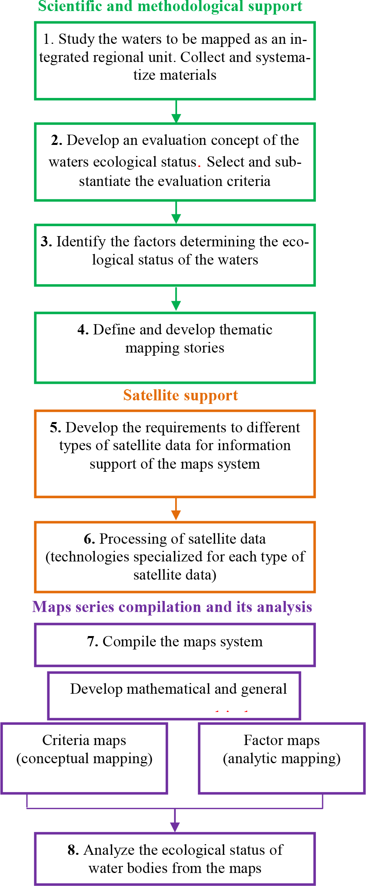
Figure 4. Methods of cartographic assessment of the ecological status of waters, using satellite data.

At the first stage of our methodology, we study the area to be mapped from a whole complex of sources. The stage involves not only the collection of raw materials on the object of the research, but also includes scientific generalization and systematization of the data, which provides a comprehensive study of the water area as an integrated regional unit, identification of its unique properties and characteristic (typical) features.
The second and third stages are set out in the consideration of the concept of the research, evaluation criteria, and environmental factors that affect the ecological condition. Further steps are based on the processing of information by a technology specialized for each type of satellite data. The following software products have been used: SeaDAS 6.4 – a package for processing data received from optical scanners of the ocean color; ITT Envi 4.8 and ESRI ArcGIS 9.3, as well as FORTRAN-programs.
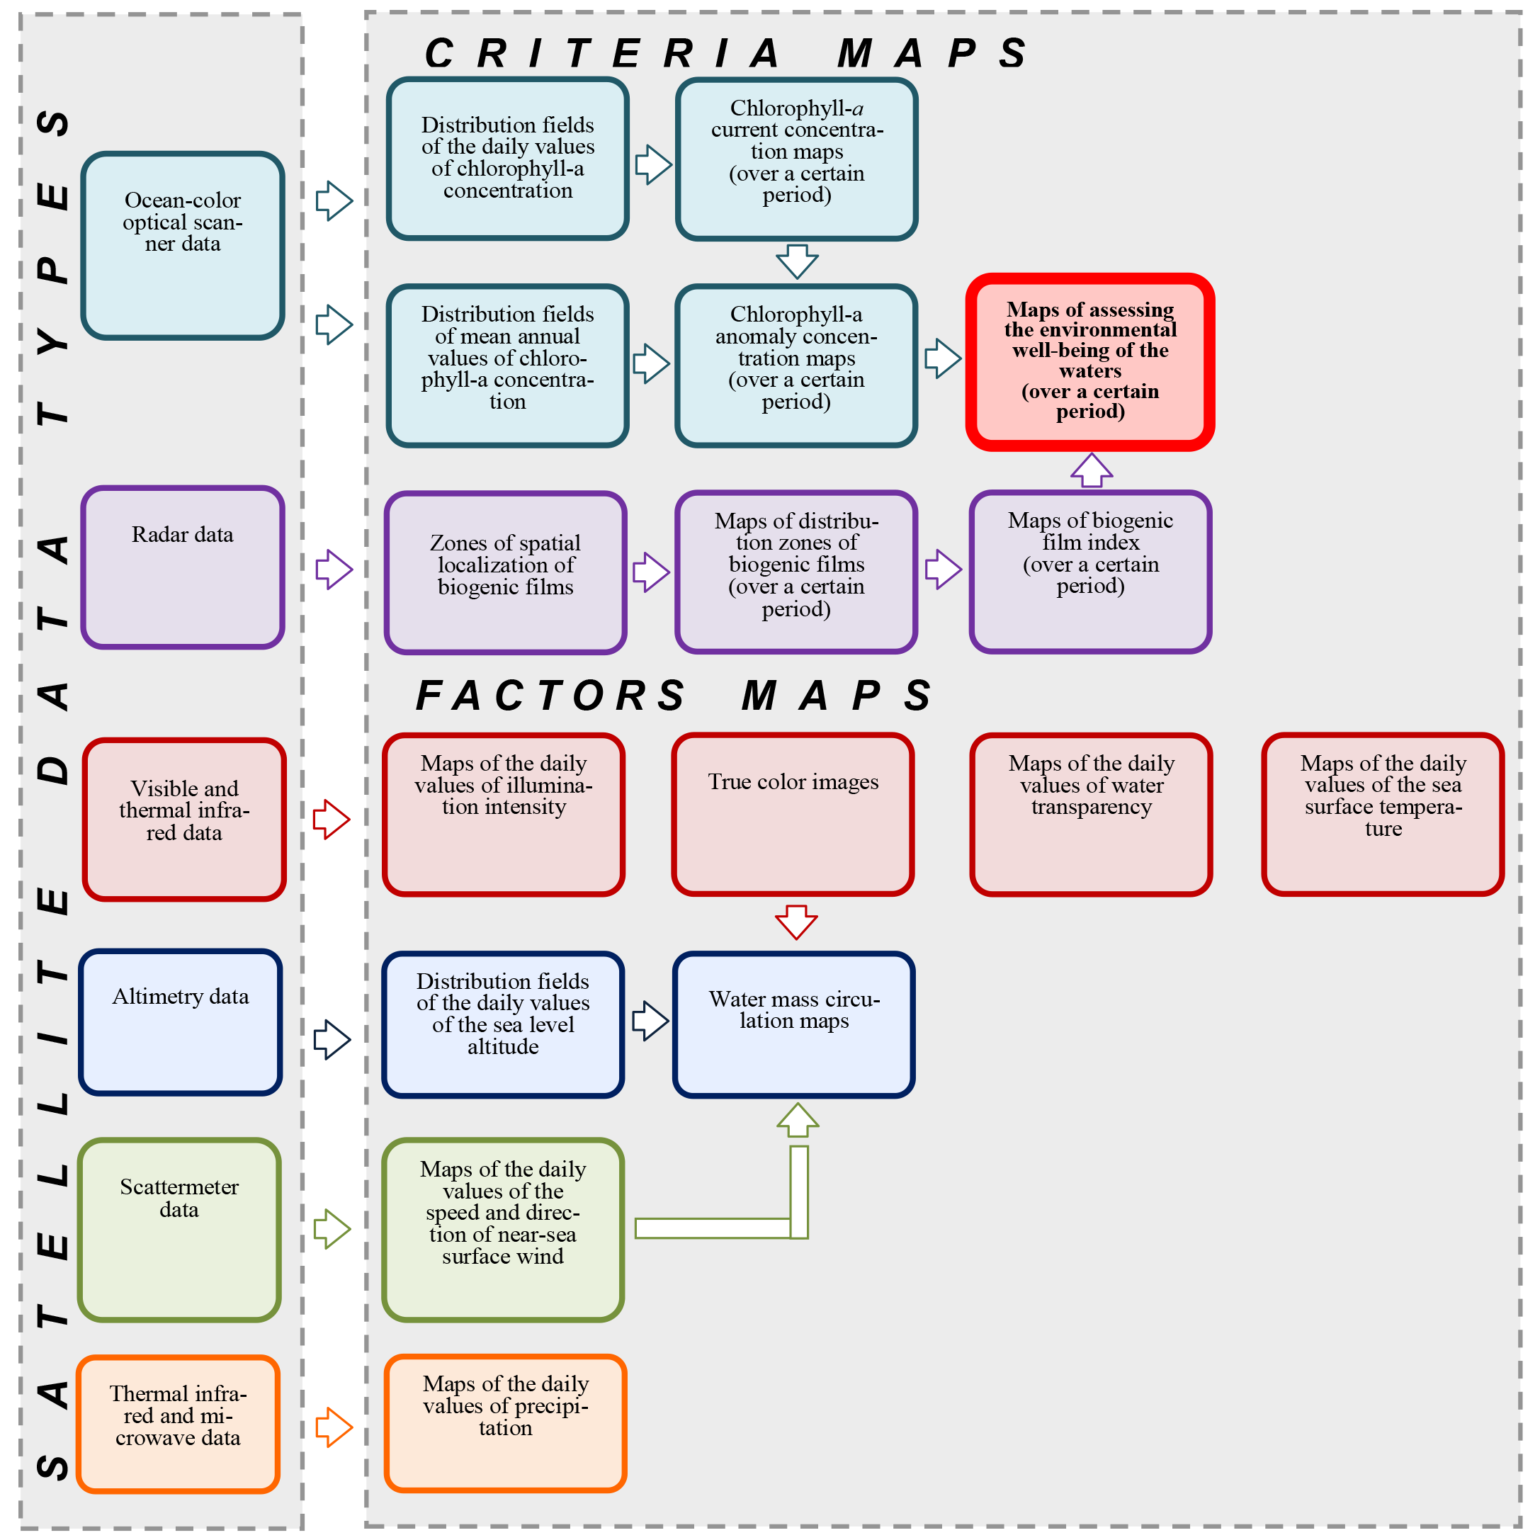
Satellite data used to construct maps of the series, as well as the steps in their creation are shown by the functional flow diagram developed (Figure 5).
Figure 5. Functional flow chart drawing of maps based on satellite data.

At the final stage of the procedure, a dual map series analysis is done applying the methods of geoinformation mapping providing spatial adjustment of data in the required combinations.

Conclusion
Criteria maps allow us to estimate the degree of well-being (distress) of the ecological status of the waters, while factor maps act as an essential analytical basis for the interpretation of criteria maps and permit us to "discover" the causes of recorded anomalies.
References
Vereshchaka T.V., Andreeva Z.V. (2012) Research into areas of ecologically troubled waters from radar images // Geodesiya I Kartographiya. – 2012. – No 2. – P. 15-25.
Vereshchaka A.L., Malinnikov V.A. (2005) Fundamentals of ecology of the ocean. – M .: ed. by MIIGAiK, 2005. – 239 pp.
Zarutskaya I.P, Krasil'nikova N.V. (1989) Designing and Mapping. Maps of Nature: A Textbook. – M .: Publishing House of Moscow State University, 1989. – 296 pp.
Oceanology. Ocean Biology, ed. by Vinogradov M.E. (1997) – Vol. 1, 2. – M .: Nauka, 1977.
Colorado Center for Astrodynamics Research (CCAR) Official website – http://eddy.colorado.edu/ccar/data_viewer/info.
Official website of the Global Precipitation Climatology Project (GPCP) – http://precip.gsfc.nasa.gov.

* It is important for assessment of the ecological status to know the degree of the deviation values of chlorophyll-a concentration from the values characteristic (typical) for the ecosystem studied rather than the absolute values of its concentration.

