The spatiotemporal evolution (1975-2010) of the mobile barchan dune fields in the Jericoacoara National Park, Brazil, derived from Landsat and Quickbird satellite images
Antonio Jeovah de Andrade Meireles*, Narcélio de Sá Pereira Filho*, Adryane Gorayeb*, Jocicléa de Sousa Mendes*
* Dept. of Geography, Federal University of Ceará, Brazil
Abstract. Coastal dunes play an important role in the sediment transport of the coastal zone. The unique morphology of the Jericoacoara National Park in the northeastern Brazilian state of Ceará consists of a promontory covered by a mobile dune field consisting of large, horseshoe-shaped mobile barchan dune fields, that migrate from east to west. These dunes are responsible for the bypass and transportation of the sediments essential for the maintenance of the coastline. The present study focused on the morphodynamic evolution of these isolated mobile dunes through the recovery of multitemporal Landsat and Quickbird satellite images from the years between 1975 and 2010. The spatiotemporal analysis of the distribution and morphology of these dunes over this 35-year period revealed significant shifts in their area, perimeter, and movement patterns. It was possible to confirm that the flow of material and energy was linked to a process of continuous migration in the direction of the beach (sediment bypassing sector). The dynamics of the dune migration in the years following 2000, when the national park was established, indicate possible impacts on the morphology of the dunes resulting from the increase in tourism within the area. These changes were most significant between 2001 and 2005, possibly reflecting a greater influx of tourists and thus more intense anthropogenic impacts. The different geoprocessing techniques applied to the mapping of the morphodynamic evolution of the dune field of the Jericoacoara National Park proved to be an essential tool for the production of information that will guarantee the long-term environmental planning of this integral conservation unit.
Keywords: Space-time analysis, Geography and geospatial information science, Mobile barchan dune fields, Geostatistics,
- Introduction
Coastal dunes are morphological features derived from complex interactions between topography, vegetation, sediment sources, climatic conditions, and eolian processes, as well as the influence of human activities. Understanding the origin and quaternary evolution of these features requires the systematic analysis of a complex set of environmental and socio-economic elements. Coastal dunes are also important in integrated approaches to the analysis of coastal landscapes, principally with regard to the habitats and sediments they provide, which contribute to the control of coastal erosion ANDREWS; GARES; COLBY, 2002; MONTREWIL; BULLARD, 2011; IPCC, 2007; MEIRELES, 2011).
Barchan dunes have been the subject of numerous studies around the world, and are the best-known type of dune. The half-moon shape of these dunes is derived from a combination of continuous wind action in the same direction over the course of the year and if there is not enough sand to cover the entire surface (HERMANN; SAUERMANN; SCHWAMMLE, 2005). The movement of these dunes is proportional to wind speeds and inversely proportion to their height (HERMANN; SAUERMANN; SCHWAMMLE, 2005, JIMENEZ, 1999; LIMA; SAUERMANN, 2002).
A number of studies have focused on different aspects of barchan dunes, such as their genesis, evolution, dynamics, and geomorphology SAUERMANN, 2003; PARTELI et al, 2014; HERMANN et al, 2005; LIMA, SAUERMANN, 2002, HERMANN; SAUERMANN; SCHWAMMLE, 2005), although few data are available on long-term patterns. Most of the available studies on the dynamics of dune morphology have focused on short- to medium-term periods HESP, 2013; AL-MOSRAHY; MOURTNEY, 2013; BISHOP, 2010, CABRERA-VEGA, 2013; YIZHAQ et al, 2013).
Recent technological advances permit ever more detailed analyses of coastal systems, in particular dune fields and their morphological diversity. The multitemporal coverage of high-resolution satellite images provides new insights into the behavior of dune fields in relation to their distribution, as well as precise measurements of the movements of mobile dunes ANDREWS; GARES; COLBY, 2002; MONTREWIL; BULLARD, 2011). The advent of Geographic Information Systems (GIS) provided the potential for a range of analytic approaches, which have been amplified and perfected over the years through technological improvements in the computing hardware and GIS software (AL-MOSRAHY; MOUNTNEY, 2013).
This study presents a 35-year history (1975-2010) of the evolution of a barchan dune field based on the multitemporal recovery of a series of medium- and high resolution satellite images (Landsat and Quickbird) covering the Jericoacoara National Park in Ceará, Brazil. The objective was to describe and quantify the morphodynamic changes that occurred in the dunes over the course of this period, evaluate changes in morphology (area, perimeter, and shape), and movement patterns (evolution of the mobile dunes). It was also possible to characterize the dynamics of the local environment in relation to the modifications caused by the impacts of the ongoing increase in tourism-related activities in the region.
- Study area
The state of Ceará, located in northeastern Brazil, has a coastline of approximately 572 km consisting predominantly of extensive sandy beaches interrupted primarily by small estuaries and rocky points. Extensive fixed and mobile dune fields are found along the whole of this coast.
The study area is located on the coastal plain of Jericoacoara in the northern extreme of the state, which includes parts of the municipalities of Jijoca de Jericoacoara, Cruz, and Camocim, approximately 300 km west of the state capital, Fortaleza. The area includes most of the Jericoacoara National Park, an integral protection conservation unit established on February 4th, 2002, with a total area of 8416.08 ha (Figure 1).
The principal features of this environment are dunes, lagoons and coastal lakes, estuaries, mangrove forests and paleo-mangrove (muddy beaches), tidal channels, marine terraces, promontories, abrasion shelves, pre-coastal plateaus, and rocky and sandy beaches. These morphological components indicate the occurrence of eustatic events, reflecting the interaction of mainland-oceanic-atmospheric processes in the formation of the coastal plain. Together with fluctuations in climate and relative sea level, dynamic processes can be discerned in relation to sediment transport by wind action, estuarine hydrodynamics, seasonal fluctuations in groundwater levels, landslides and slips on the slopes of the Jericoacoara Ridge, as well as waves and tides (MEIRELES, 2011). The present study includes a short analysis of local socio-economic and cultural activities related to tourism, fisheries, and subsistence agriculture. These data were used to evaluate possible anthropogenic influences on the speed and direction of dune migration.
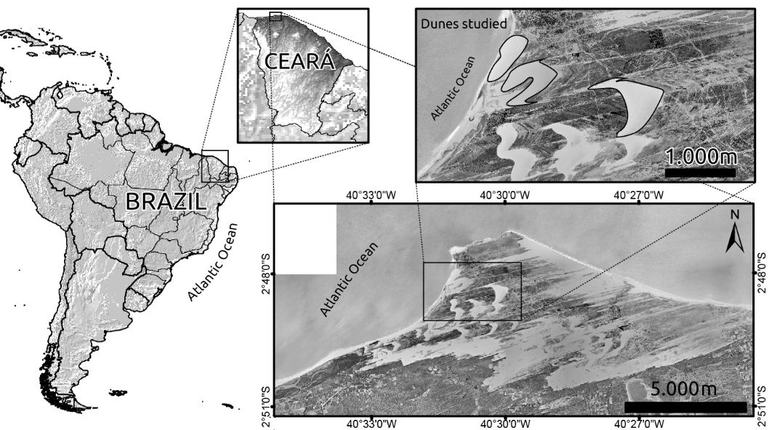
Figure 1. Location of the study area in Ceará, northeastern Brazil.
  - CLIMATIC CHARACTERISTICS
The coastal plain of Jericoacoara is characterized by a set of morphological units related directly to local and regional climate patterns. Wind action, seasonal rainfall fluctuations, and intense solar radiation, all contribute to the dynamics of sediment transport, the formation of coastal lakes, and the ecological configuration of the fauna and flora of the national park.
The winds of this region are influenced by a marked annual climate cycle, related to seasonal fluctuations in the position of the Intertropical Convergence Zone (ITCZ), which are determined by the confluence of the northeasterly and southeasterly trade winds, resulting in intense cloud cover and low atmospheric pressure (PHILANDER; PACANOWSKI, 1986).
The annual variation in rainfall levels is determined by seasonal shifts in the location of the ITCZ, the principal synoptic system determining precipitation patterns in the region, which provokes intense rains during part of the year, depending on its position. While there is some variation, these rains normally fall during the first half of the year, principally between March and May (BRANDÃO, 1995).
Mean annual precipitation in the region is approximately 823.8 mm (IPECE, 2010), with a rainy season concentrated into a five month period, which normally begins in February, reaching its highest monthly levels in March and April. Rainfall tends to decrease from July and remains low until November (Figure 2). Typically, 90% of annual precipitation is recorded during the first half of the year (ZANELLA, 2005).
The wind is an important component of the natural dynamics of coastal landscapes, and plays an important role in the composition of local morphology, principally in relation to the migration of dune fields and the input of sand for the eolian abrasion plain. The prevailing winds on this coastal plain blow from the SE, ESE, E, and NE. Mean wind speeds may exceed 4 m/s during the dry season (second half of the year). During the rainy season, with the arrival of the ITCZ, the prevailing winds move direction, blowing predominantly from the northeast, During the dry season, the winds tend to be more intense, blowing from the southeast.
The integration of rainfall levels, wind speeds, and sunlight intensity provides an important index for the analysis of the morphogenetic dynamics of the coastal plain located within the study area. During the first half of the year, increased rainfall levels are accompanied by a reduction in wind speeds and a reduced incidence of solar radiation. During the second half of the year, reduced rainfall is reflected in increased wind speeds and more intense sunlight. This combination of factors contributes to the more effective displacement of the dunes during the second half of the years, together with a reduction of the hydrostatic level of the water table, and as a consequence, the number of lakes on the coastal plain.

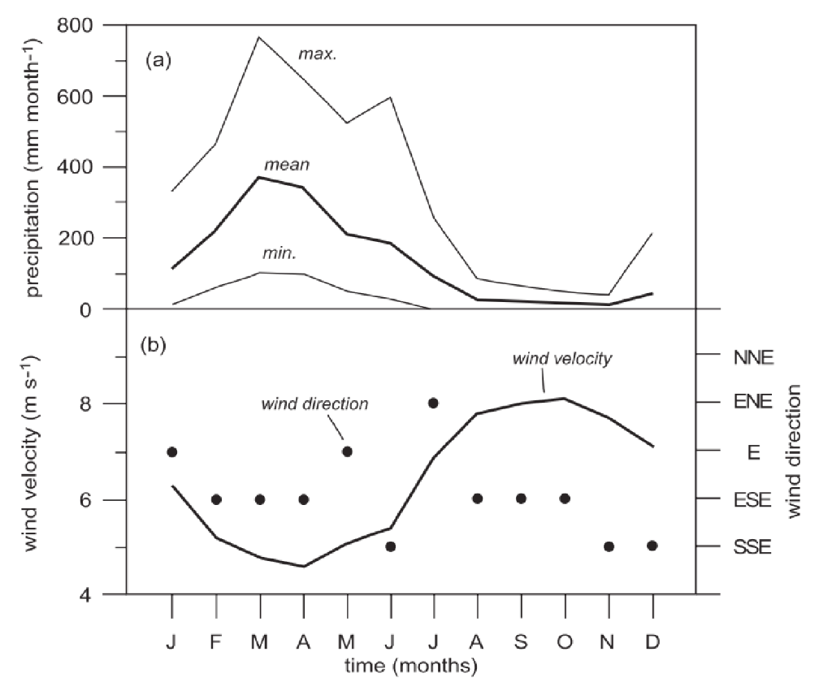
Figure 2. (a) Monthly variation in mean (minimum-maximum) precipitation in the study area. (b) Monthly variation in wind direction and velocity (from Jimenez et al., 1999).
- Material and Methods
Satellite images, GPS stations, and geoprocessing techniques were used to obtain data on the morphodynamic evolution of the dunes of the study area. The migration of the dunes located in the study area was estimated based on the analysis of a series of satellite images obtained between 1975 and 2010. Three individual dunes were identified from the set of images for analysis. The migration of these dunes was measured based on the configuration of a set of points located around the perimeter of the dunes in each year, which permitted the measurement of the displacement of the dune, a procedure used successfully in previous studies of the same area (JIMENEZ, 1999).
  - Satellite images
A total of 20 medium- and high resolution satellite images of the study dunes were obtained for the 35-year period between 1975 and 2010. The Landsat images were acquired from the DGI/INPE collection (www.dgi.inpe.br/siteDgi/index_pt.php), which is available online in the TIF format. The images obtained referred to scene 234/062 of the Landsat 1-MSS satellite for 1975, Landsat 2-MSS (for 1979,1980, and 1981), and scene 218/62 of the Landsat 5-TM (for 1985, 1987, 1991, 1992, 1993, 1994,1999, 2000, 2001, 2002, 2006, 2007, 2008, and 2010) and Landsat 7-ETM+, as well as a Quickbird image from 2005 (Table 1). The morphological components of the coastal plain were defined using an SRTM radar image obtained from the National Aeronautics and Space Administration (NASA).

Date | Satellite | Sensor | Bands | Resolution | Composition
26/05/1975 | Landsat | MSS | 4, 5, 6,7 | 80 m | 5R, 4G, 6B
07/07/1979 | Landsat | MSS | 4, 5, 6,7 | 80 m | 5R, 4G, 6B
06/08/1980 | Landsat | MSS | 4, 5, 6,7 | 80 m | 5R, 4G, 6B
07/14/1981 | Landsat | MSS | 4, 5, 6,7 | 80 m | 5R, 4G, 6B
27/07/1985 | Landsat | TM | 1, 2, 3, 4, 5, 6,7 | 30 m | 5R, 4G, 3B
17/07/1987 | Landsat | TM | 1, 2, 3, 4, 5, 6,7 | 30 m | 5R, 4G, 3B
10/06/1991 | Landsat | TM | 1, 2, 3, 4, 5, 6,7 | 30 m | 5R, 4G, 3B
31/08/1992 | Landsat | TM | 1, 2, 3, 4, 5, 6,7 | 30 m | 5R, 4G, 3B
10/06/1993 | Landsat | TM | 1, 2, 3, 4, 5, 6,7 | 30 m | 5R, 4G, 3B
10/06/1994 | Landsat | TM | 1, 2, 3, 4, 5, 6,7 | 30 m | 5R, 4G, 3B
10/06/1999 | Landsat | TM | 1, 2, 3, 4, 5, 6,7 | 30 m | 5R, 4G, 3B
Geocover Nasa | Landsat | ETM+ | 1, 2, 3, 4, 5, 6, 7, PAN | 15 m | 2R, 4G, 7B + PAN
19/08/2000 | Landsat | ETM+ | 1, 2, 3, 4, 5, 6, 7, PAN | 15 m | 5R, 4G, 3B + PAN
01/09/2001 | Landsat | ETM+ | 1, 2, 3, 4, 5, 6, 7, PAN | 15 m | 5R, 4G, 3B + PAN
19/08/2002 | Landsat | TM | 1, 2, 3, 4, 5, 6,7 | 30 m | 5R, 4G, 3B
2005 | QuickBird |  |  | 0.70 m
22/06/2006 | Landsat | TM | 1, 2, 3, 4, 5, 6,7 | 30 m | 5R, 4G, 3B
25/08/2007 | Landsat | TM | 1, 2, 3, 4, 5, 6,7 | 30 m | 5R, 4G, 3B
12/09/2008 | Landsat | TM | 1, 2, 3, 4, 5, 6,7 | 30 m | 5R, 4G, 3B
30/09/2010 | Landsat | TM | 1, 2, 3, 4, 5, 6,7 | 30 m | 5R, 4G, 3B
Table 1. Satellite images used for the extraction of spatial data and the definition of the displacement of the dune fields on the Jericoacoara coastal plain.
All the images were georeferenced and treated in ENVI 4.7, based on the UTM (Universal Transverso de Mercator) cartographic projection, with the WGS-84 Datum. Georeferencing was based on the mosaic of Landsat ETM+ images for 2000, available in NASA’s Geocover program. The precision of the existing georeferencing was defined using GPS stations. In the case of the high-resolution Quickbrid images, precise geographic information was extracted using Navstar GPS geodesic receivers, with a nominal precision of 5 mm + 1 ppm. The data were processed in the maker’s software. Ground support for the determination of the planialtimetric coordinates used for georeferencing and the generation of contours, were obtained from the Ceará state GPS reference station in the town of Sobral, 100 kilometers to the south. The points were tracked using the cinematic method, with a 5 second recording interval. The “bar” method was used for initialization, as recommended by the maker, with single frequency receptors.
The composite, georeferenced images permitted the creation of overlapping images in a GIS environment in the QGIS software. The images were superimposed for the definition of dune displacement patterns, and using the transparency resource, it was possible to compare the morphological alterations that occurred during the migration process. These data were digitalized in the form of vector shapefiles and processed using geoprocessing techniques for the calculation of the area and perimeter of each dune during each phase of the study period.
- Results
The initial results included the spatial distribution of the different geo-environmental components of the study dunes. Based on a spatiotemporal comparison of the dune morphology between 1975 and 2010, significant changes were found in the area, perimeter, and movement patterns of all the dunes. It was possible to confirm the constant flow of material and energy linked to the continuous migration of the dunes in the direction of the beach (sediment bypassing sector). A general tendency for a reduction in the area of the dunes and frequent and complex alterations of their perimeters were observed, principally in the areas closest to the urban environment of the main village and Jericoacoara Ridge.
The Por-do-Sol dune (PdS), which had a mean area of 198,472 m² between 2005 and 2010, decreased in size by approximately 18,500 m², related to the constant deficit of sediments that occurred during its movement. This was related to the fact that the dune was moving over the promontory and had reached the beach bypass sector, where the sediments become transported by wave, rather than wind forces, in the early 1990s. During this period, the perimeter was consistently of the order of 3331 m. In recent years, the perimeter has tended to expand due to the increasing complexity of the dune’s shape, which may be related to the alteration in the dynamics of sediment transport occurring since the dune reached the edge of the beach (avalanche slope in contact with the waves) and the interference in wind dynamics caused by the physical barrier of Jericoacoara Ridge.
During the same period, the decrease in the area of the Papai Noel dune (PN), which covered a mean of 380,562 m², was of the order of 61,100 m². Simultaneously, there was a reduction in the perimeter of the order of 663 m (with a tendency to maintain the barchan morphology). In recent years, possibly since 2001, the perimeter has remained relatively constant, with a mean of 3373 m.
During the study period (1975-2010), the Arraia dune decreased in area by approximately 71,545.5 m². During this same period, it was possible to identify an increase in the perimeter of the dune of the order of only 193.5 m (lowest value), reflecting its more compact shape, despite the fact that it was the largest of the dunes studied here, with a mean area of approximately 419,050 m².
The reduction in the area of the dunes analyzed in the present study may have been associated with the dispersal of sediments by the action of winds and waves, principally in the case of PdS. While winds provoke the displacement of the dunes, they also remove sand from the body of the dune (effects of the transport of suspended sand by winds of higher speed), principally during the second half of the year, when mean speeds may reach 8 m/s (ANNEL, 2003, 2006) and rainfall is negligible.
The PdS dune moved 12 m per year, on average, to the south of Jericoacoara Ridge between 1975 and 2010, with an overall displacement of approximately 350 m. Between 2005 and 2010, however, total displacement was only 50 m, with a mean of 10 m per year (see Figure 3). The PN dune migrated more rapidly than PdS, with a mean displacement of 16 m per year, for a total of 470 m over the study period. By contrast with PdS, this dune migrated more rapidly over the last 5 years of the study period, moving 22 m per year, for a total of 110 m (Figure 4).

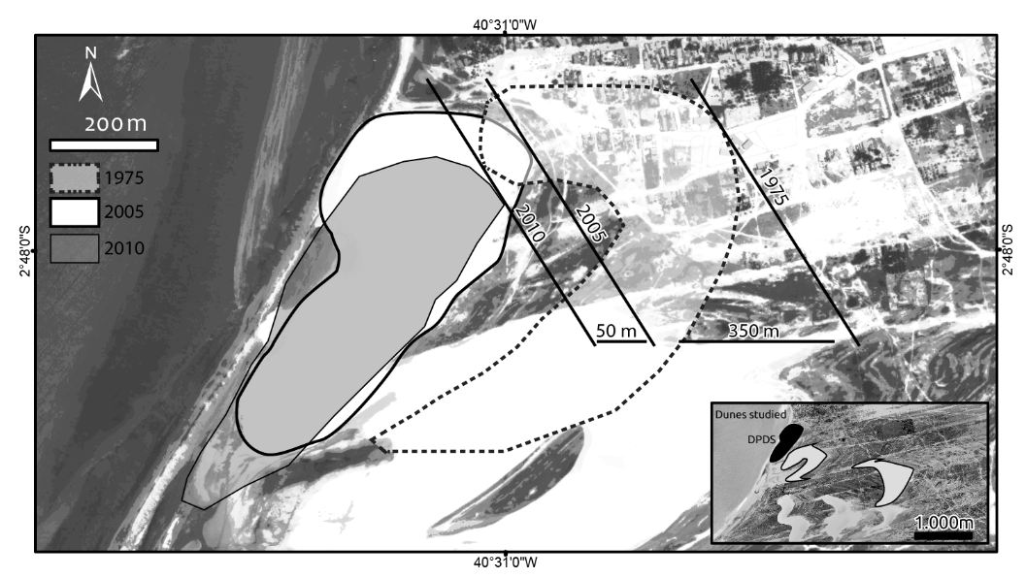
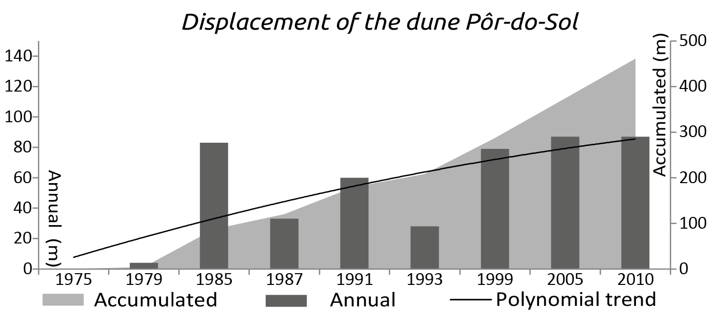
Figure 3. Displacement of the Por-do-Sol dune based on the 2005 Quickbird image and tendency curve plotted for the study period.
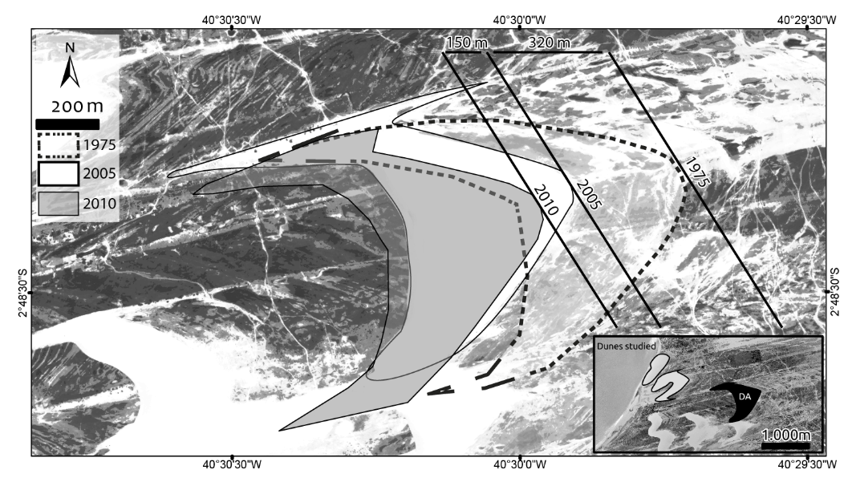
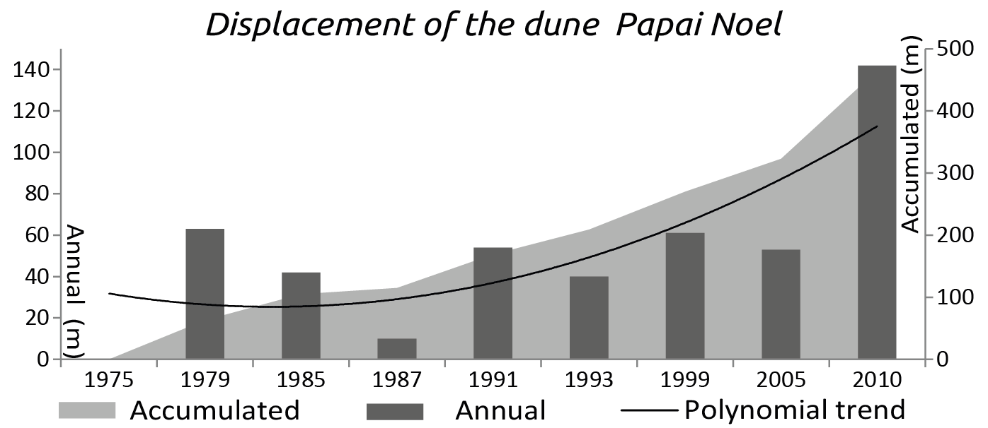
Figure 4. Displacement of the Papai Noel dune based on the 2005 Quickbird image and tendency curve plotted for the study period.
The Arraia dune moved over the Jericoacoara Promontory to the southeast of the other dunes and, like these dunes, presented a distinct pattern of displacement over the last 5 years of the study period, with a mean displacement of 30 m per year (total of 150 m), the fastest speed recorded for any of the dunes. During earlier years, this dune migrated more slowly, however, with a mean of only 10.6 m per year, and a total for the 35 years of the study period of only 320 m. (Figure 5) Overall, the data indicate that the size of the dune does not have a direct influence on its displacement velocity.

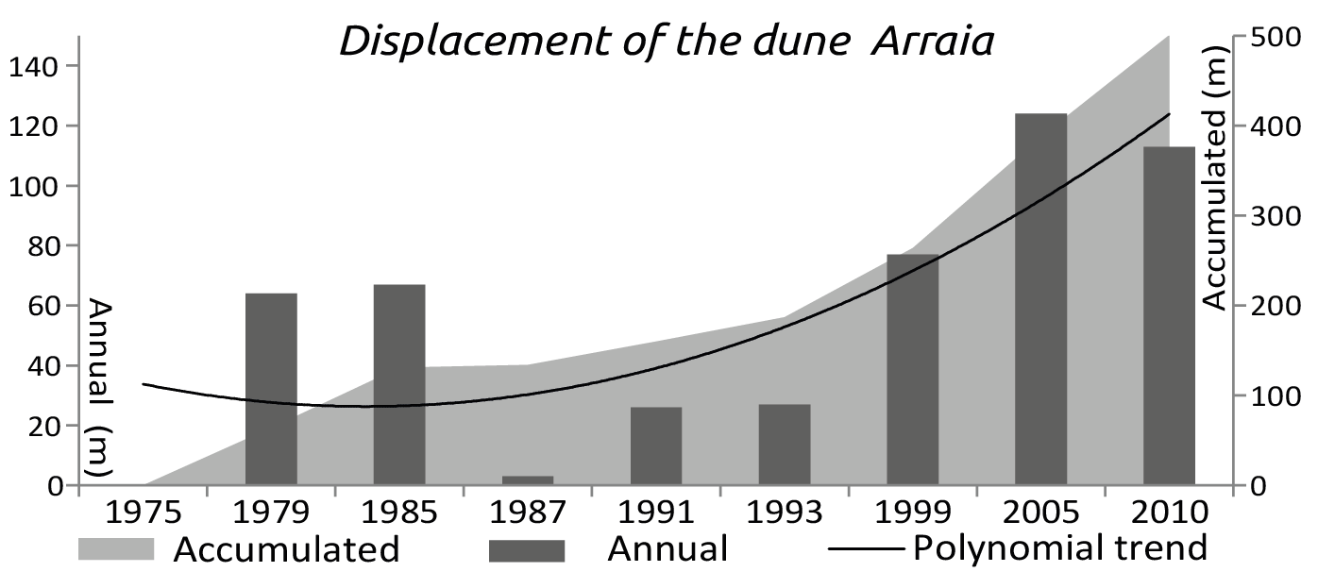
Figure 5. Displacement of the Arraia dune based on the 2005 Quickbird image and tendency curve plotted for the study period.
It seems likely that the increase in tourism within the study area, principally following the establishment of the national park (that is, from 2000 onwards), led to an increase in the numbers of visitors to the PdS dune, which attracts large numbers of tourists at the end of each day, who climb up to the top of the avalanche slope of the dune to watch the sunset. An increase in the process of gravity-induced sediment slide can be observed when visitors descend the dune, provoking significant alterations in its morphology.
The results presented here on the area, perimeter, and displacement speed of the study dunes are the first long-term data on these phenomena based on the analysis of satellite images. The observed tendency of increased displacement speed during the last 5 years of the study period may be related to the ongoing growth in the influx of tourists (MEIRELES, 2011). In addition to a considerable increase in the numbers of tourists, growing numbers of all-terrain vehicles have been transiting through the area of the national park (MEIRELES; SILVA; THIERS, 2006; MEIRELES, etal, 2013; ANNEL, 2003, 2006).
The systematic analysis of the data on mean wind velocities and climatic variation presented here may provide the basis for the identification of regional or global patterns, such as those identified by the IPCC (IPCC, 2007). The promontory (Jericoacoara Ridge) has a clear effect on wind dynamics and sediment transport and, in turn, the speed of dune displacement. The dunes closest to the beach and the ridge move the slowest (Figure 6). It is important to note that abrupt changes in the type of coast (promontory, cliffs, deltas, for example) and its outline, may cause marked changes in the configuration of local waves and winds, imposing a specific pattern of sediment transport on this stretch of the littoral, originating longitudinal sandbars, banks, and sandy spits in the fore- and backshores, interfering in the eolian transport of the sand. These morphological features and the action of the waves and tides were studied in detail by (MCLACHLAN; BURNS, 1992; CARTER; HESP; NODSTRON, 1997).
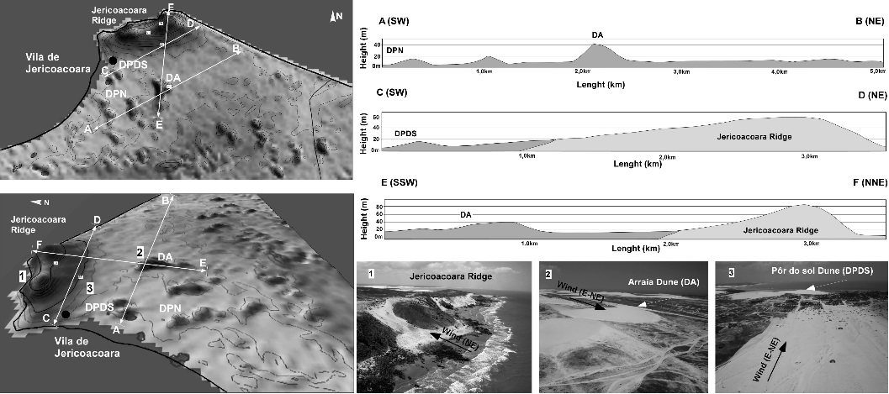
Figure 6. Morphological features of the study area and their influence on the dynamics of the local barchan dunes.
- Conclusion
The application of geoprocessing techniques for the mapping of the morphodynamic evolution of the dune field of the Jericoacoara National Park provided an essential tool for the production of diagnostic guidelines for the ongoing planning of the park’s environmental management. In particular, the spatial dynamics and evolution of the displacement of the local mobile dunes were configured.
The environmental components of the coastal morphological features related to the sediment bypass sectors linked to the beach were diagnosed and characterized. The comparison of satellite images obtained between 1975 and 2010 permitted the identification of significant changes in the physiographic features - area and perimeter - of the local dunes. These changes were more prominent in the period between 2001 and 2005, which may be related to an increase in anthropogenic impacts (numbers of tourists). These impacts included an increase in the traffic of all-terrain vehicles, and the appearance of random trails leading to the village of Jericoacoara, the degradation of sediment-anchoring vegetation, compaction of the soil, reactivation of sediment transport, and larger numbers of visitors walking on the mobile dunes, in particular the Por-do-Sol dune.
The results of this study reinforce the need for a more detailed investigation, including the definition of sectorial shifts in seawater temperatures related to the long-distance continent-ocean-atmosphere connections with higher latitudes (BROECKER, 2001). The dunes of Jericoacoara, related to the evidence of high-frequency changes in relative sea levels, may be linked to the abrupt and cyclical alterations in the temperature of the oceans, superimposed by higher orbital cycles, such as the Dansgaard-Oeschger cycles and Younger Dryas cooling event (CACHO et al., 1999; montrewil; bullard, 2011).
Overall, the results of this study provide important insights into coastal dynamics and the impacts on these processes provoked by an increase in tourism activities. Given this, further studies of the regional and global meteorological processes related to this dynamics will be important for the understanding of the influence of climatic changes on the evolution of coastal dunes. These data will be fundamental to the effective monitoring of the evolution of the dunes of the study area, through the multitemporal analysis of satellite images.
Literature Cited
A. Hesp, P (2013) Conceptual models of the evolution of transgressive dune field systems. Geomorphology 199:138–149
Al-Masrahy, MA, Mountney, NP (2013) Remote sensing of spatial variability in aeolian dune and interdune morphology in the Rub’ Al-Khali, Saudi Arabia. Aeolian Research 11:155–170
Andrews, B, Gares, PA, Colby, JD (2002) Techniques for GIS modeling of coastal dunes. Geomorphology 48(1-3):289–308
Bishop, MA (2010) Nearest neighbor analysis of mega-barchanoid dunes, Ar Rub’ al Khali, sand sea: The application of geographical indices to the understanding of dune field self-organization, maturity and environmental change. Geomorphology 120(3-4):186–194
Brandão, RL (1995) Diagnóstico Geoambiental e os principais problemas de ocupação do meio físico da região metropolitana de Fortaleza. Fortaleza: CPRM
Broecker, WS (2001) Was the medieval warm period global? Science 291:1497-1499
Cabrera-Vega, L (2013) Morphological changes in dunes as an indicator of anthropogenic interferences in arid dune fields. Journal of Coastal Research 65:1271–1276
Cacho, I, Grimalt, JO, Pelejero, C, Canals, M, Sierro, FJ, Flores, JA, Shack- Leton, NJ (1999) Dansgaard-Oeschger and Heinrich event imprints in Alboran Sea temperatures. Paleoceano- graphy 14:698-705.
Carter, RWG, Hesp, PA, Nodstrom, KF (1997) Erosional lanforms in coastal dunes. Ed. by Nords- trom, K.F.; Psuty, N. & Carter. Bill. Coastal dune – from and process 217- 250
Herrmann, HJ et al. (2005) Calculation of the separation streamlines of barchans and tranverse dunes. Physica A: Statistical Mechanics and its Applications 357(1):44–49
Herrmann, HJ, Sauermann, G, Schwämmle, V (2005) The morphology of dunes. Physica A: Statistical Mechanics and its Applications 358(1):30–38
IPCC, 2007: Climate Change 2007: The Physical Science Basis. Contribution of Working Group I to the Fourth Assessment Report of the Intergovernmental Panel on Climate Change [Solomon, S., D. Qin, M. Manning, Z, Chen, M, Marquis, KB, Averyt, MT, Miller, HL (eds.)] Cambridge University Press, Cambridge, United Kingdom and New York, NY, USA
IPECE (2010) Instituto de Pesquisa e Estratégia Econômica do Ceará. Perfil básico municipal - Jijoca de Jericoacoara
Jimenez, J. et al. (1999) Aeolian dune migration along the Ceará coast, north‐eastern Brazil. Sedimentology
Lima, A, Sauermann, G (2002) Modelling a dune field. Physica A: Statistical 310:487–500
Mclachlan, A, BURNS, M (1992) Headland bypass dunes on the South African coast: 100 yars of (mis)management. Coastal dunes, Carter, Curtis & Sheehy-Skeffington (eds); Belkema, Rotterdam 71-79
Meireles, AJA (2011) Geodinâmica dos campos de dunas móveis de Jericoacoara/Ce-Br. Revista Mercator 10(22):169–190
Montreuil, A, Bullard, J (2011) Meso-scale Coastal Dune Evolution along the North Lincolnshire coast, UK. Journal of Coastal Research 64
Moreno, A, Cacho, I, Canals, M, Prins, MA, Sánchez-Goñi, MF, Grimalt, JO, Weltje, GJ(2002) Saharan dust transport and high latitude glacial climatic variability: the Alboran Sea record. Quaternary Research 58:318-328
Parteli, EJR, et al. (2014) Origins of barchan dune asymmetry: Insights from numerical simulations. Aeolian Research 12:121–133
Philander, SGH, Pacanowski, RC (1986) A model of the seasonal cycle in the tropical Atlantic Ocean. J. Geophys. Res. 91:14192–14206
Sauermann, G. et al. (2003) Wind velocity and sand transport on a barchan dune. Geomorphology 54(3-4):245–255
Yizhaq, H. et al. (2013) Spatiotemporal model for the progression of transgressive dunes. Physica A: Statistical Mechanics and its Applications 392(19):4502–4515
Zanella, ME (2005) As características climáticas e os recursos hídricos do Estado do Ceará. In: org. da Silva, J. B.; Cavalcante, T. C.; Dantas, E. W.C. [et al]. Ceará: um novo olhar geográfico. Fortaleza: Edições Demócrito Rocha
Meireles, AJA, Silva, EV, Thiers, PRL (2006) Os campos de dunas móveis: fundamentos dinâmicos para um modelo integrado de planejamento e gestão da Zona Costeira. Revista Geousp 20:101-119
Meireles, AJA,; Gorayeb, A, Silva, DFR, Lima, GS (2013) Socio-environmental impacts of wind farms on the traditional communities of the western coast of Ceará, in the Brazilian Northeast. Journal of Coastal Research 65:81-86
ANNEL. Agência Nacional de Energia Elétrica. Relatórios 2003 e 2006. Obtidos através de www.aneel. gov.br/15.htm [consulta realizada 17 abril de 2010]

